Supplemental material

for
Structural characterization of kaempferol: spectroscopic and computational study

Dejan Milenković^{1*}, Jasmina M. Dimitrić Marković², Dušan Dimić², Svetlana Jeremić³, Dragan Amić⁴, Marijana Stanojević Pirković⁵, Zoran S. Marković³

¹Bioengineering Research and Development Center, 34000 Kragujevac, Republic of Serbia
²Faculty of Physical Chemistry, University of Belgrade, Studentski trg 12-16, 11000 Belgrade, Republic of Serbia
³Department of Chemical-Technological Sciences, State University of Novi Pazar, Vuka Karadžića bb, Novi Pazar, 36300, Republic of Serbia
⁴Faculty of Agriculture, Josip Juraj Strossmayer University of Osijek, Kralja Petra Svačića 1D, 31000 Osijek, Republic of Croatia
⁵Faculty of Medical Sciences University of Kragujevac, Svetozara Markovića 69, 34000 Kragujevac, Serbia
* Corresponding author: tel.: +381 34500088; e-mail address: deki82@kg.ac.rs

Table of contents:
Table S1. Bond angles and torsion angles in structure kaempferol, optimized with B3LYP-D3/6-311+G(d,p) model (the atom numbering is in line with Figure 1). Experimental values are also included…………................................................................................................S1
Table S2. The total electric dipole moment μ (debye), the mean polarizability α_{tot} (×10⁻²⁴ esu) and the total first order static hyperpolarizability β_{total} (×10⁻³⁰ esu)……................................S2
Table S3. Estimated free energy of binding (ΔG_{bind}) in kcal/mol, and inhibition constant (Ki) (μM) of different poses of ligand against human Procalcitonin…………...............................S3
Figure S1. IR spectrum of kamepferol………………...……………...……………………...S5
Figure S2. Raman spectrum of kamepferol……………………..……...……………………S5
Figure S3. ¹³C NMR spectrum of kaempferol in DMSO…….……………............................S6
Figure S4. ¹H NMR spectrum of kaempferol in DMSO………………………......................S6

Table S1. Bond angles and torsion angles in structure kaempferol, optimized with B3LYP-D3/6-311+G(d,p) model (the atom numbering is in line with Figure 1). Experimental values are also included.
Bond angles (˚) | Kaempferol
 | Experimental | B3LYP-D3
Ol-C2-C3 | 117.3 | 119.1
Ol-C2-C1` | 113.7 | 112.3
C2-Ol-C9 | 122.2 | 122.8
C3-C2-Cl` | 128.7 | 128.6
C2-C3-C4 | 122.5 | 121.6
C2-C3-O3 | 120.4 | 123.3
C4-C3-O3 | 117.1 | 115.1
C3-C4-C10 | 117.8 | 116.8
C3-C4-O4 | 120.6 | 119.0
C10-C4-O4 | 121.6 | 124.2
C4-C10-C5 | 121.7 | 122.2
C4-C10-C9 | 120.1 | 119.3
C5-C10-C9 | 118.2 | 118.6
C10-C5-C6 | 121.7 | 119.8
C10-C5-O5 | 117.1 | 120.7
C6-C5-O5 | 121.1 | 119.5
C5-C6-C7 | 119.3 | 119.6
C6-C7-C8 | 119.7 | 122.0
C6-C7-O7 | 120.5 | 121.5
C8-C7-O7 | 119.8 | 116.5
C7-C8-C9 | 120.5 | 117.7
Ol-C9-C10 | 120.0 | 120.5
Ol-C9-C8 | 119.4 | 117.2
C10-C9-C8 | 120.6 | 122.3
C2-Cl`-C2` | 117.2 | 122.2
C2-Cl`-C6` | 123.5 | 119.9
Cl`-C2`-C3` | 121.2 | 120.8
C2`-C3`-C4` | 118.9 | 120.4
C3`-C4`-C5` | 120.4 | 119.7
C3`-C4`-O4` | 120.8 | 123.0
C5`-C4`-O4` | 118.8 | 117.4
C4`-C5`-C6` | 120.2 | 119.9
Cl`-C6`-C5` | 120.1 | 121.4
τ(C3-C2-C1`-C2`) | 168.9 | 0.0

Table S2. The total electric dipole moment μ (debye), the mean polarizability α_{tot} (×10⁻²⁴ esu) and the total first order static hyperpolarizability β_{total} (×10⁻³⁰ esu).

Parameters | Values
µ_{x} | 1.374602
µ_{y} | -1.136802
µ_{z} | 0.0002
µ_{tot} | 1.783774
α_{xx} | 353.470000
α_{xy} | -7.556910
α_{yy} | 228.796000
α_{xz} | 0.000932
α_{yz} | 0.006826
α_{zz} | 96.664100
α_{tot} | 33.53688 ×10⁻²⁴ esu
Δα | 222.816468
β_{xxx} | 3729.690000
β_{xxy} | -899.012000
β_{xyy} | -532.409000
β_{yyy} | 61.513200
β_{xxz} | -0.030886
β_{xyz} | -0.010685
β_{yyz} | 0.008098
β_{xzz} | -6.133230
β_{yzz} | 34.853400
β_{zzz} | -0.002287
β_{tot} | 28.42771×10⁻³⁰ esu

Table S3. Estimated free energy of binding (ΔG_{bind}) in kcal/mol, and inhibition constant (Ki) (μM) of different poses of ligand against human Procalcitonin.
Conformations  of ligand | $Δ$ΔG_{bind}  (kcal/mol) | K_{i}  (μM) | Hydrogen  Bond | Hydrophobic Contact
1 | -2.68 | 1.04x10⁴ | A:ASP53 | A:LEU52  A:PRO55  A:ARG56
2 | -2.66 | 1.12x10⁴ | A:ASP53 | A:LEU52  A:PRO55  A:ARG56
3 | -2.64 | 1.15x10⁴ | A:ASP53 | A:LEU52  A:PRO55  A:ARG56
4 | -2.61 | 1.22x10⁴ | / | A:LEU52  A:PRO55  A:ARG56
5 | -2.29 | 2.11x10⁴ | A:ARG56 | A:PRO55  A:ARG56  A:LEU52
6 | -2.27 | 2.16x10⁴ | A:ASP53  A:ARG60 | A:ARG56
7 | -2.26 | 2.19x10⁴ | A:ARG56 | A:PRO55  A:ARG56  A:LEU52
8 | -1.97 | 3.62x10⁴ | A:ASN64 | A:MET69  A:LEU65
9 | -1.94 | 3.79x10⁴ | / | A:LEU52  A:PRO55  A:ARG56
10 | -1.79 | 4.84x10⁴ | / | A:TYR73  A:MET69  A:LEU70

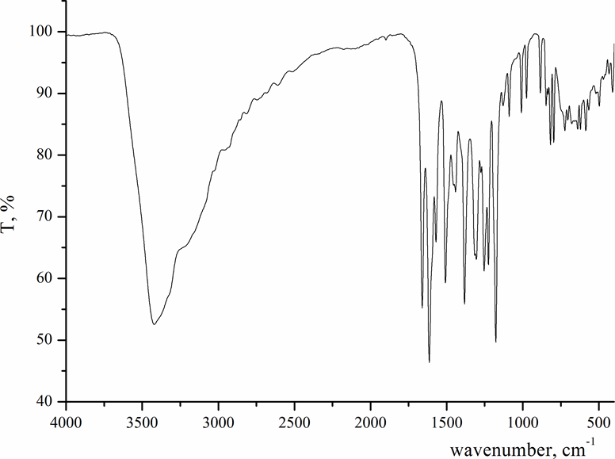
Fig. S1. IR spectrum of kaempferol.

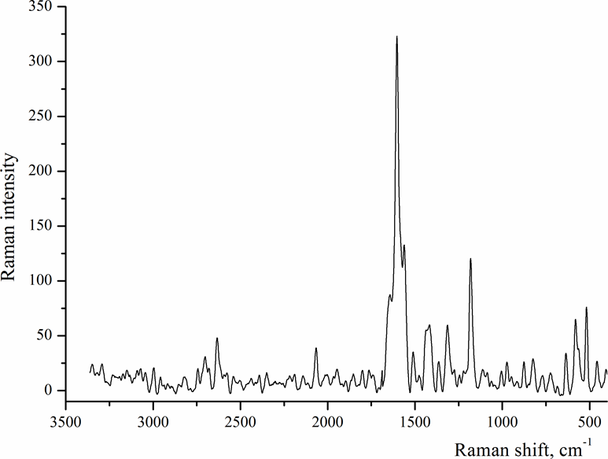

Fig. S2. Raman spectrum of kaempferol.
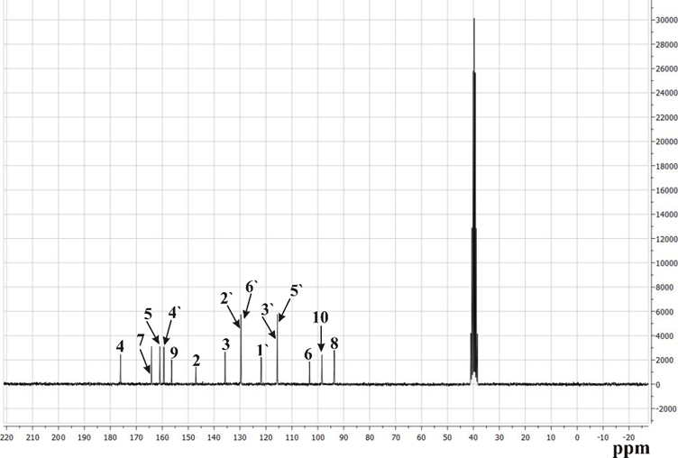
Fig. S3: ¹³C NMR spectrum of kaempferol in DMSO.

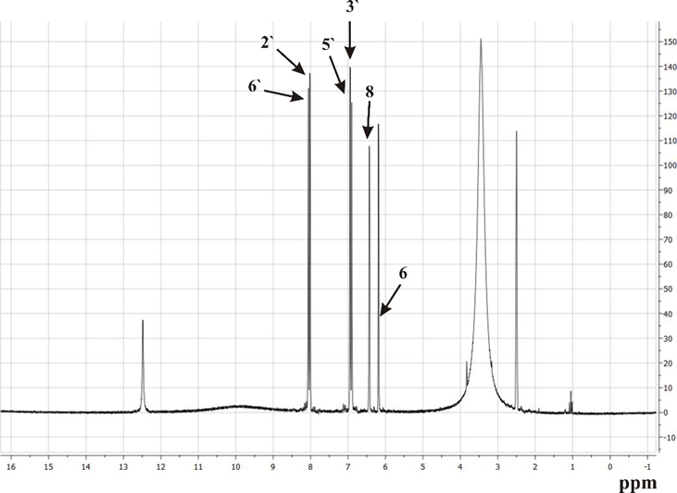

Fig. S4. ¹H NMR spectrum of kaempferol in DMSO.

