Supplementary information
Fe(III)-Doxycycline Complexes with Diimine Ligands: Syntheses, Characterization and Biological Properties

Joshua A. Obaleye^{a,}* and Olufunso O. Abosede^{a,b},
ª Department of Chemistry, University of Ilorin, P.M.B. 1515, Ilorin, Nigeria
^{b} Present address: Department of Chemistry, Federal University Otuoke, P.M.B. 126, Yenagoa, Bayelsa State.
jobaleye@yahoo.com or jobaleye@unilorin.edu.ng
Figure S1: FTIR spectra of the ligands and the complexes

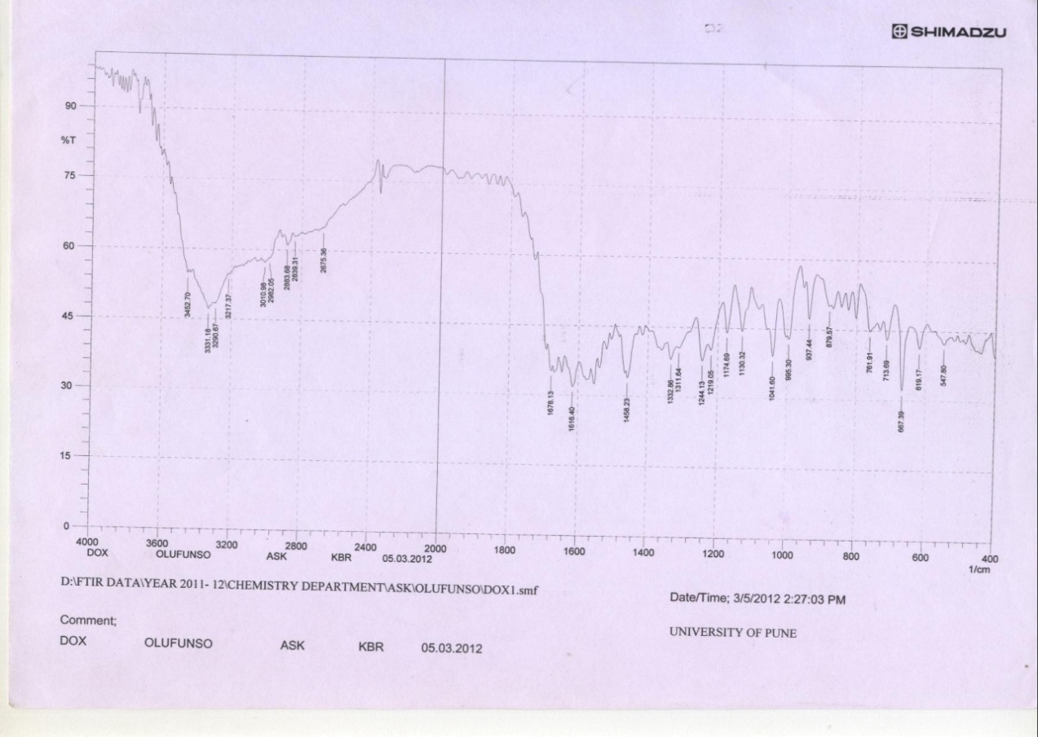
Dox
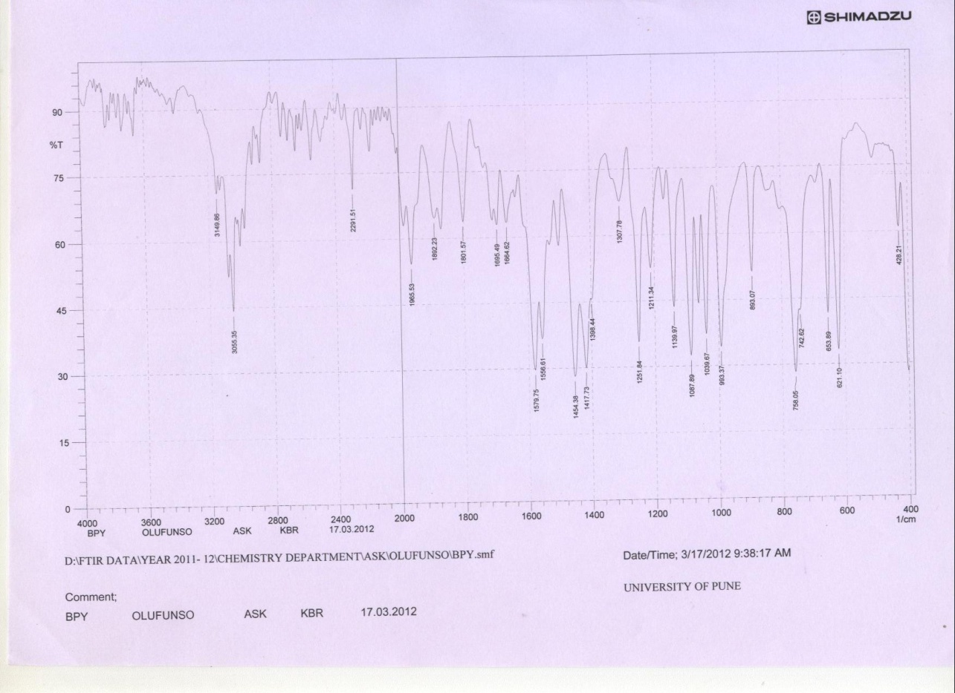
bpy
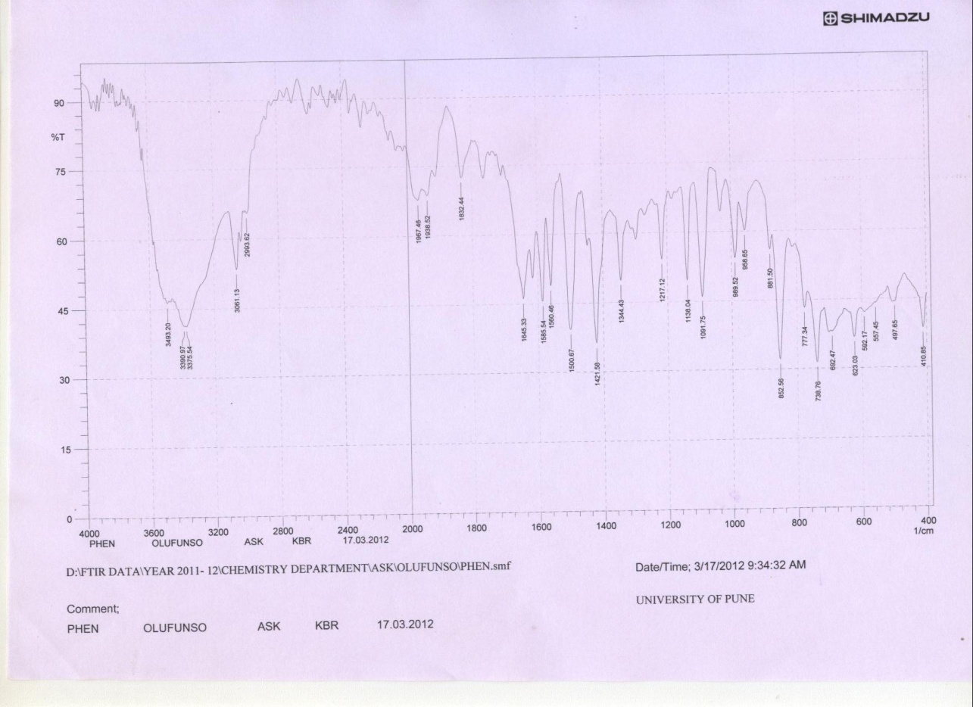
phen
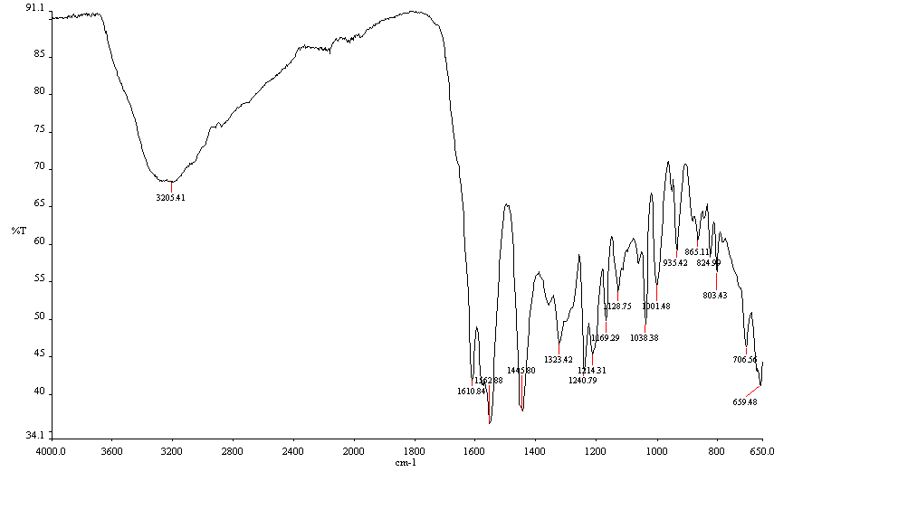
[FeDox₂Cl]Cl₂.6H₂O (1)

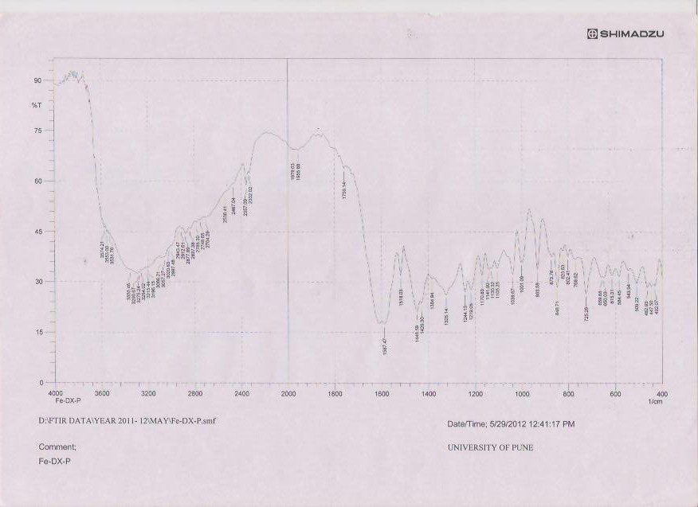
[FephenDoxCl]Cl₂.5H₂O (3)

