Study of Corrosion Inhibition for Mild Steel in NaCl Solution by propolis extract
Veselinka Grudić¹, Ivana Bošković^{1*}, Sanja Martinez², Bojana Knežević¹
¹Faculty of Metallurgy and Technology, University of Montenegro, Džordža Vašingtona BB, 81000 Podgorica, Podgorica, Montenegro
² Faculty of Chemical Engineering and Technology, University of Zagreb, Trg Marka Marulića 19, 10000 Zagreb, Croatia
*Corresponding author: Ivana Bošković, E/mail: ivabo@ac.me
Abstract
This paper studies the corrosion inhibition of X52 5L carbon steel in 0.51 mol dm⁻³ sodium chloride solution in the presence of propolis extract. The inhibition efficiency of propolis extract in a chloride solution was tested by its adding to the working solution and by making a solid propolis coating on the electrode surface. The possibility of corrosion inhibition in the presence of propolis in flow conditions as well as at different temperatures was investigated by electrochemical methods: potentiodynamic polarization method and electrochemical impedance spectroscopy. It was shown that propolis extract acts as a corrosion inhibitor of anodic type whose efficiency increases with increasing of temperature and with stirring of solution. The best protection is achieved by applying propolis coating in flow systems. The EIS method confirmed formation of a protective layer by adsorption of propolis extract on the electrode surface. The results of the FTIR, SEM and EDX surface tests are consistent with the results of electrochemical testing and suggest that propolis extract acts as a corrosion inhibitor of steel by forming a protective film on the electrode surface.
Keywords: carbon steel, propolis, corrosion, inhibition efficiency

1. INTRODUCTION
Carbon steel as a construction material, is often in contact with aggressive media, such as sea water. Since the iron ions with chloride, unlike other metals, do not form a hard soluble salts, steel corrodes in environments where the chloride ions are present [1]. One way of stopping or reducing corrosion is the use of inhibitors. Most synthetic inhibitors, despite high efficiency, are toxic and not used. Therefore, natural products, which are non-toxic, biodegradable and readily available, are increasingly becoming used. Previous researches indicate the possibility of using different plant extracts as a corrosion inhibitor for carbon steel [2-8]. Their inhibition activity is attributed to the presence of complex organic compounds in their composition such as: polyphenols, alkaloids, flavonoids, carbohydrates, amino acids. These compounds contain polar functional groups (with S, N or oxygen atoms), multiple bonds, or aromatic rings which are responsible for adsorption of inhibitor on the metal surface. In addition to herbal extracts, bee products were used as efficient inhibitors of metal’s and alloy’s corrosion [9-17]. Propolis is a bee product of a complex composition which varies depending on time and place of collection [18].
In this paper the possibility of inhibition of carbon steel corrosion by propolis in 0.51 mol dm -3 NaCl solution in flow conditions and at different temperatures was investigated. The tests were performed by electrochemical methods: potentiodynamic polarization method and electrochemical impedance spectroscopy. Also, in order to obtain more detailed information about the steel surface in inhibited and uninhibited systems, FTIR, SEM and EDX analysis were performed.

2. EXPERIMENTAL
2.1. Materials
Corrosion tests were performed on carbon steel X52 5L which composition in mass fractions of elements, w/% are: C 0.26, Si 0.40, Mn 1.40, P 0.03, S 0.03 and the remainder is Fe. Cylindrical steel samples were soldered beforehand to insulated copper wires in order to achieve good electrical contact and insulated by polymeric mass (Simgal- R paste) on all sides, except the base of the cylinder which was directly exposed to the electrolyte.
2.2. Solution preparation
The measurements were carried out in 0.51 mol dm⁻³ NaCl solution in absence and in the presence of commercial alcoholic propolis extract. The NaCl solution was prepared by dissolution of weighed amount of solid NaCl (p.a. purity) in redistilled water.
A commercial propolis alcohol extract, which is insoluble in an aqueous NaCl solution, was used in experimental measurements. Therefore, the calculated amounts of commercial extract are diluted with 30 cm³ of ethanol and added to 200 cm³ of 0.51 mol dm⁻³ NaCl solution. The solution was constantly mixed in order to fully dissolve propolis. After that, the working electrode was immersed in prepared solution and left for 24 hours at stirring rate of 250 rpm and electrochemical tests were then performed. For the purpose of comparing the results, the behavior of the steel in the pure electrolyte solution after 24 hours of electrolyte and electrode contact was monitored.
In addition to examining the possibility of corrosion inhibition by propolis extract added to the electrolyte solution, the inhibition effiency of propolis coating was also investigated. The electrode with the solid coating of propolis was prepared by applying alcohol propolis extract to the electrode surface. The obtained coating was dried in the air for 24 hours.
2.3. Methods
Potentiostate-Galvanostate 273 analyzer model PAR – 325II, interfaced with software for the corrosion investigations, was used for electrochemical tests in 0.51 mol dm⁻³ NaCl solution. A conventional thermostated three-electrode cell, employing a steel carbon disc as working electrode, supergraphite as counter electrode, and saturated calomel electrode as reference electrode was used for measurements. The potentiodynamic polarisation experiments were performed at a scan rate of 1 mV s⁻¹ in the potential range ±150 mV relative to open circuit potential.
The measurements were carried out in a temperature range of 35 ° C to 65 ° C. For flow system simulation, the electrolyte was mixed with a magnetic stirrer.
In order to examine the properties of the oxide layer in absence and in presence of an inhibitor, the FTIR spectra were recorded using the Perkin Elemer Spectrum One spectrometer. The spectra were obtained in the range from 450 to 4000 cm⁻¹, with a scan resolution of 4 cm⁻¹. Pellets used as samples were obtained in a mold using a hydraulic press. Samples were made by removing corrosion products from the steel plate surface by rubbing with KBr (350 g) which is a carrier.
The electrochemical impedance spectroscopy method was applied to obtain information of the electrochemical system nature. The excitation amplitude of 10 mV peak-to-peak in the frequency range from 50 mHz to 10 kHz, at open circuit potential, was used.

3. RESULTS AND DISCUSSION
3.1. Polarization curves
The influence of stirring on corrosion behavior of the steel in 0.51 mol dm⁻³ NaCl solution after 24 hours of electrode and electrolyte contact is shown in Figure 1. Solution mixing has a great influence on the cathodic reaction by moving the cathodic polarization curves to higher current density values. It may be a consequence of faster oxygen diffusion, because the tested electrolyte was in contact with the air all the time [19]. With the increase of stirring rate from 250 to 700 rpm, the current density value increases from 50.326 to 68.041 μA cm⁻², while its value in the unmixed electolyte is 11.237 μA cm⁻².
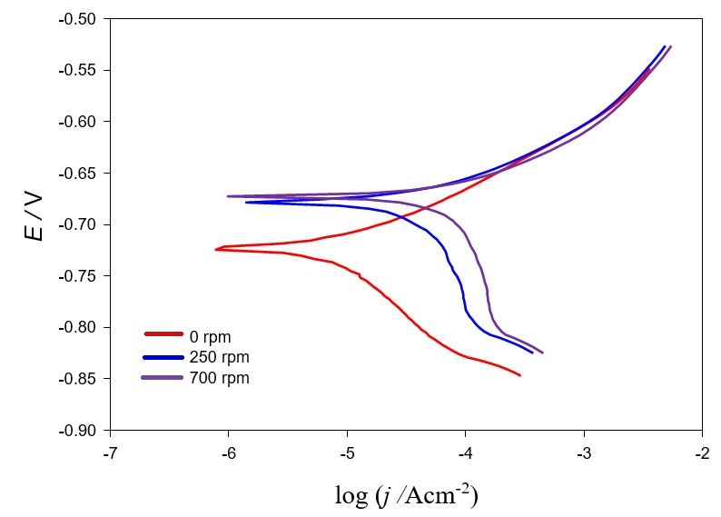
Fig. 1. Potentiodynamic polarization curves of steel in 0.51 mol dm⁻³ NaCl solution at different stirring rates after 24 hours of electrode and electrolyte contact

Figure 2 shows the potentiodynamic polarization curves in the absence and in the presence of propolis in 0.51 mol dm ⁻³ NaCl solution without stirring after 24 hours of electrode and electrolyte contact (Figure 2a) as well as at different stirring rates (Figures 2b and 2c).

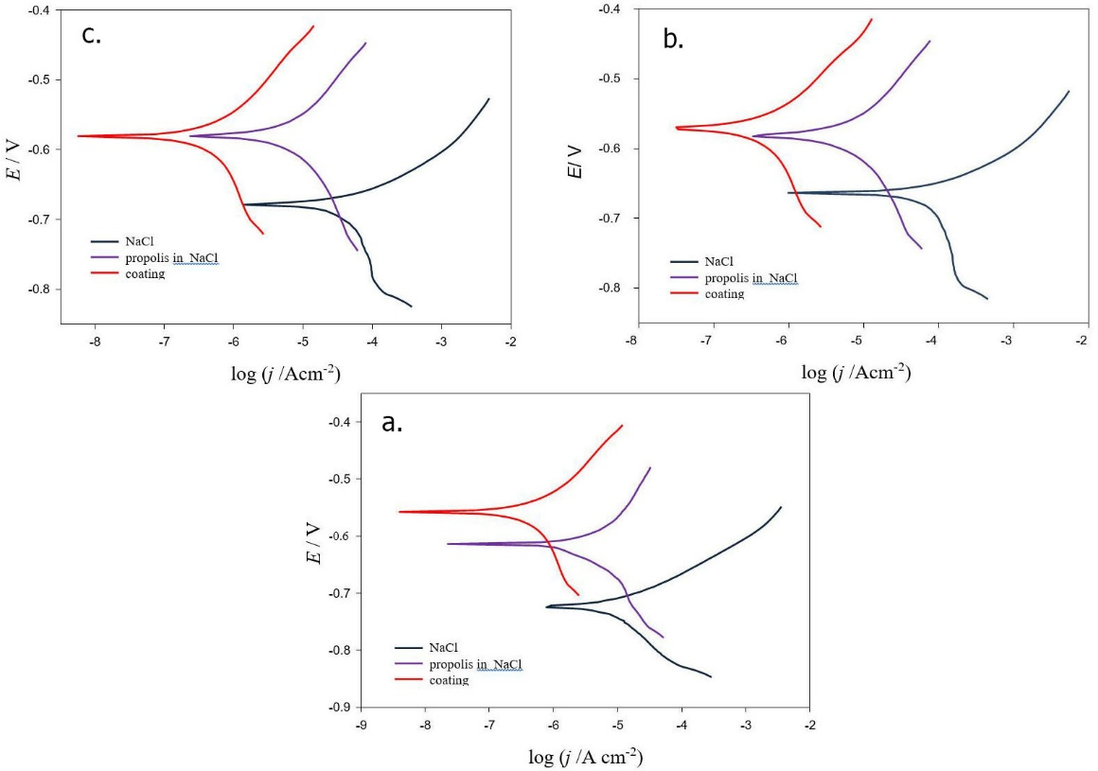
Fig. 2. The potentiodynamic polarization curves in the absence and in the presence of propolis in 0.51 mol dm ⁻³ NaCl solution: a) without stirring after 24 hours of electrode and electrolyte contact and at different stirring rates: b) 250 rpm and c) 700 rpm.

The inhibition efficiency was calculated using the equation (1):
$η\left(\%\right)=\left(\frac{j_{corr}^{0}{-j}_{corr}}{j_{corr}^{0}}\right)∙100$ (1)
where $j_{corr}$ and $j_{corr}^{0}$are the values of corrosion current density in the presence and in absence of inhibitor respectively.
The corrosion parameters obtained from the polarization curves are shown in Table 1.
Table 1 Corrosion parameters obtained from the polarization curves (Figures 1 and 2) for steel in 0.51 mol dm⁻³ NaCl solution
 | I_{corr}/μA | j_{corr}/μA cm⁻² | E_{corr}/mV | b_{a}/mV dec⁻¹ | b_{c}/mV dec⁻¹ |  | η /%
0.51 mol dm -3 NaCl
0 rpm | 1.412 | 11.237 | -723.71 | 40.75 | -96.10
250 rpm | 6.324 | 50.326 | -678.29 | 54.38 | -220.34
700 rpm | 8.550 | 68.041 | -664.14 | 48.39 | -278.23
0.51 mol dm -3 NaCl + 1 cm3 propolis extract
0 rpm | 0.329 | 2.618 | -613.5 | 88.76 | -76.05 |  | 76.7
250 rpm | 0.693 | 5.515 | -580.91 | 93.73 | -151.47 |  | 89.04
700 rpm | 0.871 | 6.931 | -579.77 | 89.92 | -156.16 |  | 89.81
Propolis coating in 0.51 mol dm -3 NaCl
0 rpm | 0.045 | 0.358 | -557.09 | 69.69 | -185.38 | 96.81
250 rpm | 0.052 | 0.414 | -569.77 | 90.40 | -213.18 | 99.18
700 rpm | 0.057 | 0.454 | -580.5 | 91.75 | -117.28 | 99.33

The values in Table 1 show decreasing of the current density with the addition of propolis extract in solution without stirring as well as in stirring solution. These results indicate the propolis extract ability to reduce the corrosion rate due to its adsorption on the steel surface.
Corrosion potential, in the presence of propolis extract, is shifted towards more positive values as well as the cathodic current density is reduced in solution without stirring as well as in stirring solution. The propolis extract can be classified as anodic type of inhibitor due to displacement in corrosion potential, which is more than 85 mV [16, 20].
Inhibition efficiency of propolis extract depends on the stirring rate and propolis extract application. It is evident that the efficiency is greater in the flow conditions and by applying propolis extract to the electrode surface. The highest efficiency (99,33%) was achieved after 24 hours exposure of electrode with propolis coating to electrolyte at a stirring rate of 700 rpm.
3.2. The influence of temperature
The influence of temperature on the corrosion behavior of carbon steel in 0.51mol dm ⁻³ NaCl solution containing propolis extract was examined in the temperature range of 308K-338K by recording potentiodynamic curves. The current values and the corresponding efficiencies are shown in Table 2.
Table 2 The values of corrosion current and inhibition efficiency on carbon steel in 0.51mol dm ⁻³ NaCl solution at different temperatures
T /K | j_{corr} /µA cm⁻² | j_{corr}⁰ /µA cm⁻² | η /%
308 | 34.412 | 16.406 | 52.32
318 | 57.828 | 21.777 | 62.34
328 | 86.896 | 31.509 | 63.73
338 | 100.462 | 36.768 | 63.40

The data presented in Table 2 show that with increasing temperature, corrosion current density increases in 0.51 mol dm⁻³ NaCl solution. The increase of the corrosion rate with increasing temperature is present to a lesser degree in uninhibited system, and therefore at higher temperature provides a higher efficiency of the protection. This indicates that the propolis extract is chemisorbed on the steel surface, because in the case of physical adsorption at the examined temperatures, organic molecules would break down. In case of chemisorption, with increasing of temperature, reinforcement of the bonds is achieved, so there is no decrease of the protection efficiency [21, 22].
3.3. Activation energy and thermodynamic parameters of the inhibition process
A quantitative relationship between temperature and corrosion rate is given by Arrhenius′s equation:
$j_{corr}=A exp\left(-\frac{E_{A}}{RT}\right)$ (2)
where: j_{corr} is current density which is directly proportional to the corrosion rate, A is the Arrhenius′s pre-exponential factor, E_{A} is the apparent activation energy, R=8,314 J K⁻¹mol⁻¹ is the universal gas constant, T/K is the absolute temperature.
A plot of ln j_{corr} versus 1/T for 0.51 mol dm⁻³ NaCl solution in absence and in presence of propolis were presented in Figure 3. Obtained straight lines have slope (-E_{A}/R) and intercept of lnA from which E_{A} and A were calculated and then listed in Table 3. The correlation coefficients (R²) show the values close to unit which indicates that the corrosion of the carbon steel in 0.5 mol dm⁻³ NaCl solution is well described by Arrhenius′s equation (Figure 3)
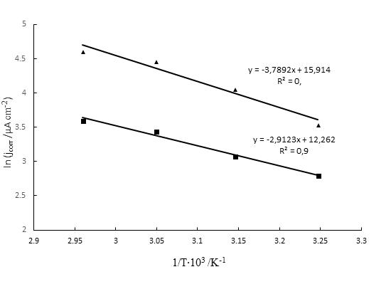
Fig. 3. Arrhenius′s plots of ln j_{corr} versus 1/T for carbon steel in 0.51 mol dm⁻³ NaCl solution without propolis (▲) and with propolis(■)
Table 3 Activation parameters of carbon steel corrosion in 0.51 mol dm⁻³ NaCl in absence and in the presence of propolis extract
 | E_{a}° /KJ mol⁻¹ | A /μA cm⁻² | ΔH_{a}° /KJ mol⁻¹ | ΔS_{a}° /J mol⁻¹ K⁻¹
0.51 mol dm⁻³ NaCl | 31.5248 | 82.1049∙10⁵ | 31.4211 | - 113.145
Propolis extract in 0.51 mol dm⁻³ NaCl | 24.3177 | 2.1951∙10⁵ | 21.5299 | - 151.781

Literature data suggests that if the activation energy is higher in the presence of inhibitor, physical adsorption is performed [23, 24], while the reduction of apparent activation energy indicates chemisorption [25, 26]. The results presented in Table 3 show that the values of E_{A} are lower in the presence of corrosion inhibitor than those obtained in the inhibitor free solution. It points out the chemisorption of the propolis on the carbon steel surface. The lower value of activation energy in the presence of inhibitor can be explained by the fact that the reaction occurs on the surface covered by inhibitor´s molecules, which resulted in a lower reaction rate than on the uncovered metal surface [27].
It can be seen (equation 2) that at the lower corrosion current values, the value of the Arrhenius′s pre-exponential factor is lower, and the apparent activation energy values are higher. Therefore, it can be concluded that the reduction of the corrosion rate in case of propolis extract inhibition is determined by the reduction of Arrhenius′s pre-exponential factor.
The two important thermodynamic parameters of corrosion were also calculated: activation enthalpy (ΔH_{a}⁰) and activation entropy (ΔS_{a}⁰) using the equation of transition state [12] :
$j_{corr}=\frac{RT}{Nh}{exp\left(\frac{∆S_{ads}^{0}}{R}\right) exp\left(-\frac{∆{H }_{ads}^{0}}{RT}\right) }^{ }$ (3)
Where: N is Avogadro's number, and h is the Planck′s constant.
A plot of ln (j_{corr}/T) versus 1/T is the straight line with the slope (−ΔH_{ads}⁰/R) and intercept [(ln (R/Nh)) + (ΔS_{ads}⁰ /R)] (Figure 4). Activation parameters of the carbon steel corrosion in 0.51 mol dm⁻³ NaCl solution in the absence and in the presence of propolis extract are presented in Table 3.
Fig. 4. A plot of ln (j_{corr}/T) versus 1/T in 0,51 mol dm⁻³ NaCl solution: without propolis (▲) and with propolis(■)
Positive values of activation enthalpy reflect endothermic corrosion process. The negative values of the activation entropy (ΔS_{ads}⁰) both in the absence and in the presence of propolis extract imply that the activated complex in the rate determining step represents an association rather than a dissociation step, meaning that a decrease in disordering takes place on going from reactants to activated complex [28].
EIS measurements at open-circuit potential were carried out to determine the kinetic parameters for electron transfer reactions at the steel/electrolyte interface and simultaneously about the surface properties of the investigated system and the shape of the impedance diagram will provide mechanistic information. The Nyquist and Bode impedance plots obtained for steel electrode in the absence and in the presence of propolis extract in 0.5 mol dm⁻³ NaCl solution are shown in Figures 5 and 6. Experimentally obtained Nyquist plots are marked by the points on the diagram, while the lines represent the simulated Nyquist curves which correspond to the constructed electric circuit model (Figure 7) The obtained results show a good correlation between experimental and simulated curves, indicating that the proposed model is good.
The presence of the inhibitor causes change in dependence of frequency in function of phase angle in all frequency domain in relation to the measurement without inhibitor (Figure 5) This phenomenon indicates that propolis molecules form a barrier on the steel surface and thus protect it from corrosion [29]. The deviation of the maximum of Nyquist curve from the ideal semicircle can be due to the imperfection of the electrode surface or inhibitor adsorption [30, 31].
The equivalent circuit proposed (Figure 7) to fit the experimental data consisting of an electrolyte resistance Rs connected with two time constants. The first time constant, observed in the high frequency region, is the result of the fast charge-transfer process in the steel dissolution reaction in the NaCl solution. In this case, R₁ represents the charge transfer resistance and CPE₁ respresents the constant phase element and replaces the capacity of the electrochemical double layer [14]. To account for the surface layer in low frequency range, additional equivalent circuit parameters were introduced, such R₂ for the surface layer resistance and CPE₂ for constant phase element of the surface layer which replaces the capacity of surface layer.
The calculated equivalent circuit parameters for carbon steel in neutral chloride solutions without and with propolis extract are presented in Table 4. The CPE is a special element whose admittance value is a function of angular frequency (ω), and the phase is independent of the frequency.
Fig. 5. Nyquist plots for carbon steel in 0.51 mol dm⁻³ NaCl solution in absence and in the presence of propolis extract

Fig. 6. Bode plots for carbon steel in 0.51 mol dm⁻³ NaCl solution: in absence and in the presence of propolis extract

Fig. 7. Equivalent circuit used in fitting the impedance spectra

Tabela 4 The equivalent circuit parameters in Figure 7 required for fitting the EIS for carbon steel in 0.51 mol dm⁻³ NaCl solution in absence and in the presence of propolis extract
 | R_{S} /Ω | CPE₁ /S s^{-n} |  |  | R₁ /Ω | CPE₂ /S s^{-n} |  |  | R₂ /Ω
 |  | Q∙10⁶ | n | C /μF |  | Q∙10⁵ | n | C /μF
NaCl | 22.12 | 433.97 | 0.74 | 233.46 | 395.50 | 156.44 | 0.56 | 6795.46 | 4218
Propolis extract | 11.78 | 2.61 | 0.73 | 0.175 | 229.00 | 23.66 | 0.72 | 353.64 | 11711

The Nyquist plots show a depressed semicircular with their centers below the real axis. This phenomenon that is known as the frequency dispersion effect is typical for solid metal electrodes [32]. For that reasons, the electrochemical double layer capacity in the electric circuit was replaced by a constant phase element to make the model better suited to the experimental results. The constant phase element is used to quantify various physical phenomena, such as inhomogeneity of the electrode surface due to roughness, oxide layers formation or adsorption of the inhibitor. CPE consists of a constant Q and a component n [33]. The rise of value n in the presence of inhibitor indicates a decrease in inhomogeneity of the surface due to adsorption inhibitor [34].

The exponent value n is used to determine the degree which control the electrochemical reaction rate. The value n less than 0.7 indicates that the electrochemical reaction is controlled by diffusion process. The value of n in the range from 0.7 to 0.9 indicates that the charge transfer is slow degree of the reaction. The values in Table 4 indicate that carbon steel corrosion rate in the chloride solution without propolis extract is controlled by diffusion, while in the system with propolis it is controlled by charge transfer [35].
The double layer capacity value is calculated according to the equation:
$C={\left(QR_{ct}^{1-n}\right)}^{\frac{1}{n}}$ (4)
There is a decreasing of the double layer capacity value (Table 4.) in the presence of inhibitor which can be explained by the inhibitor adsorption on the electrode surface. Decreasing of C is due to an increase of the electrochemical double layer thickness which is due to the reduction of the local dielectric constant. It was due to the gradual replacement of the water molecule by the inhibitor molecules at the electrode/electrolyte interface [36]. Increasing resistance R indicates corrosion rate reduction.
FTIR analysis was carried out in order to investigate the properties of the adsorbed propolis layer which causes a reduction in the corrosion rate (Figure 8.)
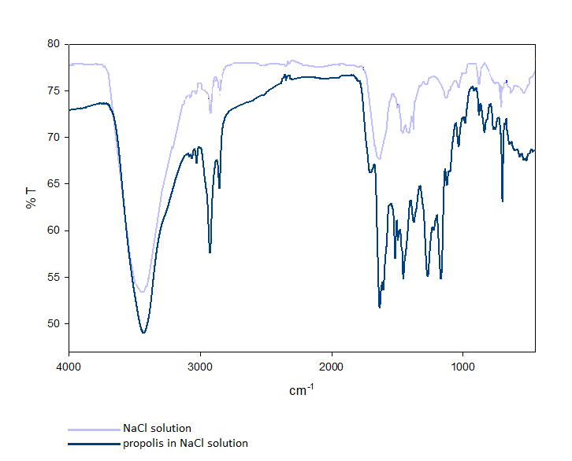
Fig. 8. FTIR spectra of corrosion products of X52 L5 steel after exposure to NaCl solution in the absence and in the presence of propolis extract
Peaks appearing at 3436 cm⁻¹ can be attributed to surface-bound water [37]. The peaks at 544 cm⁻¹ , 630 cm ⁻¹ , 897 cm ⁻¹, 1123 cm ⁻¹ and 1161 cm⁻¹ indicate the presence of iron oxide and oxyhydroxide (α -phase) as corrosion products on steel surface[38-40]. The FTIR spectrum of surface film on carbon steel formed after exposure to inhibited solution showed a displacement of peak from 3436 cm⁻¹ to 3430 cm⁻¹, as well as the absence of bonds characteristic for oxides and iron hydroxides. The peaks at 1031 cm⁻¹ and 1166 cm⁻¹ are characteristic for the C-O bond, while the peaks at 1632 cm⁻¹ and 1527 cm⁻¹ can be attributed to C = C and C = C aromatic ring [41]. Peaks characteristic for N-O, nitro N = O and nitrile C≡N bonds were observed on the spectrum of the sample in NaCl solution with propolis extract [42].
The microstructures of the steel surface analysed by SEM-EDX method before exposure to the electrolyte as well as after 24 hours immersing in electrolyte in the absence and in the presence of propolis extract are shown in Figure 9. The microstructure of the steel surface before exposure to the electrolyte shows smooth surface with scratches left behind after grinding, but without corrosion damage.
Small quantities of carbon and oxygen and mostly iron are presented on the steel before exposure to electrolyte, while large amounts of iron and oxygen and small quantities of sodium, chlorine and carbon are determined on the surface of steel exposed to NaCl. These results indicate that the surface is covered with corrosion products i.e. iron oxides and iron chlorides (Figure 9b). The results of this analysis on the sample from the inhibited system (Figure 9c) show mostly the amount of carbon about 71%, which can be related to the chemisorption of propolis on the electrode surface. Oxygen, nitrogen, iron, chlorine and sodium are present in small percentages (Figure 9c).

Fig. 9. SEM and EDX analysis of steel surface before exposure to electrolyte (a), after exposure of 0.51 mol dm⁻³ NaCl (b) and after exposure of 0.51 mol dm⁻³ NaCl in the presence of propolis (c)
4. CONCLUSIONS

On the basis of the performed examinations, it was found that the propolis extract acts as the anodic corrosion inhibitor of X52 L5 steel in 0.51 mol dm⁻³ NaCl solution. Its inhibition efficiency increases with increasing of stirring rate as well as with rising of temperature. The best inhibition efficiency is achieved by using a propolis coating, which increases at higher stirring rates. The maximum efficiency of 99.33% was obtained at a stirring rate of 700 rpm, after one day. Therefore, it is recommended using propolis as a steel inhibitor in flow systems. By analyzing the kinetic parameters it was found that the propolis was chemisorbed on the electrode surface. The results of the EIS show that in the presence of propolis extract there is a decrease in the charge transfer resistance. According to FTIR analysis, corrosion products of steel in uninhibited system are mainly oxides and iron hydroxides. The presence of bonds characteristic for organic compounds in the inhibited system confirms the adsorption of propolis on the steel surface, which is consistent with the results of electrochemical measurements. SEM and EDX analysis show the presence of mostly corrosive products on the electrode exposed to the uninhibited system while 71% of the carbon is presented on the surface inhibited by propolis extract. Due to its high efficiency and environmental friendliness propolis extract can be used as an inhibitor of steel corrosion in 0.51mol dm⁻³ NaCl.

REFERENCES
- K. Barton, Protection Against Atmospheric Corrosion, John Wiley and Sons, New York, 1973, p. 32.
- P. B. Raja, A. K.Qureshi, A. A.Rahim, H. Osman, K. Awang, Neolamarckia cadamba alkaloids as eco-friendly corrosion inhibitors for mild steel in 1 M HCl media, Corros. Sci. 69, 292-301 (2013), https://doi.org/10.1016/j.corsci.2012.11.042

- M. A. Quraishi, A. Singh, V. K. Singh V, D. Y. Yadav, A. K. Singh, Green approach to corrosion inhibition of mild steel in hydrochloric acid and sulphuric acid solutions by the extract of Murraya koenigii leaves, Mater. Chem. Phys. 122(1), 114-122 (2010), https://doi.org/10.1016/j.matchemphys.2010.02.066

- Y. Li, P. Zhao, Q. Liang, B. R. Hou, Berberine as a natural source inhibitor for mild steel in 1 M H₂SO₄, Appl. Surf. Sci. 252(5), 1245-1253 (2005), https://doi.org/10.1016/j.apsusc.2005.02.094

- E. E. Oguzie, Corrosion inhibitive effect and adsorption behaviour of Hibiscus sabdariffa extract on mild steel in acidic media, Port. Electrochim. Acta 26 (3), 303-314 (2008),

- A. Bouyanzer, B. Hammouti, A study of anti-corrosive effects of Artemisia oil on steel, Pigment & Resin Technology, 33(5), 287-292 (2004), https://doi.org/10.1108/0369942041056048/

- N. O. Eddy, S. A. Odoemelam, A. O. Odiongenyi, Ethanol extract of musa species peels as a green corrosion inhibitor for mild steel: Kinetics, adsorption and thermodynamic considerations, Electron. J. Environ. Agric. Food Chem. 8(4) 243-245
(2009)

- K. Anuradha, R. Vimala, B. Narayanasamy, J. Selvi, R. S. Arockia, Corrosion inhibition of carbon steel in low chloride media by an aqueous extract of hibiscus rosa-sinensis Linn, J. Chem. Eng. Commun. 195(3), 352-366 (2007), https://doi.org/10.1080/00986440701673283

- I. Radojčić, K. Berković, S. Kovač, J. Vorkapić-Furac, Natural honey and blackradish juice as tin corrosion inhibitors, Corros. Sci. 50, 1498–1504 (2008), https://doi.org/10.1016/j.corsci.2008.01.013
- W. B.Wan Nik, M. F. Zulkifli, R. Rosliza, M. J.Ghazali, K. F. Khaled, Potential of honey as corrosion inhibitor for aluminium alloy in seawater, World Appl. Sci. J. 14, 215–220 (2011),
- A.Y. El-Etre, M. Abdallah, Natural honey as corrosion inhibitor for metals andalloys. II. C-steel in high saline water, Corros. Sci. 42(4), 731–738 (2000), https://doi.org/10.1016/S0010-938X(99)00106-7
- A.O. Odiongenyi, I.S. Enengedi, I. Ibok, E.J. Ukpong, Inhibition of the corrosionof zinc in 0.1 M HCl by ethanol extract of honey, Int. J. Chem. Mater. Environ. Res. 2, 16–25 (2015),
- R. Rosliza, W.B. Wan Nik, S. Izman, Y. Prawoto, Anti-corrosive properties ofnatural honey on Al-Mg-Si alloy in seawater, Curr. Appl. Phys. 10, 923–929 (2010), https://doi.org/10.1016/j.cap.2009.11.074
- L. Vrsalović, S. Gudić, M. Kliskić, Salvia officinalis L. honey as corrosion inhibitor for CuNiFe in sodium chloride solution, Ind. J. Chem. Technol. 19, 96–102 (2012),
- F. Gapsari, R. Soenoko, A. Suprapto, W. Suprapto, Bee wax propolis extract aseco-friendly corrosion inhibitors for 304SS in sulfuric acid, Int. J. Corros. 2015,1–10 (2015), http://dx.doi.org/10.1155/2015/567202

- A.S. Fouda, A. Hamdy Badr, Aqueous extract of propolis as corrosion inhibitorfor carbon steel in aqueous solutions, Afr. J. Pure Appl. Chem. 7, 350–359 (2013), DOI : 10.5897/AJPAC2013.0524
- L. M. P. Dolabella, J. G. Oliveira, V. Lins, T. Matencio, W. L. Vasconcelos, Ethanol extract of propolis as a protective coating for mild steel in chloride media, J.Coat. Technol. Res. 13, 543–555 (2016),
- K.R. Markham, K.A. Mitchell, A.L. Wilkins, J.A. Daldy, Y. Lu, HPLC and GC–MS identification of the major organic constituents in New Zealand propolis, Phytochem. 42, 205–211 (1996), https://doi.org/10.1016/0031-9422(96)83286-9
- R. Babolan, Corrosion tests and standards, Application and interpretation- second edition, ASTM International, USA, 2005
- H. Otmačić- Ćurković, E. Stupnišek-Lisac, H. Takenouti, The influence of pH value on the efficiency of imidazole based corrosion inhibitors of copper, Corros. Sci. 52, 398 (2010) https://doi.org/10.1016/j.corsci.2009.09.026

- A. Frignani, G. Trabanelli, F. Zucchi, and M. Zucchini, Proceedings of 5th European Symposium of Corrosion Inhibitors, Ferrara, Italy, 1980, p. 1185.
- V. S. Sastri, Corrosion Inhibitors: Principles and Applications, J. Wiley, New York, 1998, p. 39.
- S. M. A. Hosseini, M. Salari, E. Jamalizadeh, S. Khezripoor, M. Seifi, Inhibition of mild steel corrosion in sulfuric acid by some newly synthesized organic compounds, Mater. Chem. Phys.119, 100-105 (2010), https://doi.org/10.1016/j.matchemphys.2009.08.029
- X. He, Y. Jiang, C. Li, W. Wang, B. Hou, L. Wu, Inhibition properties and adsorption behavior of imidazole and 2-phenyl-2-imidazoline on AA5052 in 1.0 M HCl solution, Corros. Sci. 83, 124–136 (2014), https://doi.org/10.1016/j.corsci.2014.02.004
- M. Behpour, S.M. Ghoreishi, N. Soltani, M. Salavati-Niasari, M. Hamadanian, A.
Gandomi, Electrochemical and theoretical investigation on the corrosion inhibition of mild steel by thiosalicylaldehyde derivatives in hydrochloric acid solution, Corros. Sci. 50, 2172–2181 (2008), https://doi.org/10.1016/j.corsci.2008.06.020

- X. Wang, Y. Wan, Y. Gu, Y. Ma, F. Shi, W. Nui, Q. Wang, Inhibition and adsorptive behavior of synthesized 1,4-bis (2-benzimidazolyl) benzene on mild steel in 3 M HCl solution, Int. J. Electrochem. Sci. 9, 1840–1853 (2014),
- G.M. Schmid, H.J. Huang, Spectro-electrochemical studies of the inhibition effect of 4, 7-diphenyl -1, 10-phenanthroline on the corrosion of 304 stainless steel, Corros. Sci. 20, 1041-1057 (1980), https://doi.org/10.1016/0010-938X(80)90083-9
- S. Andreani, M. Znini , J. Paolini, L. Majidi, B. Hammouti, J. Costa, A. Muselli, Study of Corrosion Inhibition for Mild Steel in Hydrochloric Acid Solution by Limbarda crithmoides (L.) Essential Oil of Corsica, J. Mater. Environ. Sci. 7 (1), 187-195 (2016),
- D. Asefi, M.Arami, N.Mahmoodi, Electrochemical effect of cationic gemini surfactant and halide salts on corrosion inhibition of low carbon steel in acid medium, Corros. Sci. 52, 794-800 (2010), https://doi.org/10.1016/j.corsci.2009.10.039
- S.Shukla, M.Quraishi, The effects of pharmaceutically active compound doxycycline on the corrosion of mild steel in hydrochloric acid solution, Corros. Sci. 52, 314-321 (2010), https://doi.org/10.1016/j.corsci.2009.09.017
- H. Ashassi-Sorkhabi, N. Ghalebsaz-Jeddi, F. Hasemzadeh, H. Jahani, Corrosion inhibition of carbon steel in hydrochloric acid by some polyethylene glycols, Electrochim. Acta 51, 3848-3854 (2006), https://doi.org/10.1016/j.electacta.2005.11.002
- K.F. Khaled, Corrosion control of copper in nitric acid solutions using some amino acids − a combined experimental and theoretical study, Corros. Sci. 52, 3225–3234 (2010), https://doi.org/10.1016/j.corsci.2010.05.039
- S. Deng, X. Li, X. Xie, Hydroxymethyl urea and 1,3-bis(hydroxymethyl) urea as corrosion inhibitors for steel in HCl solution, Corros. Sci. 80, 276–289 (2014), https://doi.org/10.1016/j.corsci.2013.11.041
- C. C. Li, X.Y. Guo, S. Shen, P. Song, T. Xu, Y. Wen, H.F. Yang, Adsorption and corrosion inhibition of phytic acid calcium on the copper surface in 3 wt.% NaCl solution, Corros. Sci. 83, 147–154 (2014), https://doi.org/10.1016/j.corsci.2014.02.001
- D.K. Yadav, M.A. Quraishi, B. Maiti, Inhibition effect of some benzylidenes on mild steel in 1 M HCl: an experimental and theoretical correlation, Corros. Sci. 55, 254–266 (2012), https://doi.org/10.1016/j.corsci.2011.10.030
- D. Wang, B. Xiang, Y. Liang, S. Song, C. Liu, Corrosion control of copper in 3.5 wt.% NaCl solution by Domperidone: experimental and theoretical study, Corros. Sci. 85, 77–86 (2014), https://doi.org/10.1016/j.corsci.2014.04.002
- R. M. Cornell, U. Schwertmann, The Iron–Oxides – Structure, Properties, Reactions, Occurences and Uses, Springer, Berlin, 1996, p. 573
- S. Hosseinpour, M. Johnson, Vibrational Spectroscopy in Studies of Atmospheric Corrosion, Materials 10(4), 413 (2017), https://doi.org/10.3390/ma10040413
- R. Jasinski, A. Lob, FTIR Measurements of Iron Oxides on Low Alloy Steel, J. Electrochem. Soc.135(3), 551-556 (1988), doi 10.1149/1.2095656
- R. I. Pramana, R. Kusumastuti, J.W. Soedarsono, A. Rustandi, Corrosion Inhibition of Low Carbon Steel by Pluchea Indica Less. in 3.5% NaCl Solution, Adv. Mater. Res. 785-786, 20-24 (2013), https://doi.org/10.4028/www.scientific.net/AMR.785-786.20
- H. Hachelef, , A. Benmoussat, A. Khelifa, M. Meziane, Study of the propolis extract as a corrosion inhibitor of copper alloy in ethylene glycol/water 0.1 M NaCl, J. Fundam. App. Sci. 9(2), 650-668 (2017), http://dx.doi.org/10.4314/jfas.v9i2.3
- R. N. Oliveira et al., FTIR analysis and quantification of phenols and flavonoids of five commercially available plants extracts used in wound healing, Matéria (RioJ.) 21(3), 767-779 (2016), http://dx.doi.org/10.1590/S1517-707620160003.0072

