**Table S1** IR spectral data of free ligands (cm-1).

|  |  |  |  |  |  |  |  |  |  |  |
| --- | --- | --- | --- | --- | --- | --- | --- | --- | --- | --- |
|  | **Hsba** | | **23dap** | **23da5Brp** | **23da5Clp** | **2a3bxp** | **2a3OHp** | **2a3mp** | **2a3m6Etp** | **2a3NO26mp** |
| ν(O-H) | 2900(br) | - | | - | - | - | 3422(br) |  | - | - |
| ν(NH2) | 3364(m)  3289(m) | 3311(m)  3253(m)  3143(m)  3115(m) | | 3374(m)  3307(m)  3281(m)  3218(m) | 3377(m)  3309(m)  3287(m)  3223(m) | 3309(m)  3261(m) | 3346(m)  3224(m) | 3325(m)  3153(m) | 3344(m)  3251(m) | 3329(m)  3201(m) |
| ν(C-H)Ar | 3110(s) | 3053(w) | | 3052(w) | 3058(w) | 3074(w) | 3062(w) | 3087(w) | 3057(w) | 3096(w) |
| ν(C-H)Al | 2994(w)  2954(w)  2850(w) | - | | - | - | 3034(w)  2967(w)  2890(w) | - | 2989(w)  2849(w)  2727(w) | 2952(w)  2895(w)  2838(w) | 3012(w)  2956(w)  2904(w) |
| ν(C=O) | 1684(s)  1480(s) | - | | - | - | - | - | - | - | - |
| ν(C=N)  ν(C=C) | 1578(s)  1541(s)  1492(s)  1472(s)  1435(s) | 1590(s)  1552(s)  1480(s)  1445(s) | | 1608(s)  1588(s)  1558(s)  1476(s)  1439(s) | 1619(s)  1611(s)  1588(s)  1568(s)  1476(s)  1443(s) | 1609(s)  1587(s)  1497(s)  1477(s)  1437(s) | 1612(s)  1634(s)  1576(s)  1482(s)  1468(s) | 1614(s)  1555(s)  1476(s)  1375(s) | 1614(s)  1594(s)  1581(s)  1541(s)  1471(s) | 1613(s)  1587(s)  1486(s)  1472(s)  1424(s) |
| ν(NO2) | - | - | | - | - | - | - | - |  | 1531(s)  1336(s) |
| ν(C-O) | 1357(s)  1212(s)  1052(s) | - | | - | - | 1353(s)  1276(s)  1081(s) | 1354(s)  1234(s)  1082(s) | - | - | - |
| ν(S=O) | 1277(s)  1189(s)  1149(s) | - | | - | - | - | - | - | - | - |
| ν(py) | - | 781(s) | | 797(s) | 784(s) | 740(s) | 776(s) | 794(s) | 838(s) | 779(s) |

a abbreviations: w, weak; m, medium; s, strong; b, broad

**Table S2** IR spectral data of **1-9** (cm-1).

|  |  |  |  |  |  |  |  |  |  |
| --- | --- | --- | --- | --- | --- | --- | --- | --- | --- |
|  | **1** | **2** | **3** | **4** | **5** | **6** | **7** | **8** | **9** |
| ν(O-H) | 3488(br) | 3430(br) | 3446(br) | 3427(br) | - | 3568(br) | 3582(br) | 3526(br) | 3489(br) |
| ν(NH2) | 3370(m)  3251(m) | 3396(m)  3372(m)  3336(m)  3188(m) | 3384(m)  3205(m) | 3302(m)  3217(m) | 3319(m)  3229(m)  3280(m)  3202(m) | 3372(m)  3275(m) | 3476(m)  3382(m)  3321(m)  3289(m) | 3435(m)  3371(m)  3266(m)  3186(m) | 3428(m)  3292(m)  3231(m)  3154(m) |
| ν(C-H)Ar | 3110(s) | 3105(s) | 3054(s) | 3074(s) | 3086(s) | 3103(s) | 3075(s) | 3027(s) | 3074(s) |
| ν(C-H)Alf. | 2994(w)  2954(w)  2850(w) | 2943(w)  2900(w)  2840(w) | 2948(w)  2885(w)  2828(w) | 2907(w)  2840(w) | 2980(w)  2885(w)  2842(w) | 2948(w)  2854(w) | 2942(w)  2846(w)  2746(w) | 2956(w)  2849(w) | 2891(w)  2801(w) |
| ν(C=O) | 1612(s)  1467(s) | 1626(s)  1475(s) | 1621(s)  1475(s) | 1621(s)  1469(s) | 1626(s)  1472(s) | 1612(s)  1463(s) | 1623(s)  1481(s) | 1639(s)  1484(s) | 1636(s)  1486(s) |
| ν(C=N)  ν(C=C) | 1581(s)  1543(s)  1468(s)  1454(s)  1437(s) | 1556(s)  1518(s)  1507(s)  1497(s)  1424(s) | 1604(s)  1557(s)  1506(s)  1424(s) | 1555(s)  1489(s) | 1583(s)  1562(s)  1492(s)  1432(s) | 1581(s)  1559(s)  1531(s)  1421(s) | 1583(s)  1562(s)  1459(s)  1425(s) | 1604(s)  1581(s)  1548(s)  1484(s)  1413(s) | 1585(s)  1558(s)  1501(s)  1417(s) |
| ν(NO2) | - | - | - | - | - | - | - |  | 1558(s)  1335(s) |
| ν(C-O) | 1387(s)  1257(s)  1089(s) | 1355(s)  1257(s)  1030(s) | 1353(s)  1254(s)  1084(s) | 1371(s)  1255(s)  1088(s) | 1374(s)  1283(s)  1087(s) | 1375(s)  1255(s)  1087(s) | 1371(s)  1258(s)  1091(s) | 1382(s)  1255(s)  1089(s) | 1353(s)  1249(s)  1050(s) |
| ν(S=O) | 1277(s)  1189(s)  1149(s) | 1322(s)  1157(s)  1134(s) | 1331(s)  1157(s)  1131(s) | 1329(s)  1167(s)  1122(s) | 1335(s)  1168(s)  1123(s) | 1299(s)  1166(s)  1121(s) | 1295(s)  1170(s)  1124(s) | 1276(s)  1171(s)  1123(s) | 1304(s)  1137(s) |
| ν(py) | - | 769(s) | 766(s) | 770(s) | 750(s) | 799(s) | 758(s) | 798(s) | 759(s) |
| ν(M-N) | - | 453(w) | 450(w) | 454(w) | 453(w) | 496(w) | 459(w) | 453(w) | 484(w) |
| ν(M-O) | 582(w) | 606(w) | 606(w) | 606(w) | 606(w) | 579(w) | 576(w) | 585(w) | 559(w) |

a abbreviations: w, weak; m, medium; s, strong; b, broad

**Table S3** Optical properties all compounds in DMSO (nm(Lmol‑1cm-1)).

|  |  |  |  |
| --- | --- | --- | --- |
| **Compound** | **λ** | **Compound** | **λ** |
| **sba** | 301(32270) | **1** | 786(190)  296(33260) |
| **2,3dap** | 321(28170)  302(28680) | **2** | 794(290)  300(31840)  276(18500) |
| **2,3da5Brp** | 347(30460)  295(34370) | **3** | 788(260)  416(4980)  296(13650) |
| **2,3da5Clp** | 329(38640)  308(47900) | **4** | 773(250)  561(12250)  291(23880)  269(11160) |
| **2a3bxp** | 321(39760)  308(38660) | **5** | 770(140)  395(14740)  293(27270) |
| **2a3OHp** | 324(32740)  309(32270) | **6** | 735(260)  508(4660)  295(19020) |
| **2a3mp** | 324(32740)  300(31940) | **7** | 771(150)  302(31740)  296(31640) |
| **2a3m6Etp** | 321(32150)  318(31840) | **8** | 798(160)  290(26820) |
| **2a3NO26mp** | 396(26330)  369(28040)  286(22590) | **9** | 784(180)  426(18850)  366(22180)  292(27620) |



**Figure S1** FT-IR spectrum of compound **1**.



**Figure S2** FT-IR spectrum of compound **2**.



**Figure S3** FT-IR spectrum of compound **3**.



**Figure S4** FT-IR spectrum of compound **4**.



**Figure S5** FT-IR spectrum of compound **5**.



**Figure S6** FT-IR spectrum of compound **6**.



**Figure S7** FT-IR spectrum of compound **7**.



**Figure S8** FT-IR spectrum of compound **8**.



**Figure S9** FT-IR spectrum of compound **9**.

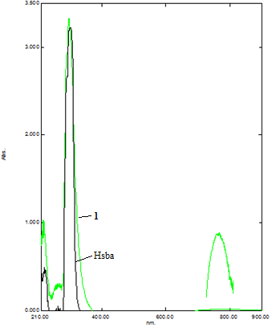

**Figure S10** UV–Vis spectrum of compound **1** and the free ligand, Hsba.

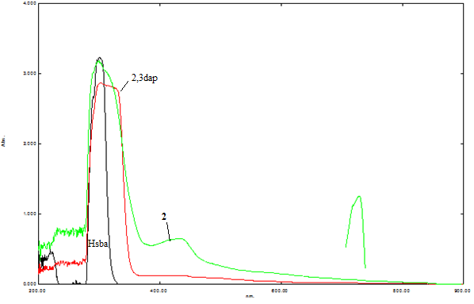

**Figure S11** UV–Vis spectrum of compound **2** and the free ligands, Hsba and 2,3dap.

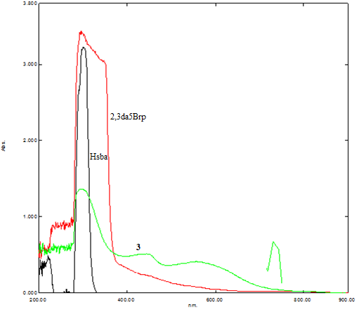

**Figure S12** UV–Vis spectrum of compound **3** and the free ligands, Hsba and 2,3da5Brp.

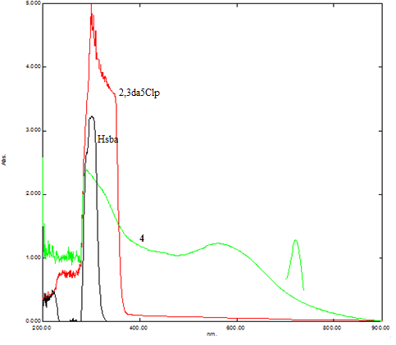

**Figure S13** UV–Vis spectrum of compound **4** and the free ligands, Hsba and 2,3da5Clp.

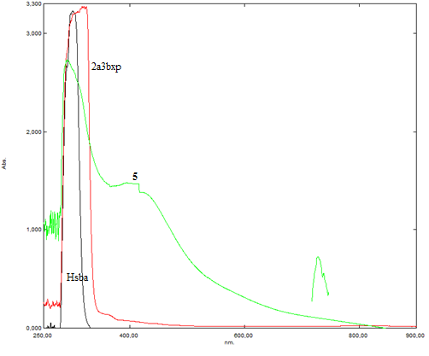

**Figure S14** UV–Vis spectrum of compound **5** and the free ligands, Hsba and 2a3bxp.

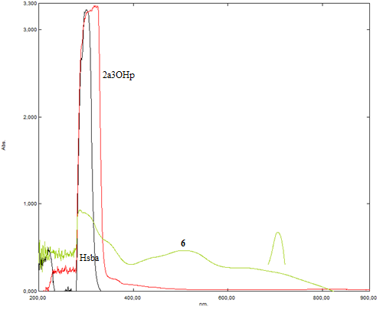

**Figure S15** UV–Vis spectrum of compound **6** and the free ligands, Hsba and 2a3OHp.

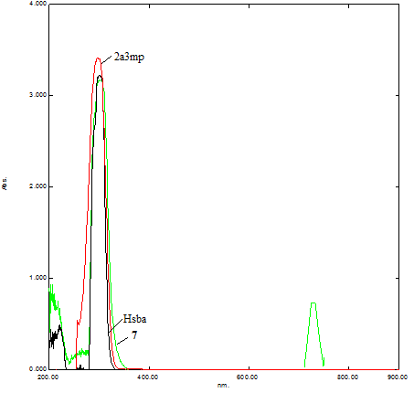

**Figure S16** UV–Vis spectrum of compound **7** and the free ligands, Hsba and 2a3mp.

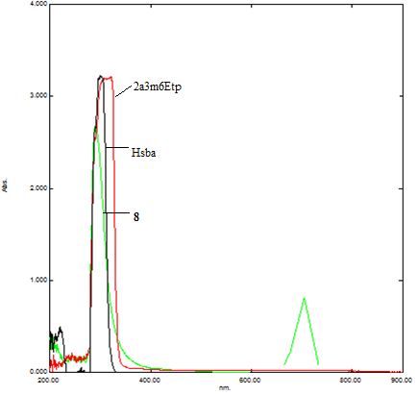

**Figure S17** UV–Vis spectrum of compound **8** and the free ligands, Hsba and 2a3m6Etp.

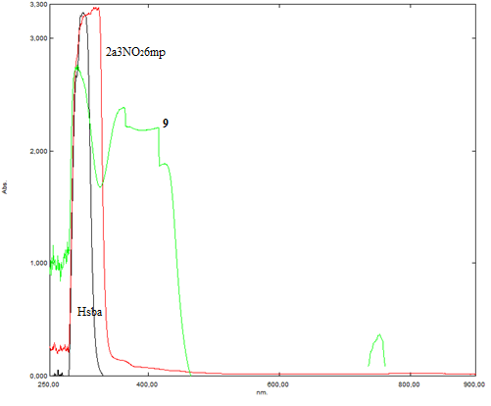

**Figure S18** UV–Vis spectrum of compound **9** and the free ligands, Hsba and 2a3NO26mp.