Supplementary File

Synthesis of New Organoselenium Compounds: Characterization and Biological Studies

Nimra Naz¹, Saima Saqib³, Muhammad Irfan Majeed¹, Muhammad Adnan Iqbal^{1,2,*}
¹Department of Chemistry, University of Agriculture Faisalabad-38040, Pakistan
²Organometallic and Coordination Chemistry Laboratory, Department of Chemistry, University of Agriculture-Faisalabad, Pakistan
³Government Postgraduate College for Women, Samanabad-Lahore, Pakistan

Fig. S1 Spectrum for Ligand 1 and Product 1

Fig. S2 Spectrum for Ligand 2 and Product 2.
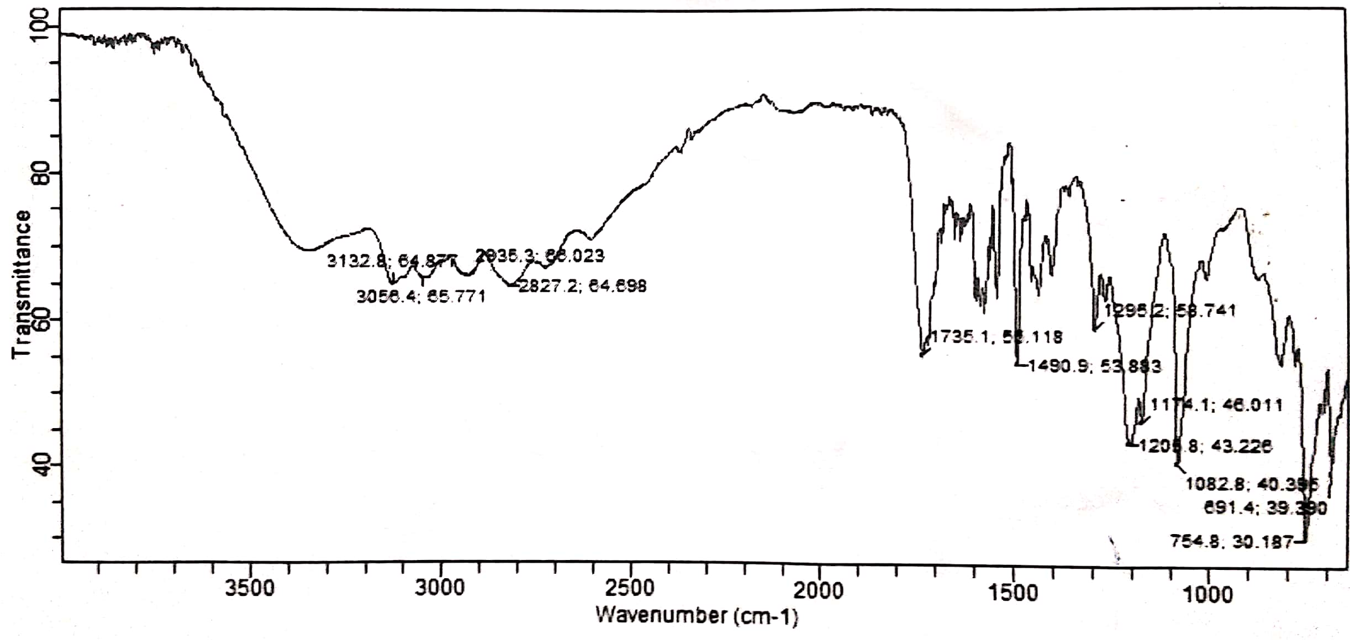
Fig. S3 FT-IR analysis of ligand 1

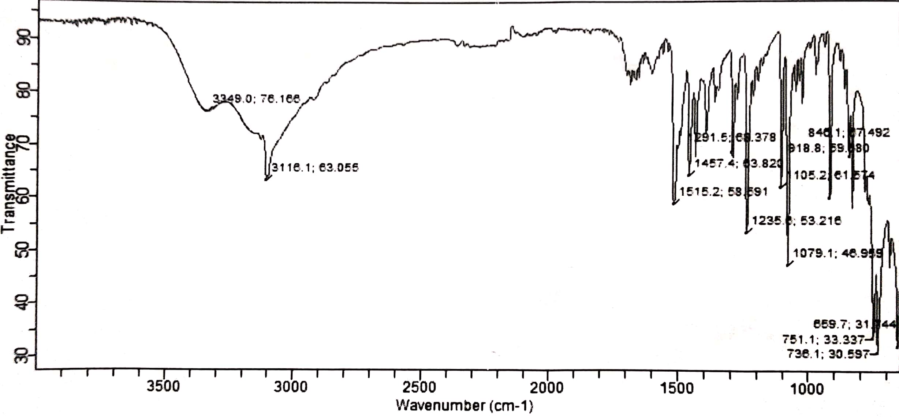
Fig. S4 FT-IR analysis of Product 1.

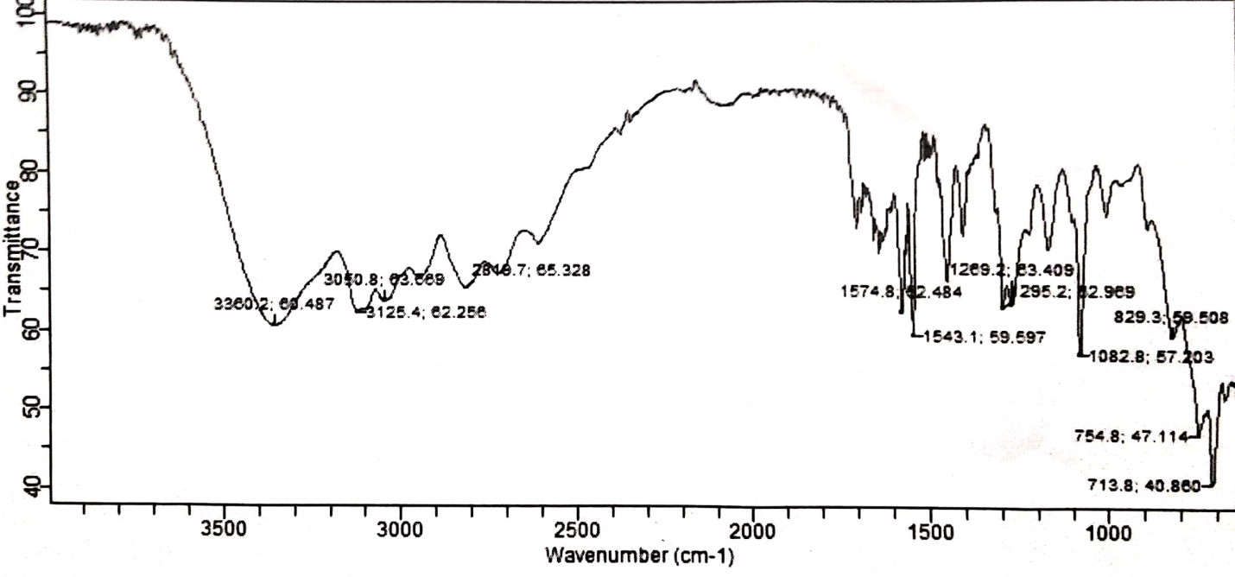
Fig. S5 FT-IR analysis of L2

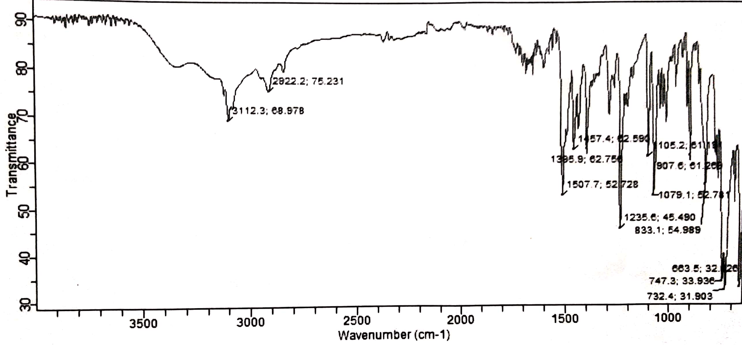
Fig. S6 FT-IR analysis of Product 2

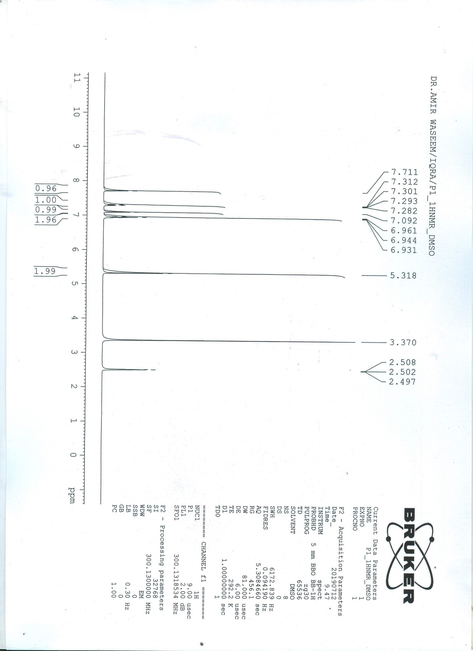
Fig. S7 ¹H-NMR of Product 1.
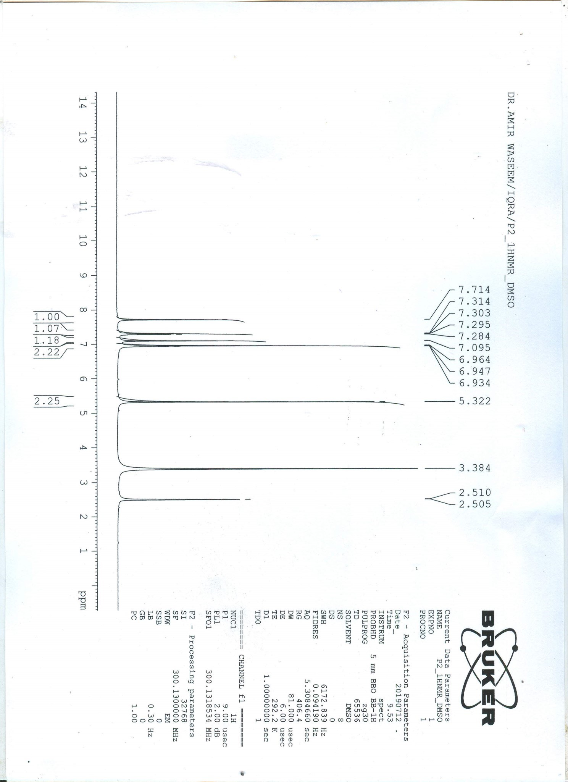
Fig. S8 ¹H-NMR of Product 2.

Fig. S9 ¹³C-NMR of Product 1.

Fig. S10 ¹³C-NMR of Product 2.

