TiO₂/ZnO: Type-II Heterostructures for Electrochemical Crystal Violet Dye Degradation Studies
Dilip Kumar Behara^{* ϯ}, Jalajakshi Tammineni*, and Mukkara Sudha Maheswari*
^{* ϯ}Department of Chemical Engineering, JNTUA College of Engineering, Ananthapuramu-515002, Andhra Pradesh, India
^{ϯ}Corresponding author email id: dileepbh.chemengg@jntua.ac.in
Telephone No: 91-9247192692, ORCID No:0000-0002-4005-7234
Supplementary Material

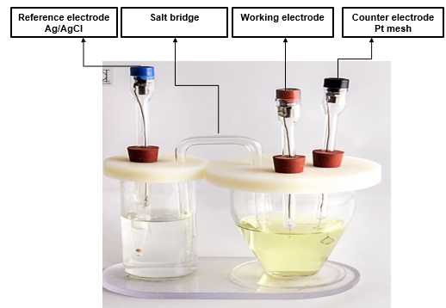
Fig. S1: Electrochemical measurement set up (3-probe measurements)
Electrochemical analysis tests
Cyclic voltammetry experiments were carried out at room temperature using Potentiostat (K-lyte 1.0). The cell used for voltammetric experiments was three-electrode type with Ag/AgCl as reference electrode, Pt mesh as counter electrode as shown in Fig S1.The electrocatalysts TiO₂, ZnO are fabricated on Ti Substrate as working electrodes (Ti/TiO₂, Ti/ZnO and Ti/TiO₂/ZnO) with 0.1 M Na₂SO₄ solution as supporting electrolyte. Voltammetric studies were performed at different fixed voltages of 0.6V, 1.2V, 1.2V, 1.3V, 1.2V, and 1.0V for Bare Ti, Ti/TiO₂, Ti/ZnO and Ti/TiO₂/ZnO respectively at a scan rate of 0.05 V/s. These are the potentials where the oxidation peak hump begins. Dye concentration of 55 mg/L was selected for all experiments.

Fig. S2: EDAX spectra of TiO₂ & ZnO samples

The EDAX spectra taken for TiO₂ and ZnO samples (Fig S2). The spectra confirms presence of both elements Ti, O, and Zn in electrode assemblies.

S. No | Name of the electrode assembly | Time in attaining 80 % decolorization, hrs
1 | Bare Ti | 12
2 | Ti/ZnO | 10.5
3 | Ti/TiO₂ | 9
4 | Ti/ TiO₂/ZnO | 6.5

Table S1: Time in attaining 80 % decolorization for various electrode assemblies

