Figures:

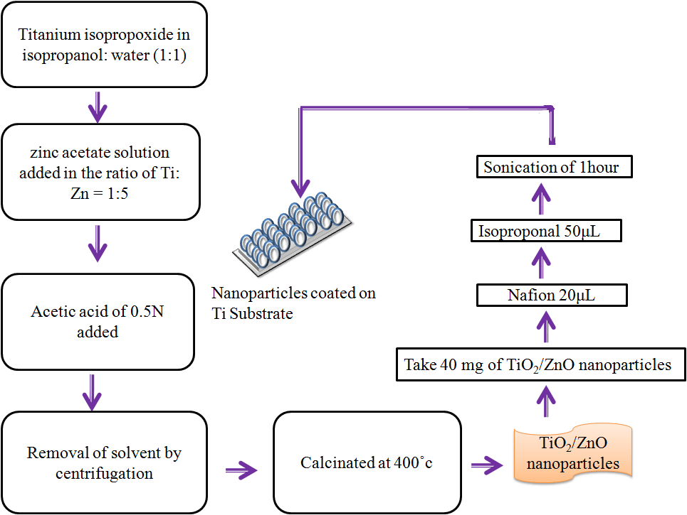

Fig. 1. Schematic representation of synthesis and fabrication of nanoparticles on Ti substrate

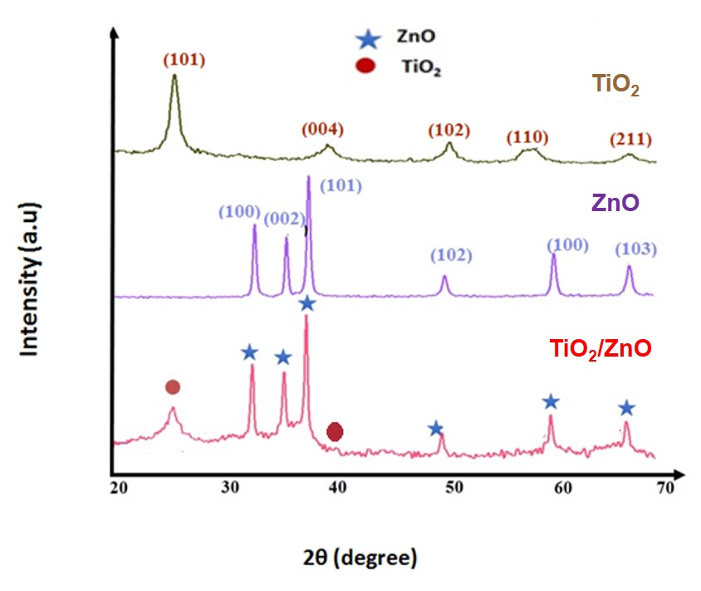
Fig. 2. X-Ray diffraction patterns of TiO₂, ZnO, and TiO₂/ZnO nanocomposites
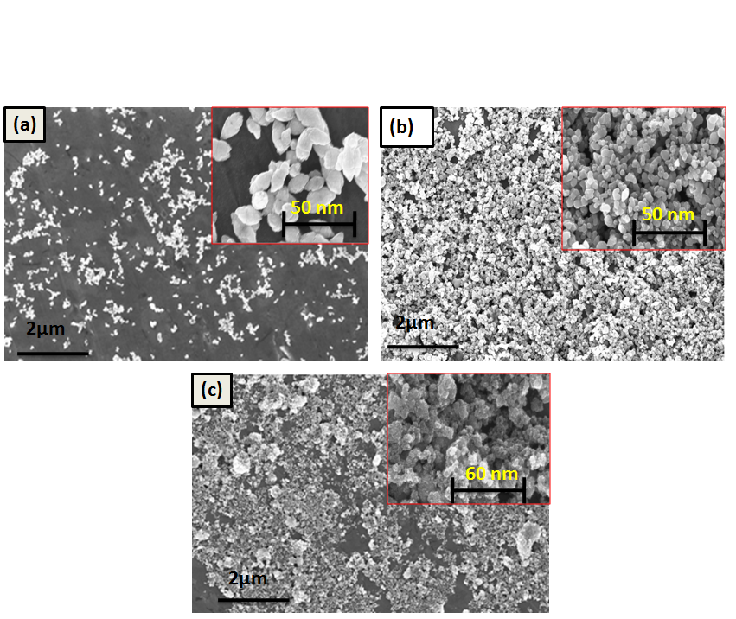
Fig. 3. Representative FE-SEM images of (a) ZnO, (b)TiO₂, and (c)TiO₂/ZnO nanocomposite
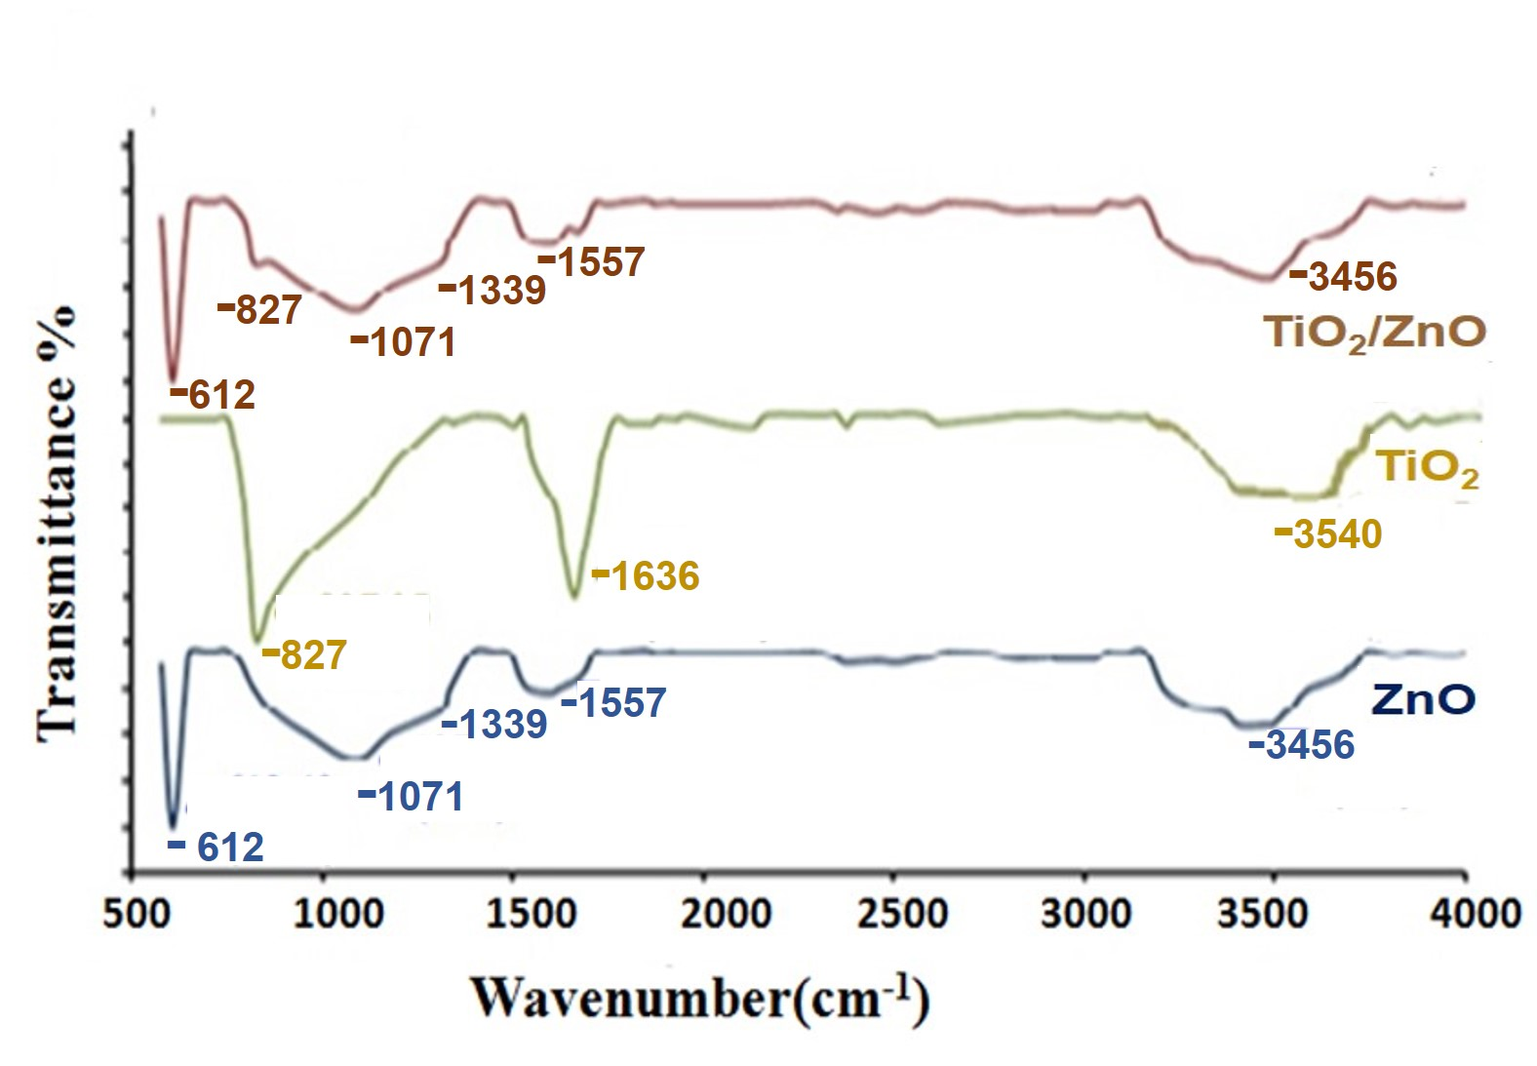
Fig. 4. FTIR spectra of ZnO, TiO₂ and TiO₂/ZnO nanocomposites

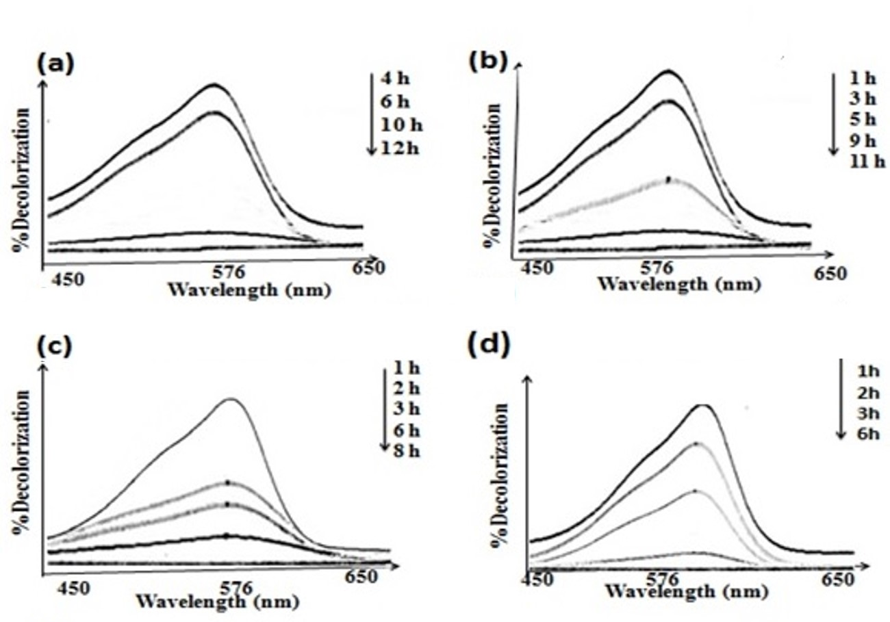
Fig. 5. Decolourization (%) V/s. wavelength (nm) for (a) Bare Ti, (b)Ti/TiO₂, (c)Ti/ZnO and (d) Ti/TiO₂/ZnO electrodes

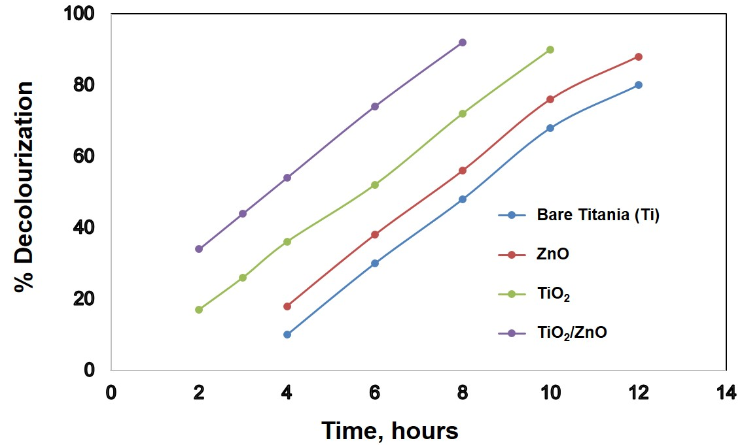
Fig. 6. % Decolorization vs. Time for all fabricated electrode samples

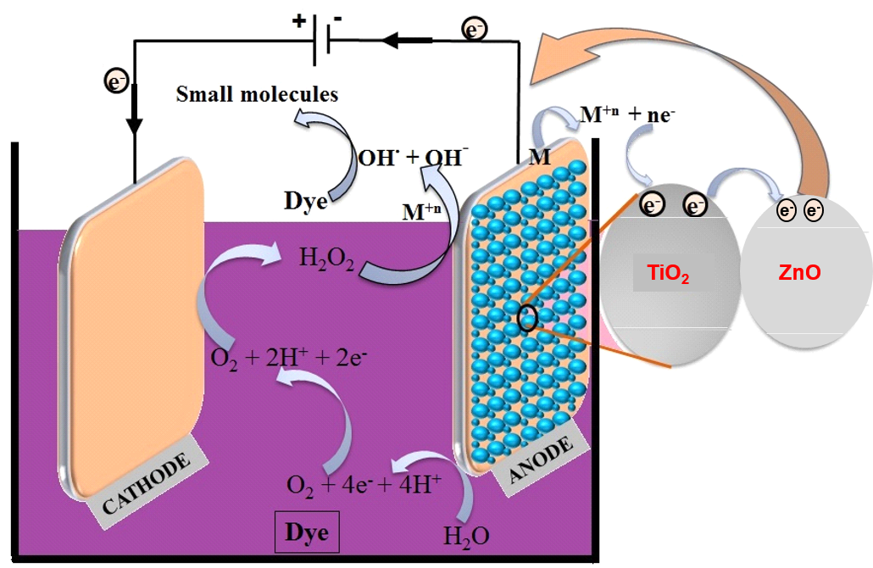
Fig. 7: TOC Graphic: Schematic representing charge carrier path in electrochemical degradation

