Supplementary material

SYNTHESIS AND CHARACTERIZATION OF NOVEL 1,2,3-TRIAZOLE-BRIDGED
OXIME POLYURETHANES OBTAINED FROM AN ISOMANNIDE DERIVATIVE

Fatih Bayrak¹, Ayhan Oral², Kadir Ay^{1*}

¹Department of Chemistry, Faculty of Arts and Sciences, Manisa Celal Bayar University, Manisa, Turkey
²Department of Chemistry, Faculty of Arts and Sciences, Çanakkale Onsekiz Mart University,
Çanakkale, Turkey
kadir.ay@cbu.edu.tr

Spectrum 1. FTIR spectrum of compound 3 in KBr disc
Spectrum 2. FTIR spectrum of compound 4 in KBr disc
Spectrum 3. FTIR spectrum of compound 5 in KBr disc
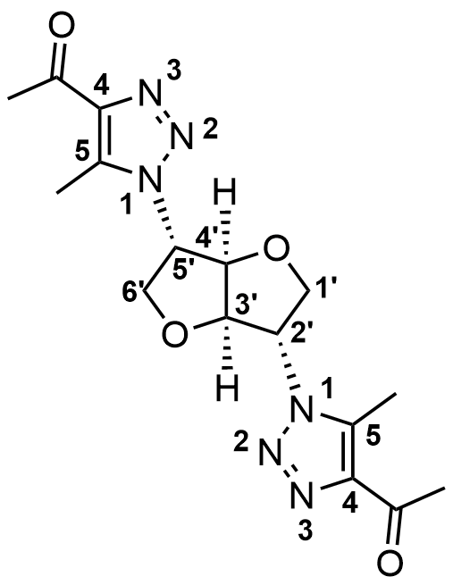
Spectrum 4. ¹H NMR spectrum of compound 5 in CDCl₃
Spectrum 5. Expanded ¹H NMR spectrum of compound 5 in CDCl₃
Spectrum 6. Expanded ¹H NMR spectrum of compound 5 in CDCl₃
Spectrum 7. Expanded ¹H NMR spectrum of compound 5 in CDCl₃
Spectrum 8. ¹³C NMR spectrum of compound 5 in CDCl₃
Spectrum 9. COSY spectrum of compound 5 in CDCl₃
Spectrum 10. Expanded COSY spectrum of compound 5 in CDCl₃

Spectrum 11. NOESY spectrum of compound 5 in CDCl₃
Spectrum 12. Expanded NOESY spectrum of compound 5 in CDCl₃
Spectrum 13. HSQC spectrum of compound 5 in CDCl₃
Spectrum 14. Expanded HSQC spectrum of compound 5 in CDCl₃
Spectrum 15. HMBC spectrum of compound 5 in CDCl₃
Spectrum 16. Expanded HMBC spectrum of compound 5 in CDCl₃
Spectrum 17. Expanded HMBC spectrum of compound 5 in CDCl₃
Spectrum 18. LC-MS spectrum of compound 5
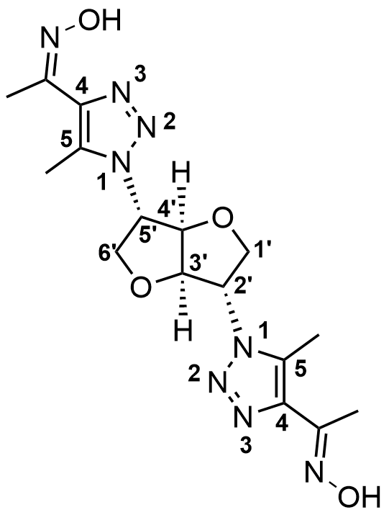
Spectrum 19. FTIR spectrum of compound 6 in KBr disc
Spectrum 20. Overlapped FTIR spectra of compound 5 and 6 in KBr disc
Spectrum 21. ¹H NMR spectrum of compound 6 in DMSO-d6
Spectrum 22. Expanded ¹H NMR spectrum of compound 6 in DMSO-d6
Spectrum 23. Expanded ¹H NMR spectrum of compound 6 in DMSO-d6
Spectrum 24. ¹³C NMR spectrum of compound 6 in DMSO-d6
Spectrum 25. LC-MS spectrum of compound 6

Spectrum 26. FTIR spectrum of P-1 in KBr disc
Spectrum 27. ¹H NMR spectrum of P-1 in DMSO-d6
Spectrum 28. Expanded ¹H NMR spectrum of P-1 in DMSO-d6
Spectrum 29. ¹³C NMR spectrum of P-1 in DMSO-d6
Spectrum 30. FTIR spectrum of P-2 in KBr disc
Spectrum 31. ¹H NMR spectrum of P-2 in DMSO-d6
Spectrum 32. Expanded ¹H NMR spectrum of P-2 in DMSO-d6
Spectrum 33. ¹³C NMR spectrum of P-2 in DMSO-d6
Spectrum 34. FTIR spectrum of P-3 in KBr disc
Spectrum 35. ¹H NMR spectrum of P-3 in DMSO-d6
Spectrum 36. Expanded ¹H NMR spectrum of P-3 in DMSO-d6
Spectrum 37. ¹³C NMR spectrum of P-3 in DMSO-d6

Spectrum 38. FTIR spectrum of P-4 in KBr disc
Spectrum 39. ¹H NMR spectrum of P-4 in DMSO-d6
Spectrum 40. Expanded ¹H NMR spectrum of P-4 in DMSO-d6
Spectrum 41. ¹³C NMR spectrum of P-4 in DMSO-d6
Spectrum 42. FTIR spectrum of P-5 in KBr disc
Spectrum 43. ¹H NMR spectrum of P-5 in DMSO6
Spectrum 44. Expanded ¹H NMR spectrum of P-5 in DMSO-d6
Spectrum 45. ¹³C NMR spectrum of P-5 in DMSO-d6

