Supplementary File
Critical Aspects in Exploring Time Analysis for the Voltammetric Estimation of Kinetic Parameters of Surface Electrode Mechanisms Coupled with Chemical Reactions
Rubin Gulaboski^{1*}, Valentin Mirceski^{2,3}, Milivoj Lovric⁴

¹Faculty of Medical Sciences, Goce Delcev University, Stip, Macedonia
²Institute of Chemistry, Faculty of Natural Sciences and Mathematics, Ss Cyril and Methodius University, Arhimedova 5, 1000, Skopje, Macedonia
³Faculty of Chemistry, Department of Inorganic and Analytical Chemistry, University of Lodz, Tamka 12, 91–403 Lodz, Poland
⁴Divkovićeva 13, Zagreb 10090, Croatia

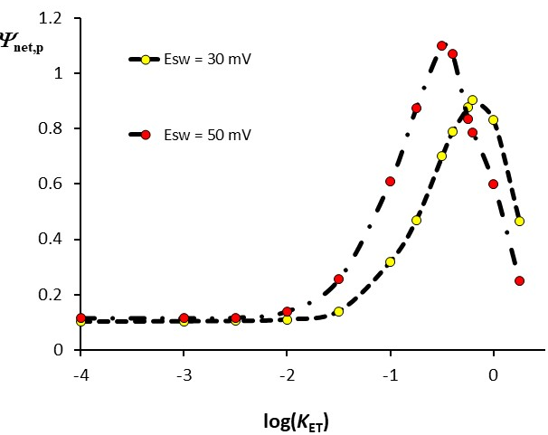
Fig. S1. Simple surface electrode reaction: Dependence of the net-peak current Ψ_{net,p} on the logarithm of the dimensionless electrode kinetic parameter K_{ET} (quasireversible maximum) simulated for two vales of the SW amplitude (the values are given in the plot). The simulation conditions are: electron transfer coefficient α = 0.5, the stoichiometric number of electrons n = 2, temperature T = 298 K, and step potential dE = 4 mV.

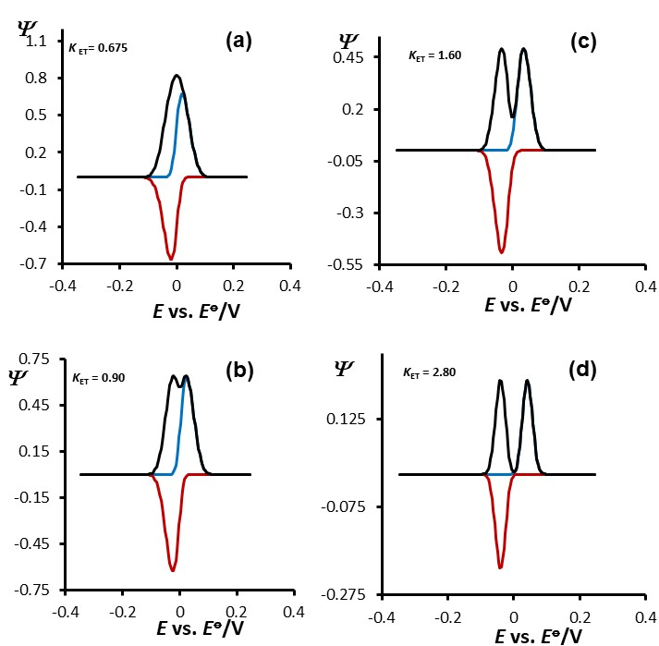

Fig. S2. Simple surface electrode reaction: The phenomenon of the net-peak splitting as a function of dimensionless electrode kinetic parameter K_{ET} (the values are given in the plot), for the SW amplitude of E_{sw} = 50 mV. Other conditions of the simulations are identical as for Fig. S1.

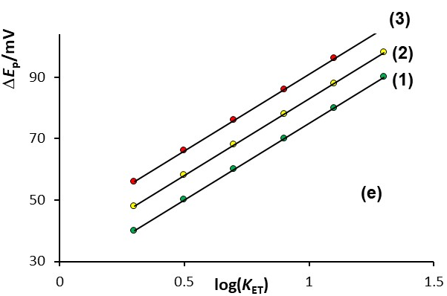
Fig. S3. Simple surface electrode reaction: The potential separation ΔE_{p} of the split net-peaks as a function of the logarithm of the dimensionless electrode kinetic parameter K_{ET} for the SW amplitudes of E_{sw} = 30 mV (1), 40 mV (2) and 50 mV (3). Other conditions of the simulations are identical as for Fig. S1

