Supporting data for
New sulfonylhydrazones containing methane sulfonic acid hydrazide having human anti-carbonic anhydrase and anti-microbial activity: Synthesis, spectroscopic characterization, electrochemical properties and biological activities

Demet Uzunª*, Ebru Erdoğduª, Ayla Balaban Gündüzalpª*, Ümmühan Özmen Özdemirª, Ali Öztürk^{b}, Neslihan Özbek^{c}, Kerem Kaya^{d}, Olkar Abdulmajet^{e}

ªDepartment of Chemistry, Faculty of Science, Gazi University, Ankara, Turkey
^{b}Department of Medical Microbiology, Faculty of Medicine, Niğde Ömer Halisdemir University, Niğde, Turkey.
^{c}Department of Mathematics and Science Education,, Ahi Evran University, Kırsehir, Turkey
^{d} Department of Chemistry, Faculty of Science, İstanbul Technical University, İstanbul, Turkey
^{e}Department of Chemistry, Faculty of Medicine, Gazi University, Ankara, Turkey

*demetuzun@gazi.edu.tr
*balaban@gazi.edu.tr

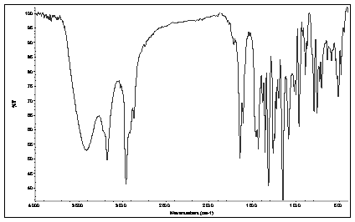
Fig. S1. FT-IR spectrum of II

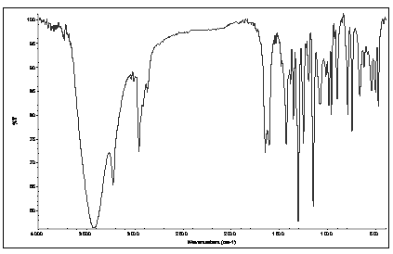
Fig. S2. FT-IR spectrum of III

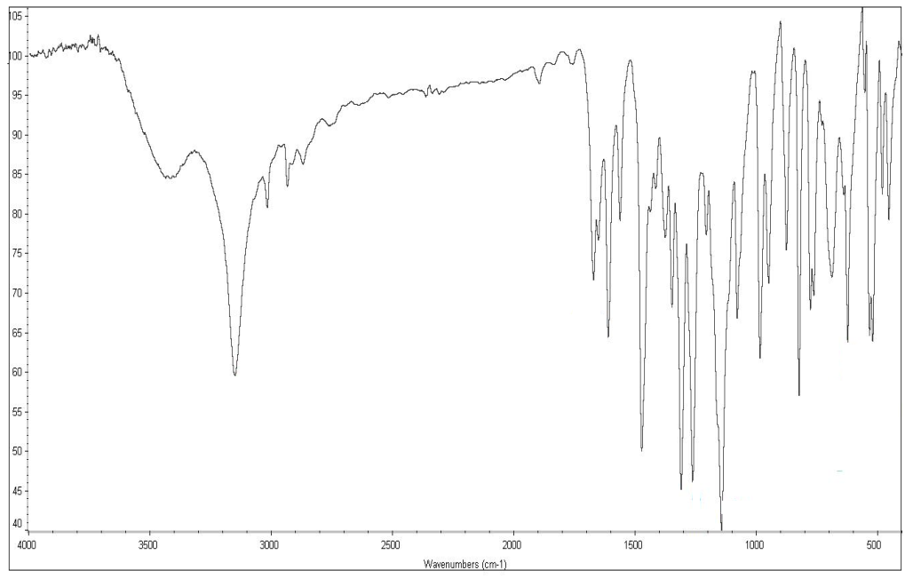
Fig. S3. FT-IR spectrum of IV

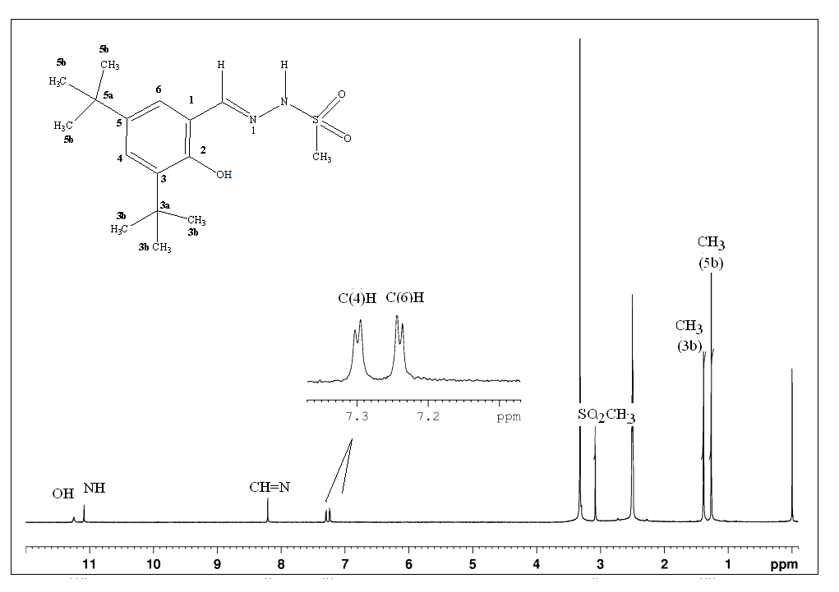
Fig. S4. ¹H NMR (DMSO-d₆) spectrum of II
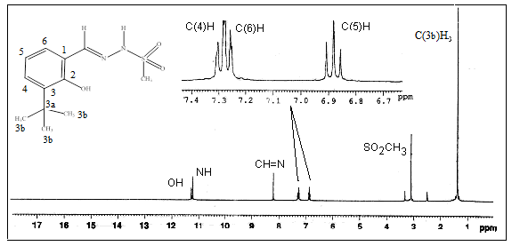
Fig. S5. ¹H NMR (DMSO-d₆) spectrum of III

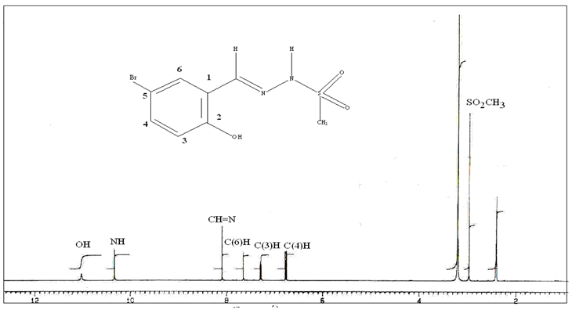
Fig. S6. ¹H NMR (DMSO-d₆) spectrum of IV

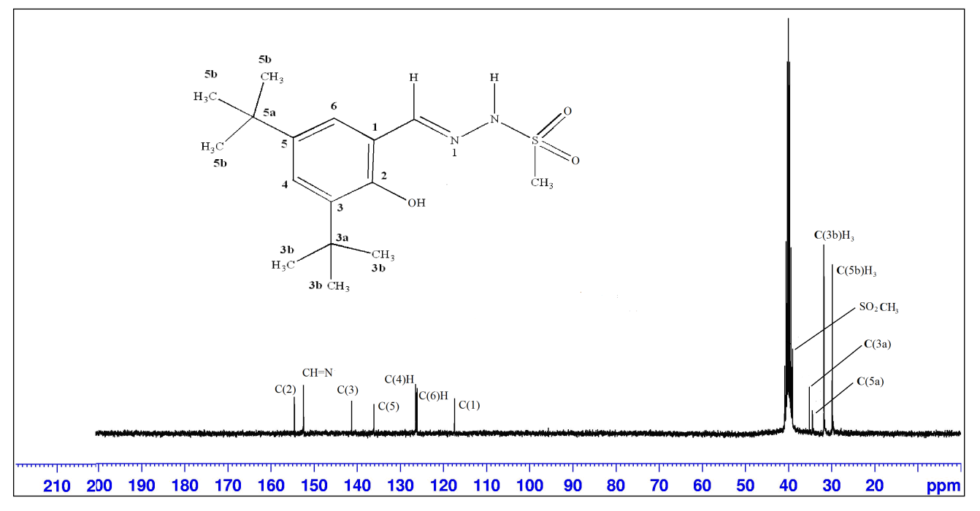
Fig. S7. ¹³C NMR (DMSO-d₆) spectrum of II

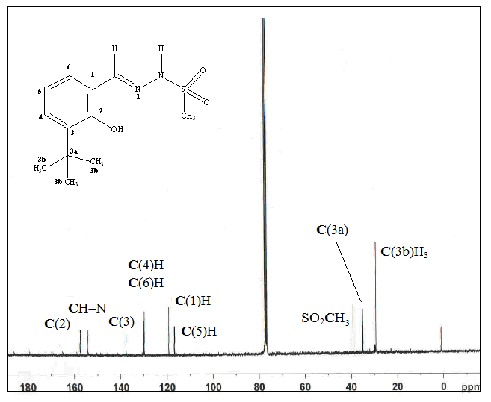
Fig. S8. ¹³C NMR (DMSO-d₆) spectrum of III

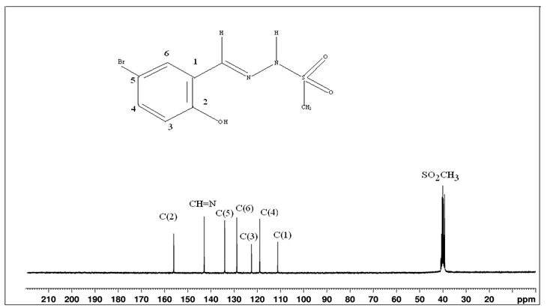
Fig. S9. ¹³C NMR (DMSO-d₆) spectrum of IV

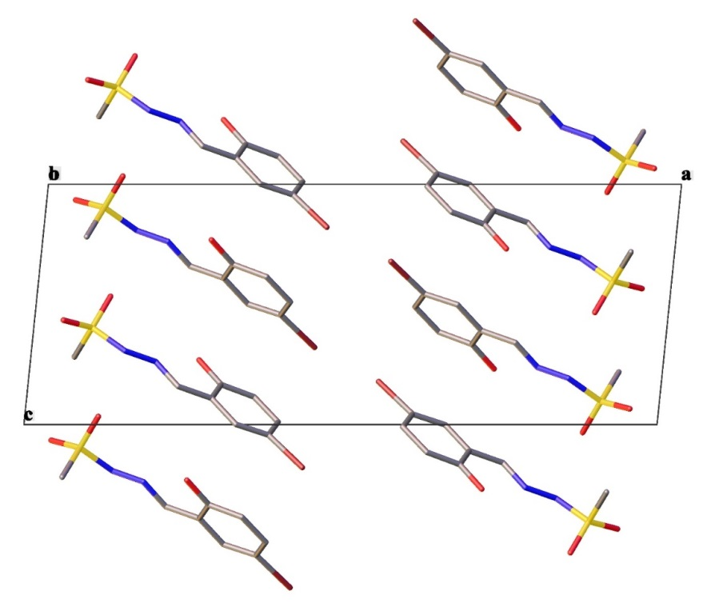
Fig. S10. Packing motif of the crystal IV

Table S1. Hydrogen-bond geometry (Å, º) for IV
D-H---A | D-H | H---A | D---A | D-H---A
N2-H2---O2 | 0.91( 5) | 2.00 (5) | 2.91 (6) | 174 (5)
O1-H1a---N1 | 0.79 (7) | 1.97 (7) | 2.64 (6) | 143 (7)

Table S2. MBC/MFC values of compounds against the bacterial and fungal strains tested
MBC/MFC (µg/mL)
Gram-positive bacteria |  |  | Gram-negative bacteria |  |  |  | Fungi
Compounds | S. aureus | S. epidermidis | E. coli | P. aeruginosa | S. maltophilia | K. pneumoniae | C. albicans | A. fumigatus
II | 64 | 64 | 128 | 64 | 32 | 128 | 16 | 32
III | 64 | 8 | 128 | 64 | 32 | 128 | 32 | 32
1V | 256 | 128 | 128 | 128 | 32 | 128 | 16 | 32
Sulfamethoxazole | 256 | >256 | 256 | >256 | 128 | 256 | - | -
Sulfisoxazole | >256 | >256 | >256 | >256 | >256 | >256 | - | -
Fluconazole | - | - | - | - | - | - | 64 | 128

