**Supplemental Materials**

**Synthesis and Characterization of Some Novel 1,3-Thiazole and 2-Amino 1,3,4-thiadiazole Derivatives**

**Mustafa Er*, Ayşe Şahin, Hakan Tahtacı**

Department of Chemistry, Karabuk University, 78050 Karabuk, Turkey,

[mustafaer@karabuk.edu.tr](mailto:mustafaer@karabuk.edu.tr)

**Supplemental Materials**

*1H and 13C NMR spectra of compounds*

**H NMR and 13C NMR Spectra of the Compounds 3a-c, 5a-c, 7a-e, 9a-e**



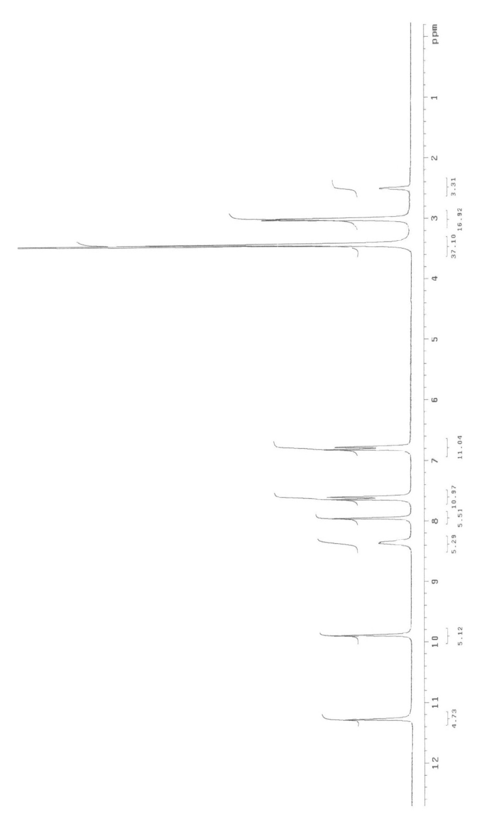

**Figure S1.** 1H NMR Spectrum (DMSO-d6) **(3a)**

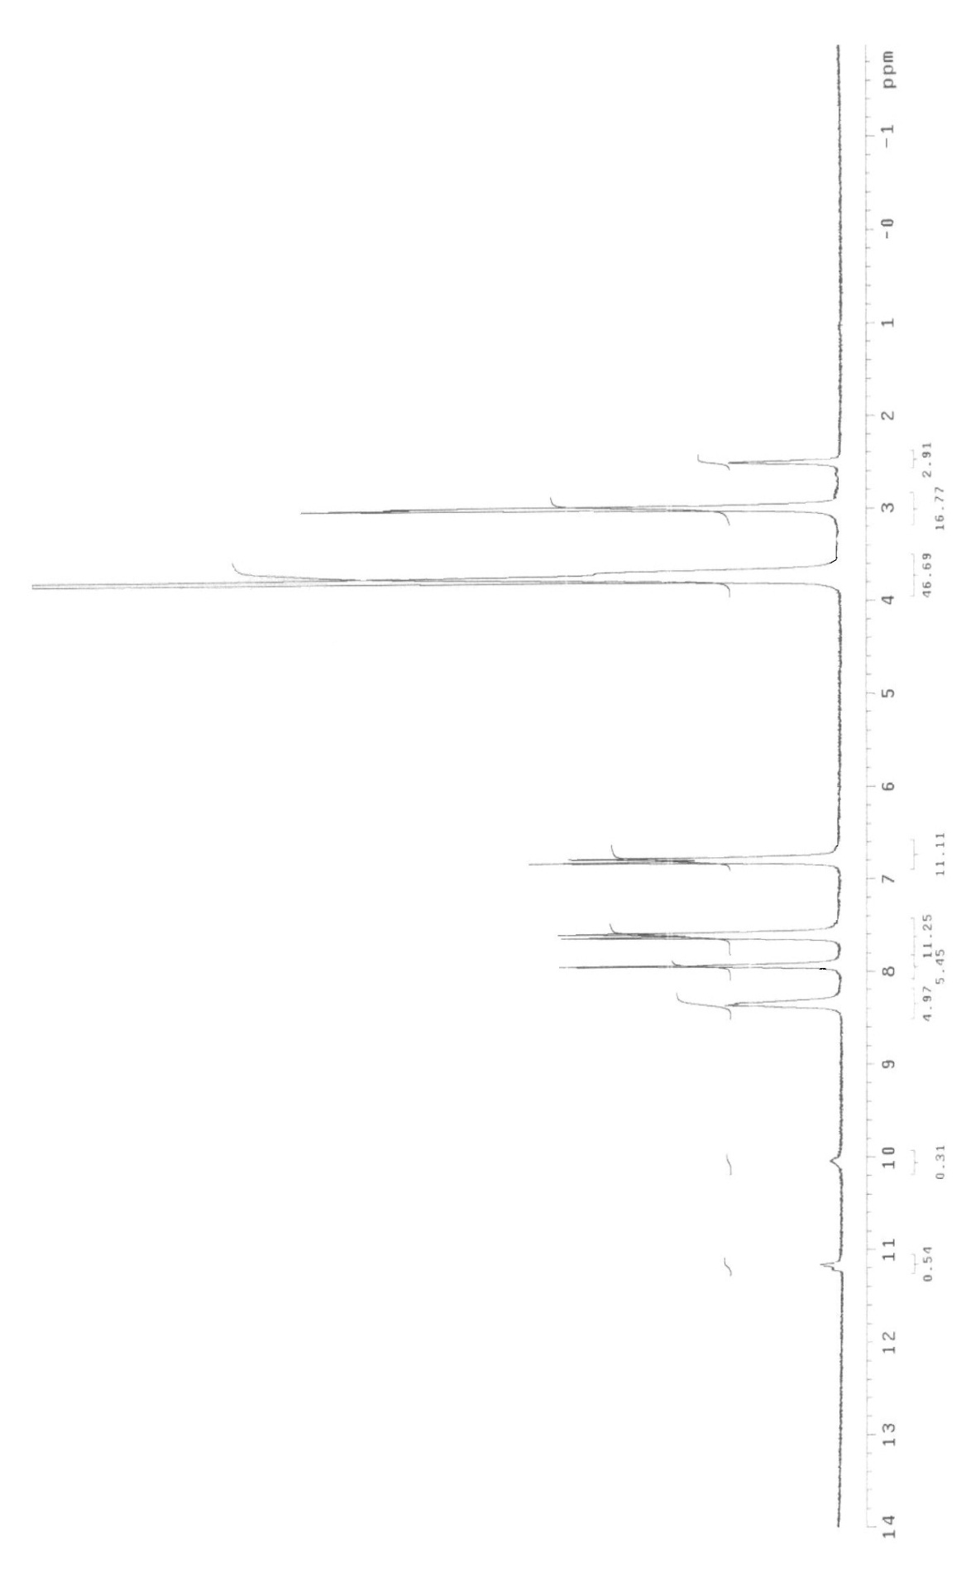



**Figure S2.** 1H NMR Exchange Spectrum (DMSO-d6 + D2O) **(3a)**

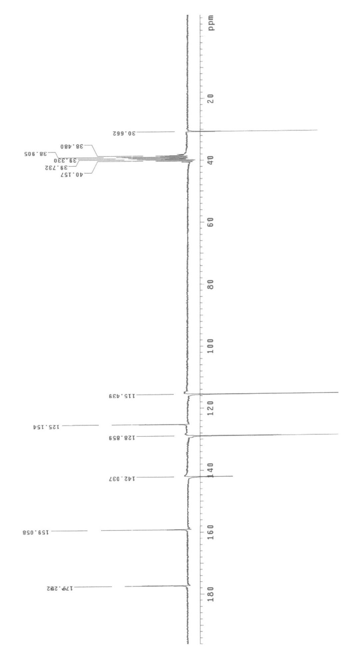



**Figure S3.**  13C NMR (APT) Spectrum (DMSO-d6) **(3a)**

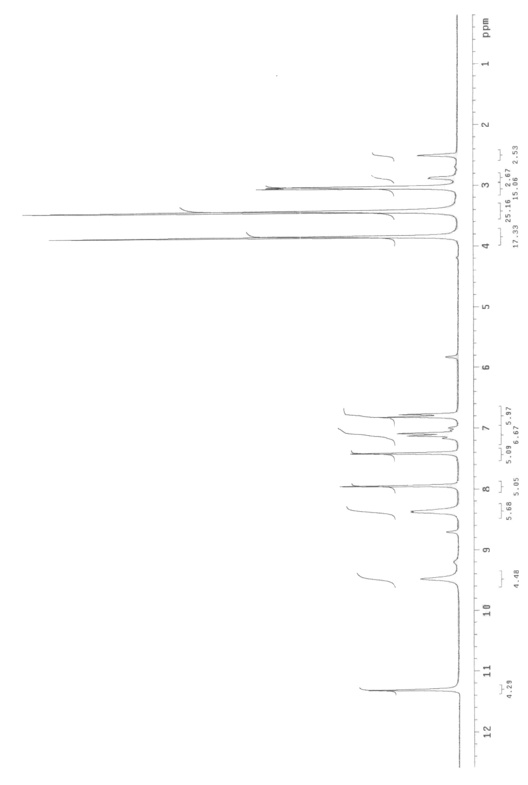





**Figure S4.** 1H NMR Spectrum (DMSO-d6) **(3b)**

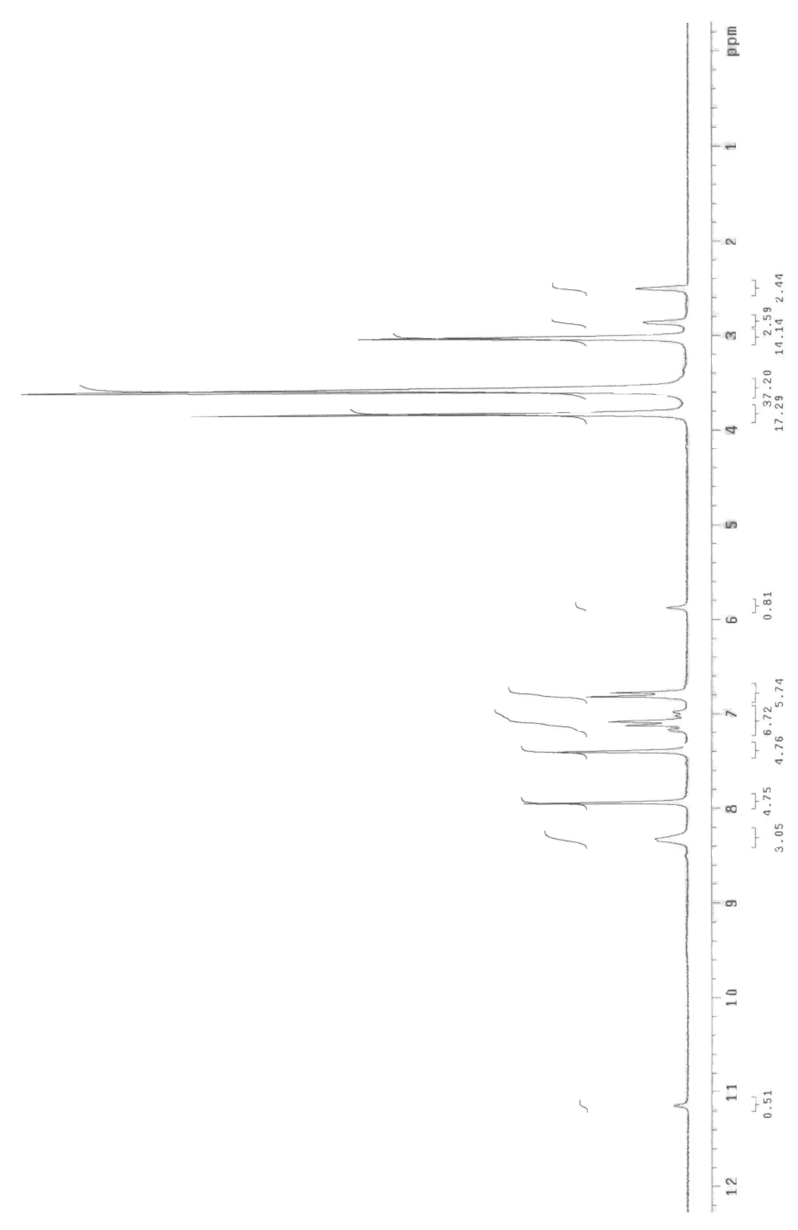





**Figure S5.** 1H NMR Exchange Spectrum (DMSO-d6 + D2O) **(3b)**

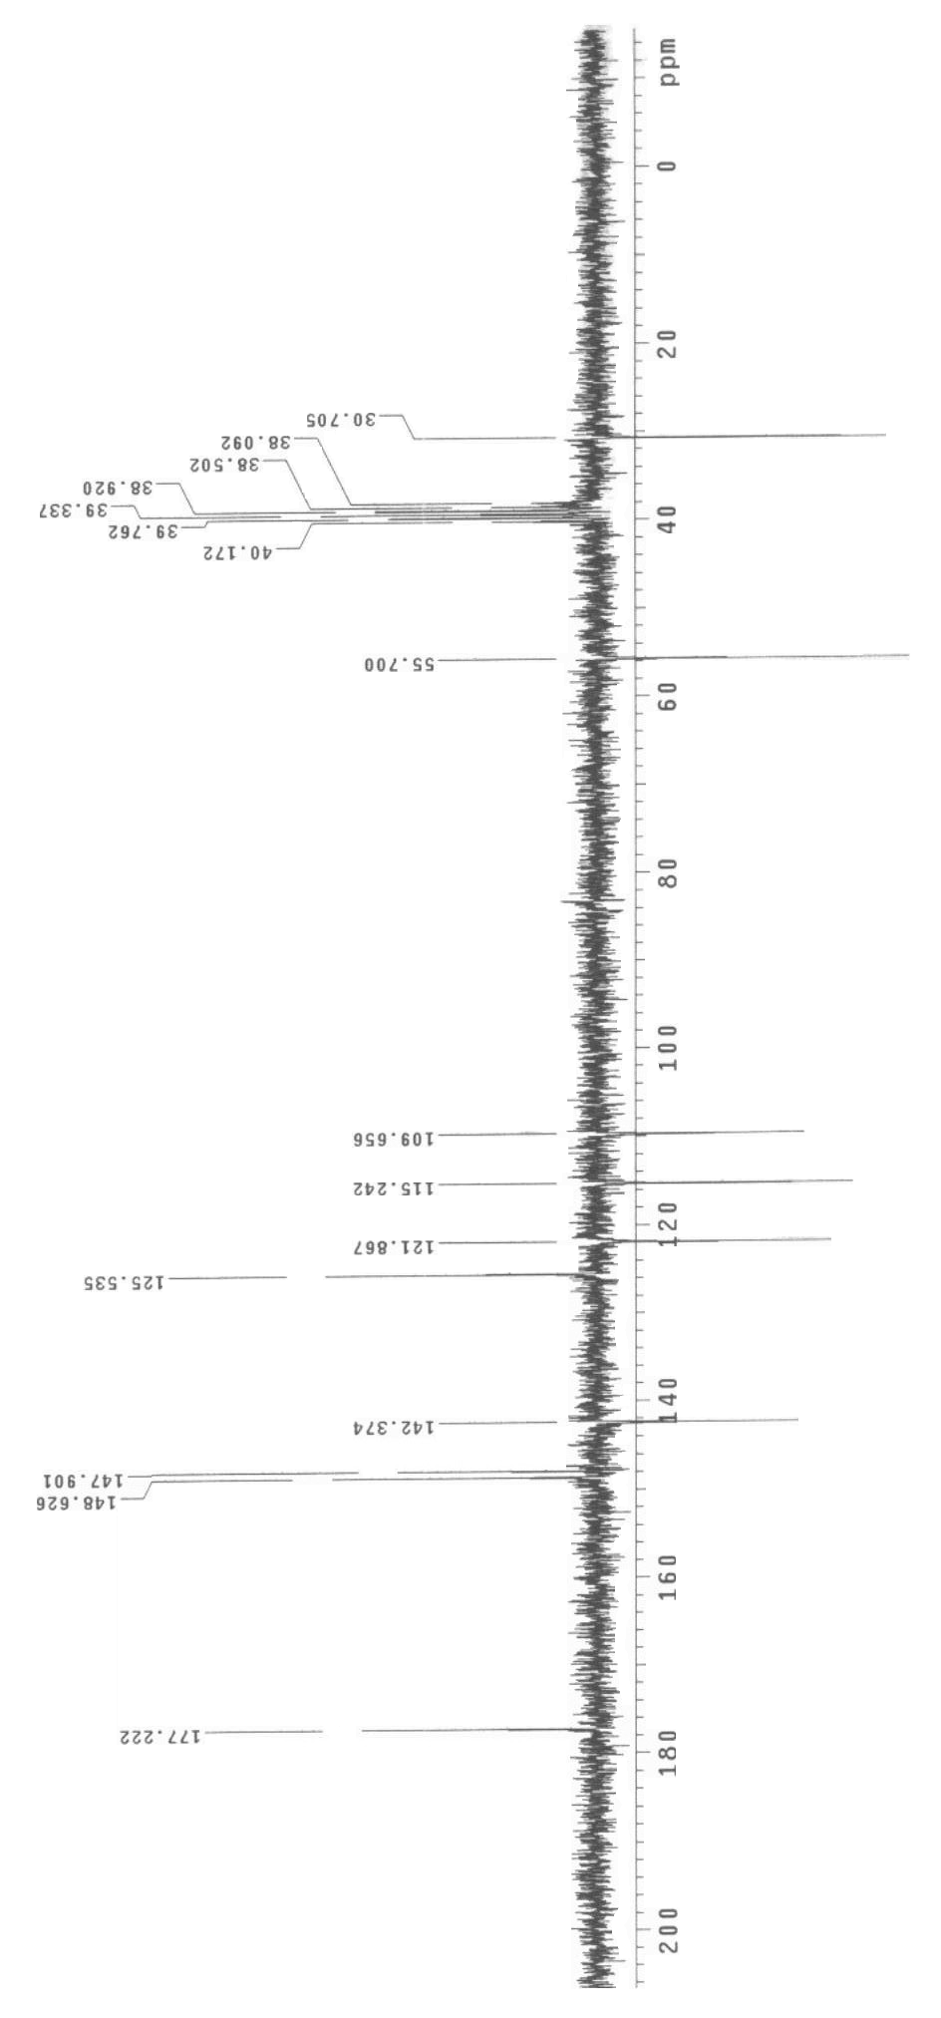



**Figure S6.** 13C NMR (APT) Spectrum (DMSO-d6) **(3b)**

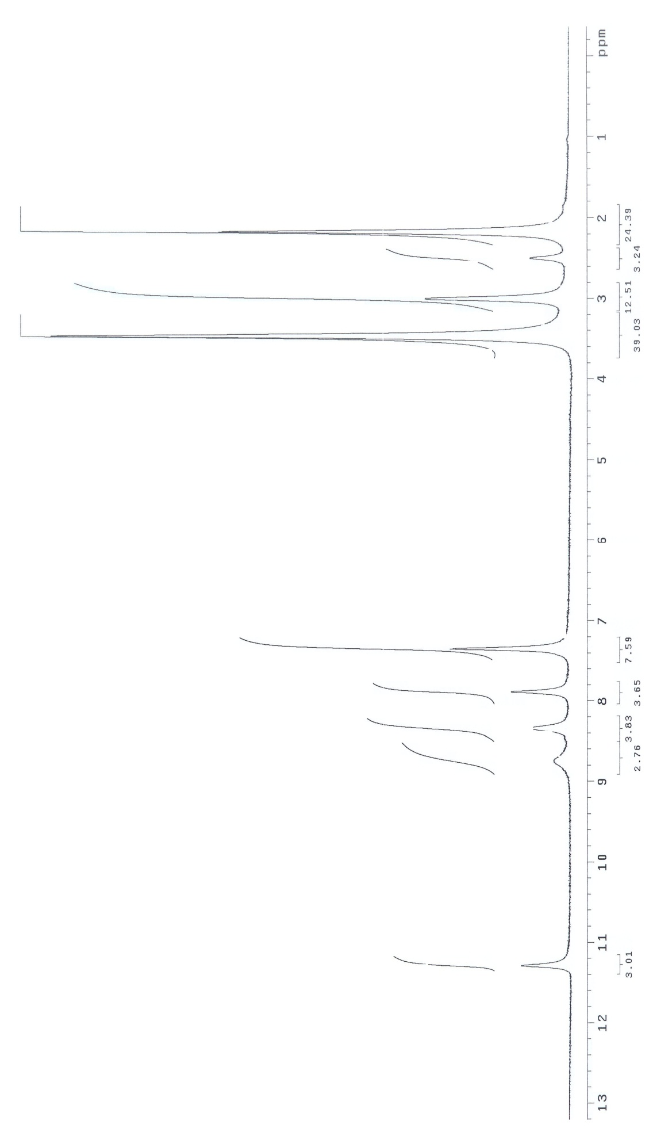



**Figure S7.** 1H NMR Spectrum (DMSO-d6) **(3c)**

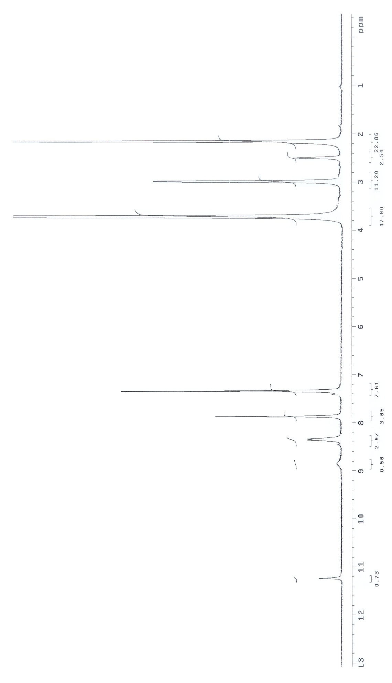



**Figure S8**. 1H NMR Exchange Spectrum (DMSO-d6 + D2O) **(3c)**

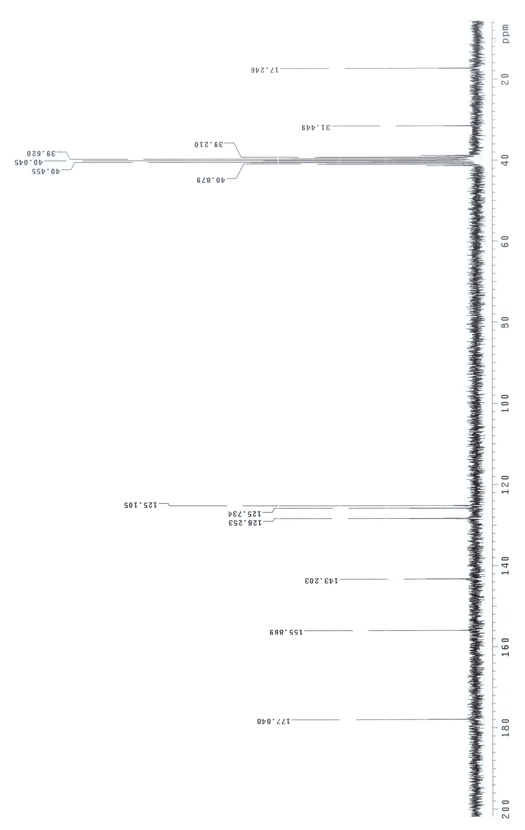



**Figure S9**. 13C NMR Spectrum (DMSO-d6) **(3c)**

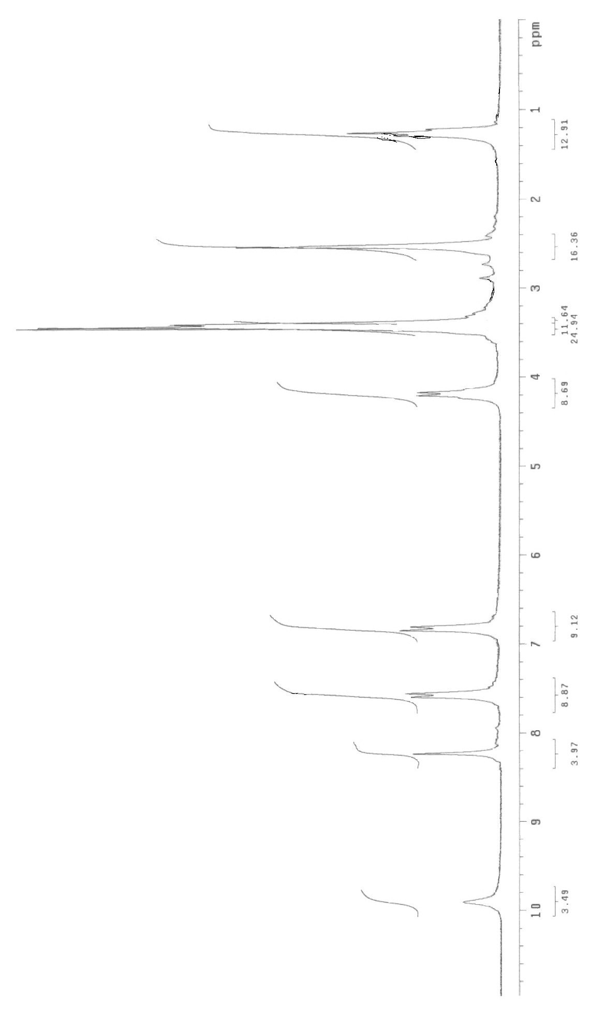



**Figure S10**. 1H NMR Spectrum (DMSO-d6) **(5a)**

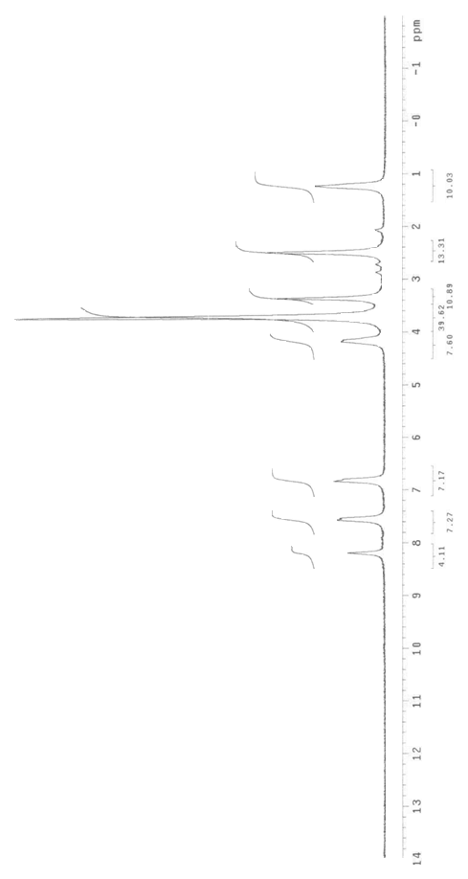

**Figure S11.**1H NMR Exchange Spectrum (DMSO-d6 + D2O) **(5a)**



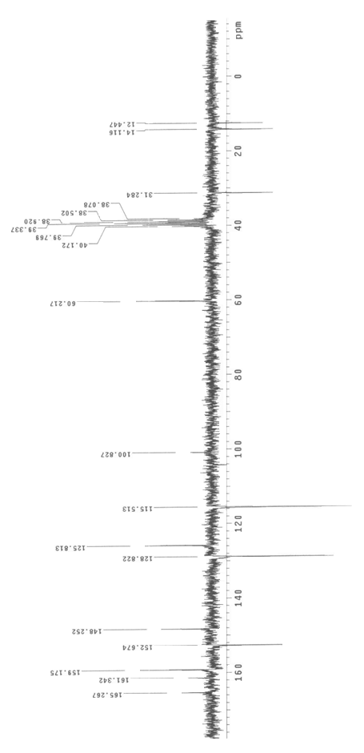



**Figure S12.** 13C NMR (APT) Spectrum (DMSO-d6) **(5a)**

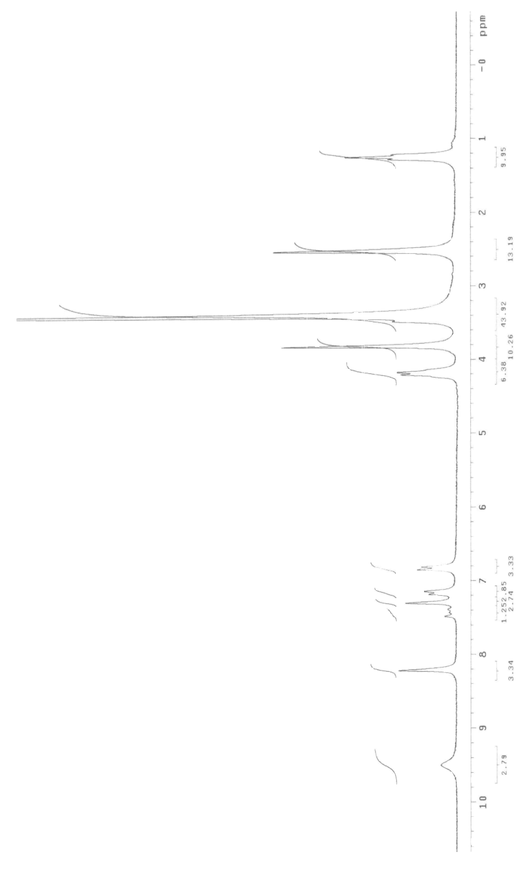



**Figure S13.** 1H NMR Spectrum (DMSO-d6) **(5b)**

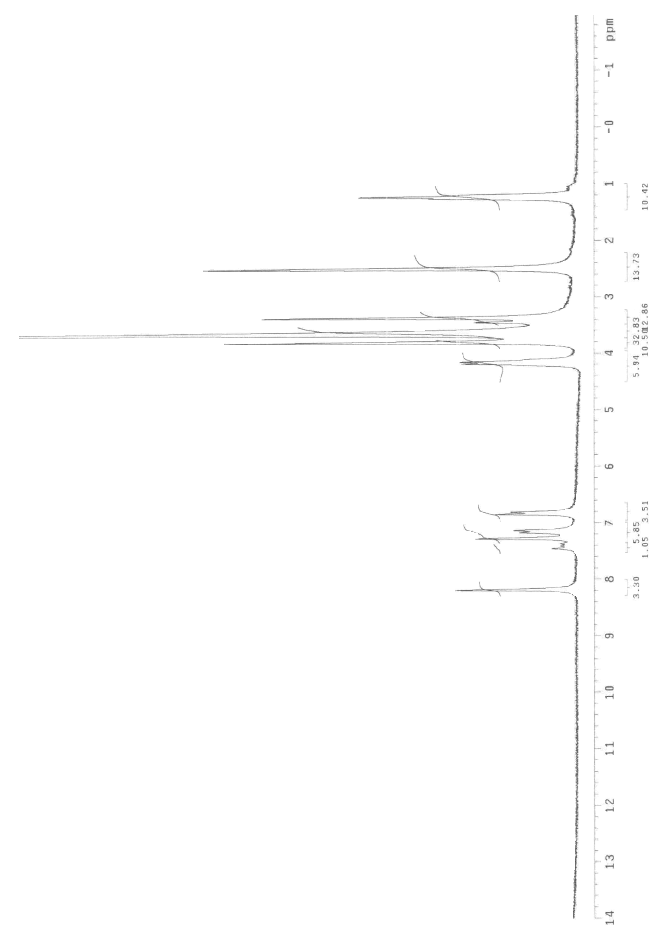



**Figure S14.** 1H NMR Exchange Spectrum (DMSO-d6 + D2O) **(5b)**

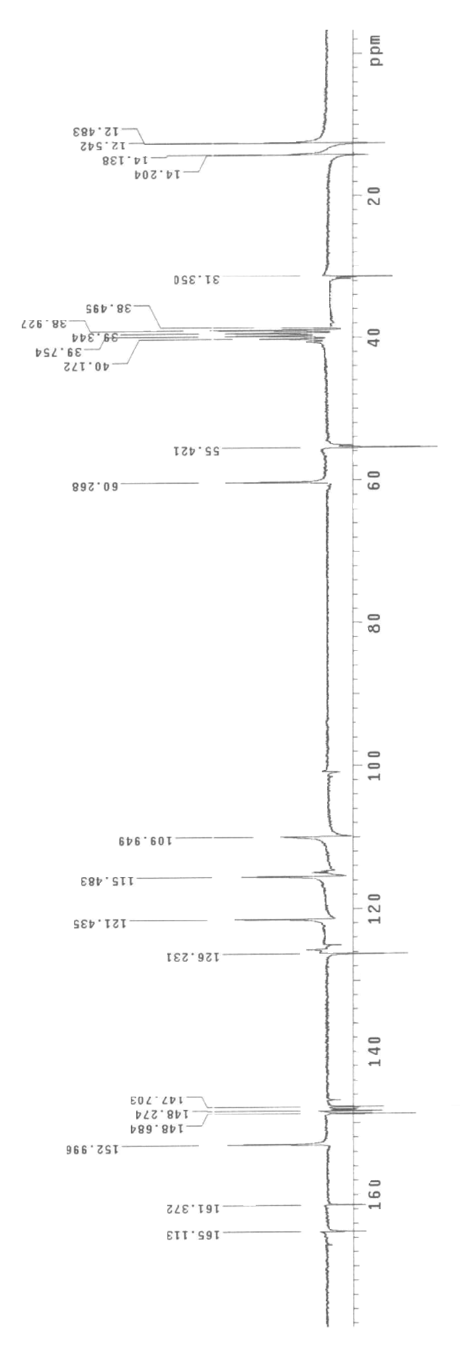



**Figure S15.** 13C NMR (APT) Spectrum(DMSO-d6) **(5b)**

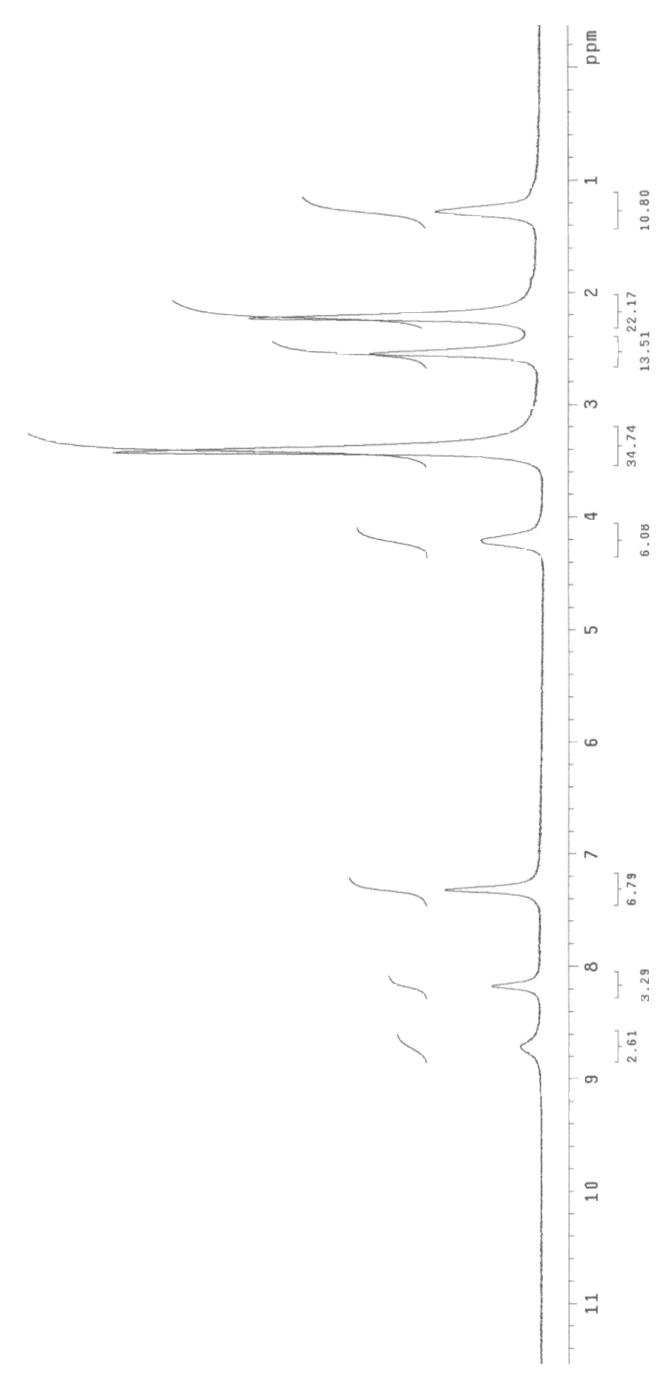



**Figure S16.** 1H NMR Spectrum (DMSO-d6) **(5c)**

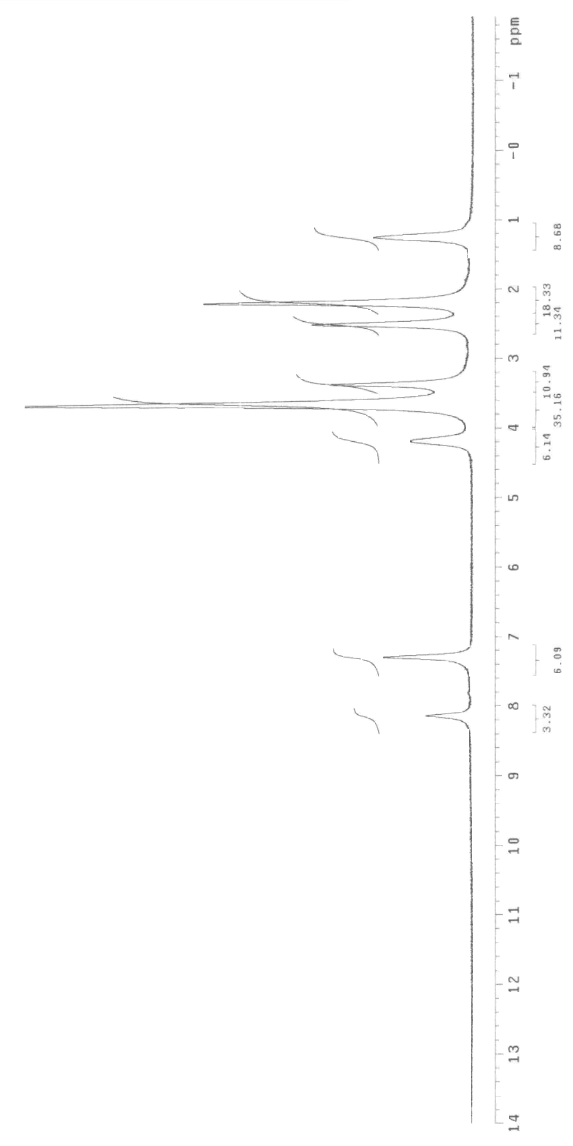



**Figure S17.** 1H NMR Exchange Spectrum (DMSO-d6 + D2O) **(5c)**

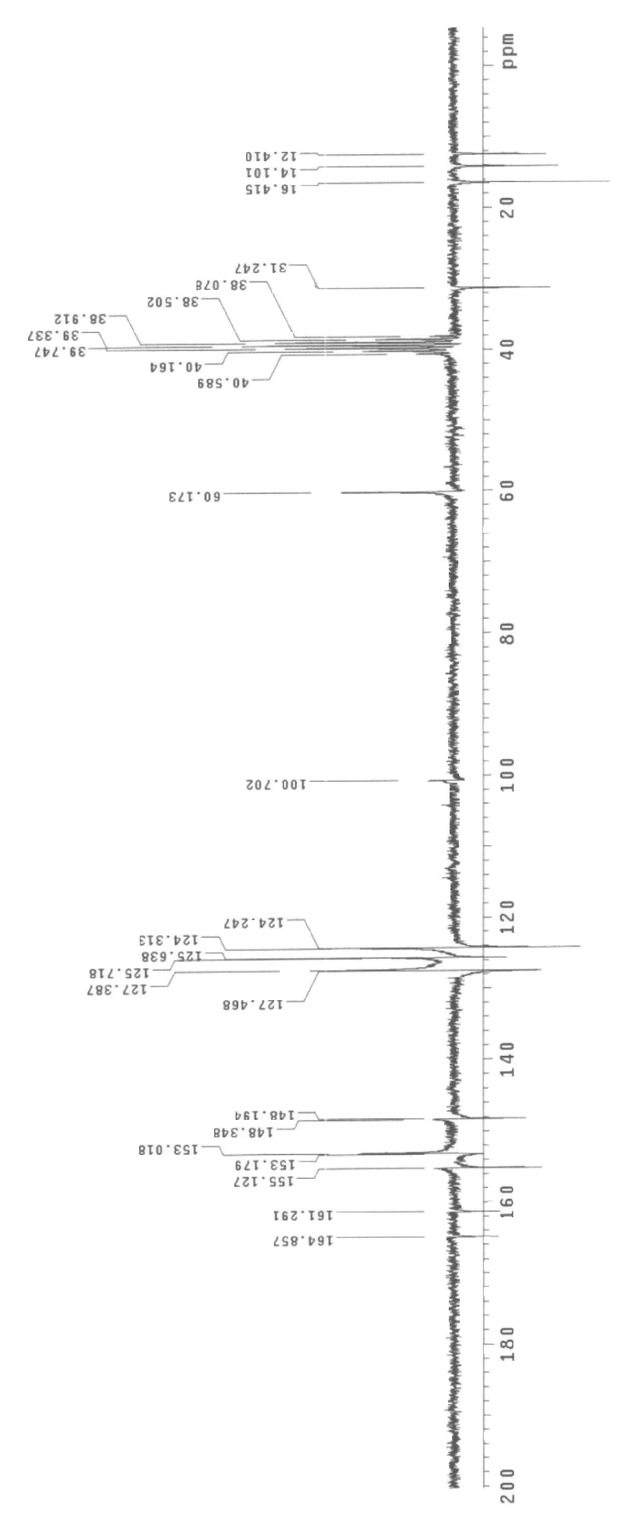



**Figure S18.** 13C NMR (APT) Spectrum (DMSO-d6) **(5c)**

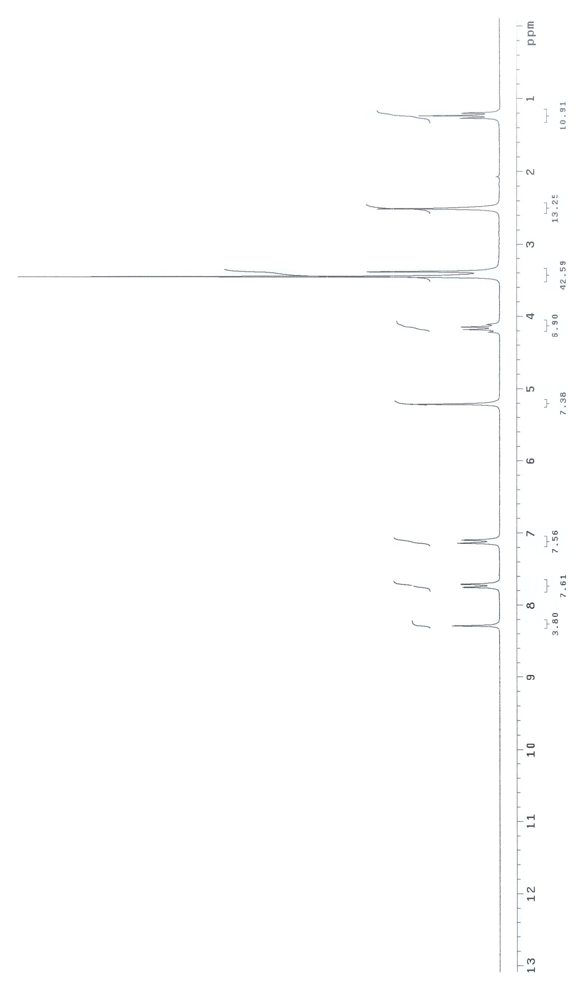



**Figure S19.** 1H NMR Spectrum (DMSO-d6) **(7a)**

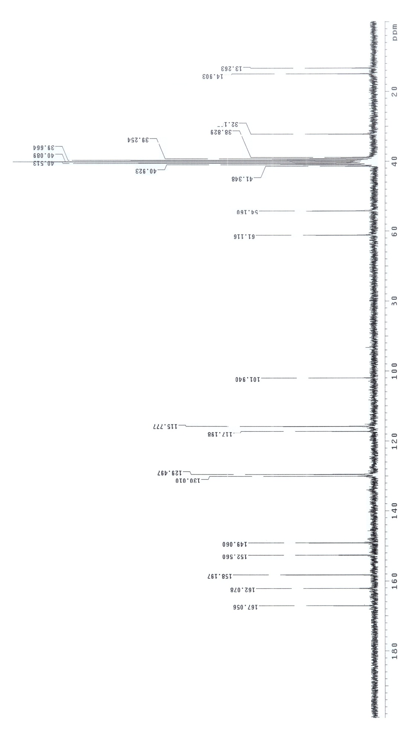



**Figure S20.** 13C NMR Spectrum (DMSO-d6) **(7a)**

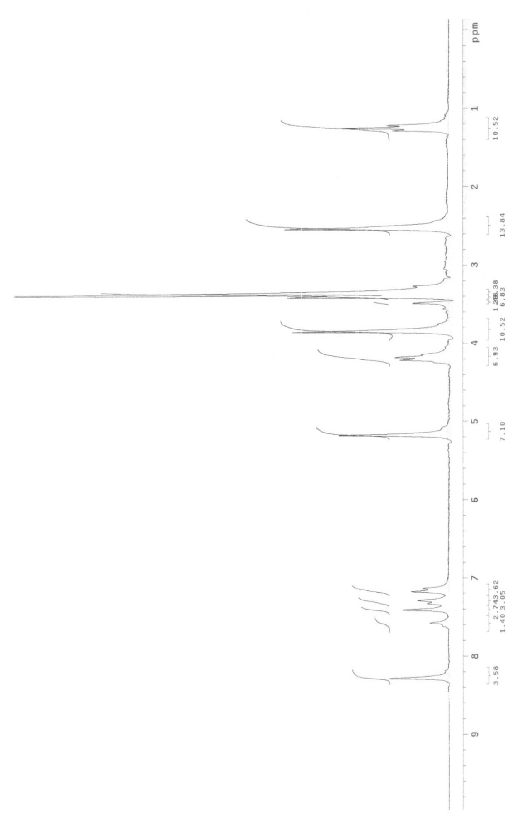



**Figure S21.** 1H NMR Spectrum (DMSO-d6) **(7b)**

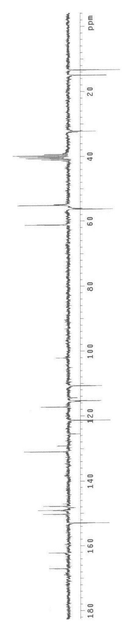



**Figure S22.** 13C NMR (APT) Spectrum (DMSO-d6) **(7b)**

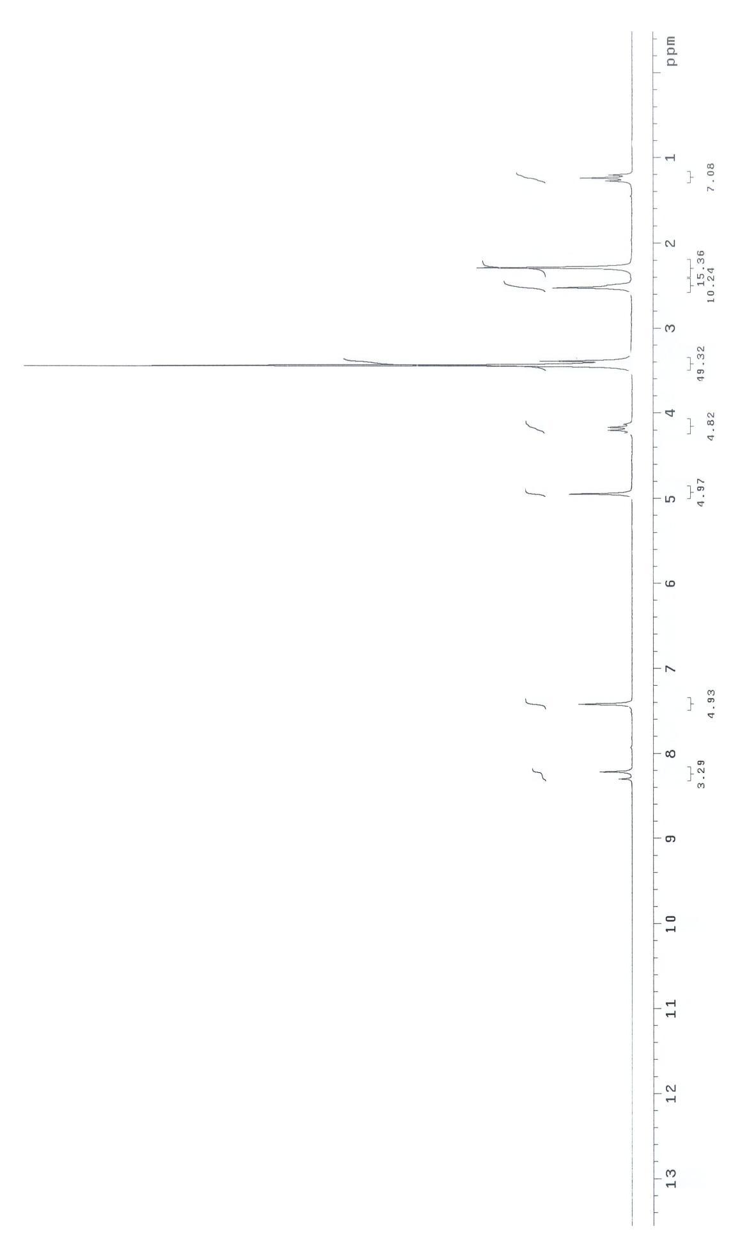



**Figure S23.**1H NMR Spectrum (DMSO-d6) **(7c)**

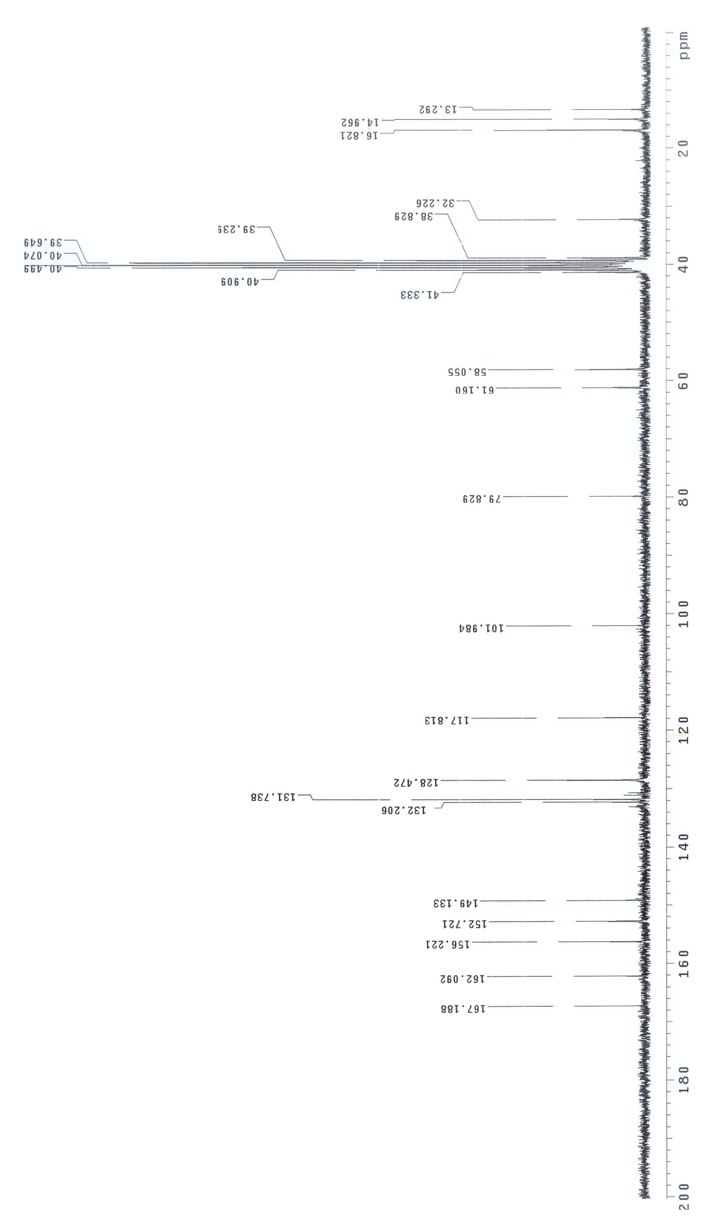



**Figure S24.** 13C NMR Spectrum (DMSO-d6) **(7c)**

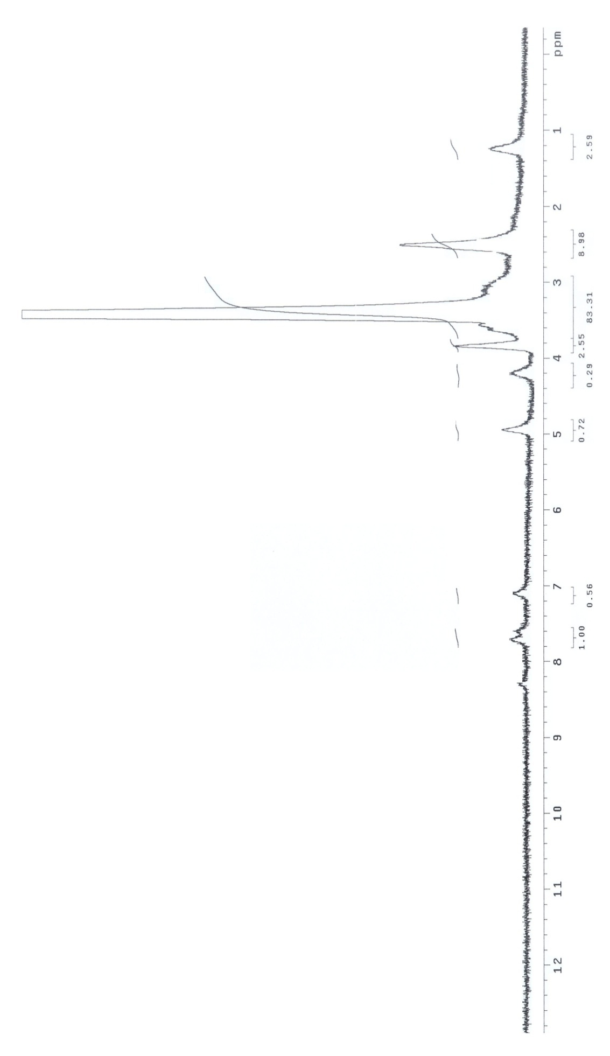



**Figure S25.** 1H NMR Spectrum (DMSO-d6) **(7d)**

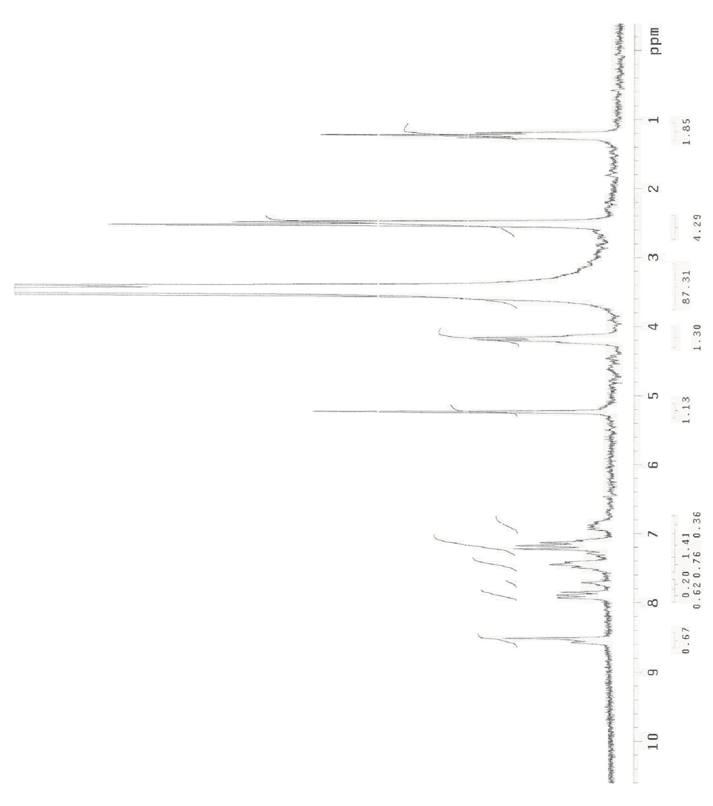



**Figure S26.** 1H NMR Spectrum (DMSO-d6) **(7e)**

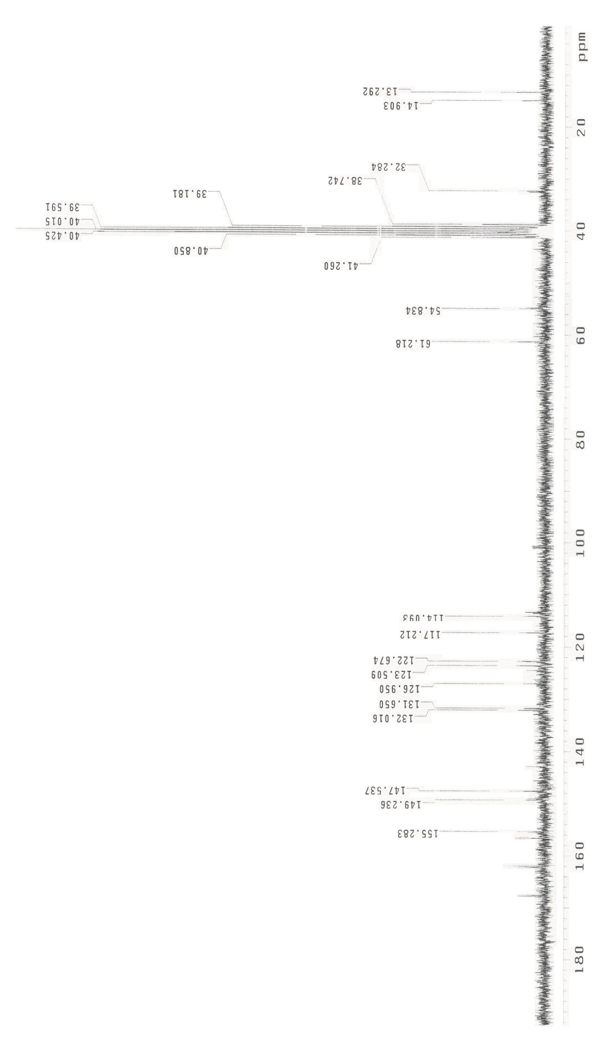



**Figure S27.** 13C NMR Spectrum (DMSO-d6) **(7e)**

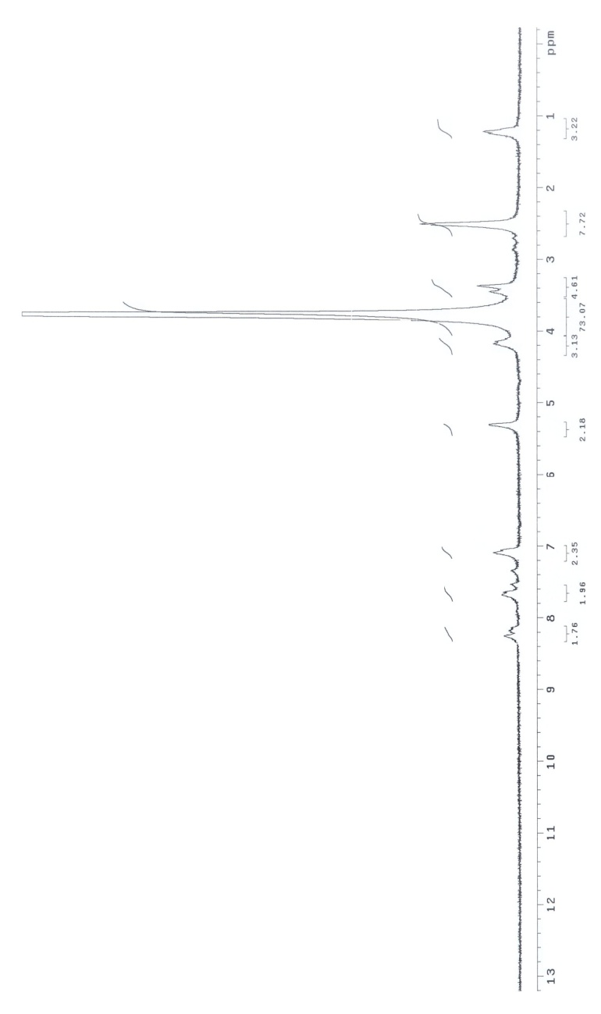



**Figure S28.** 1H NMR Spectrum (DMSO-d6) **(9a)**

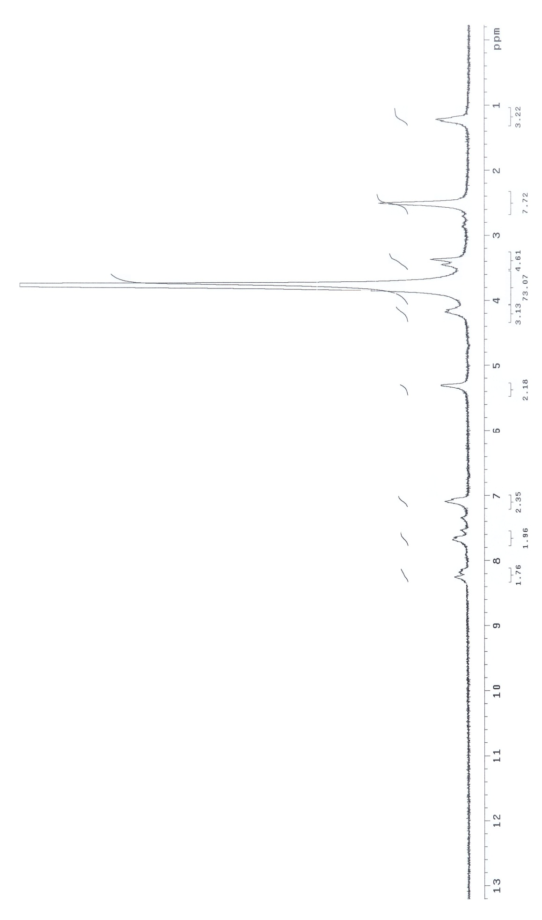



**Figure S29.** 1H NMR Exchange Spectrum (DMSO-d6 + D2O) **(9a)**

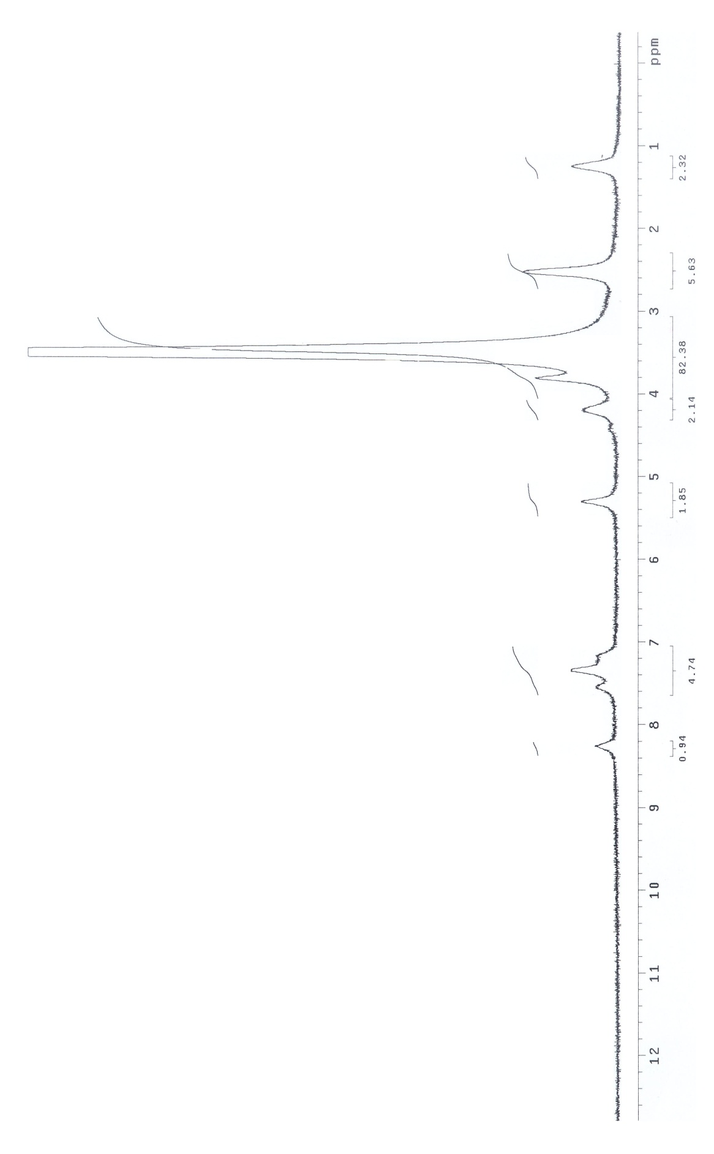



**Figure S30.** 1H NMR Spectrum (DMSO-d6) **(9b)**

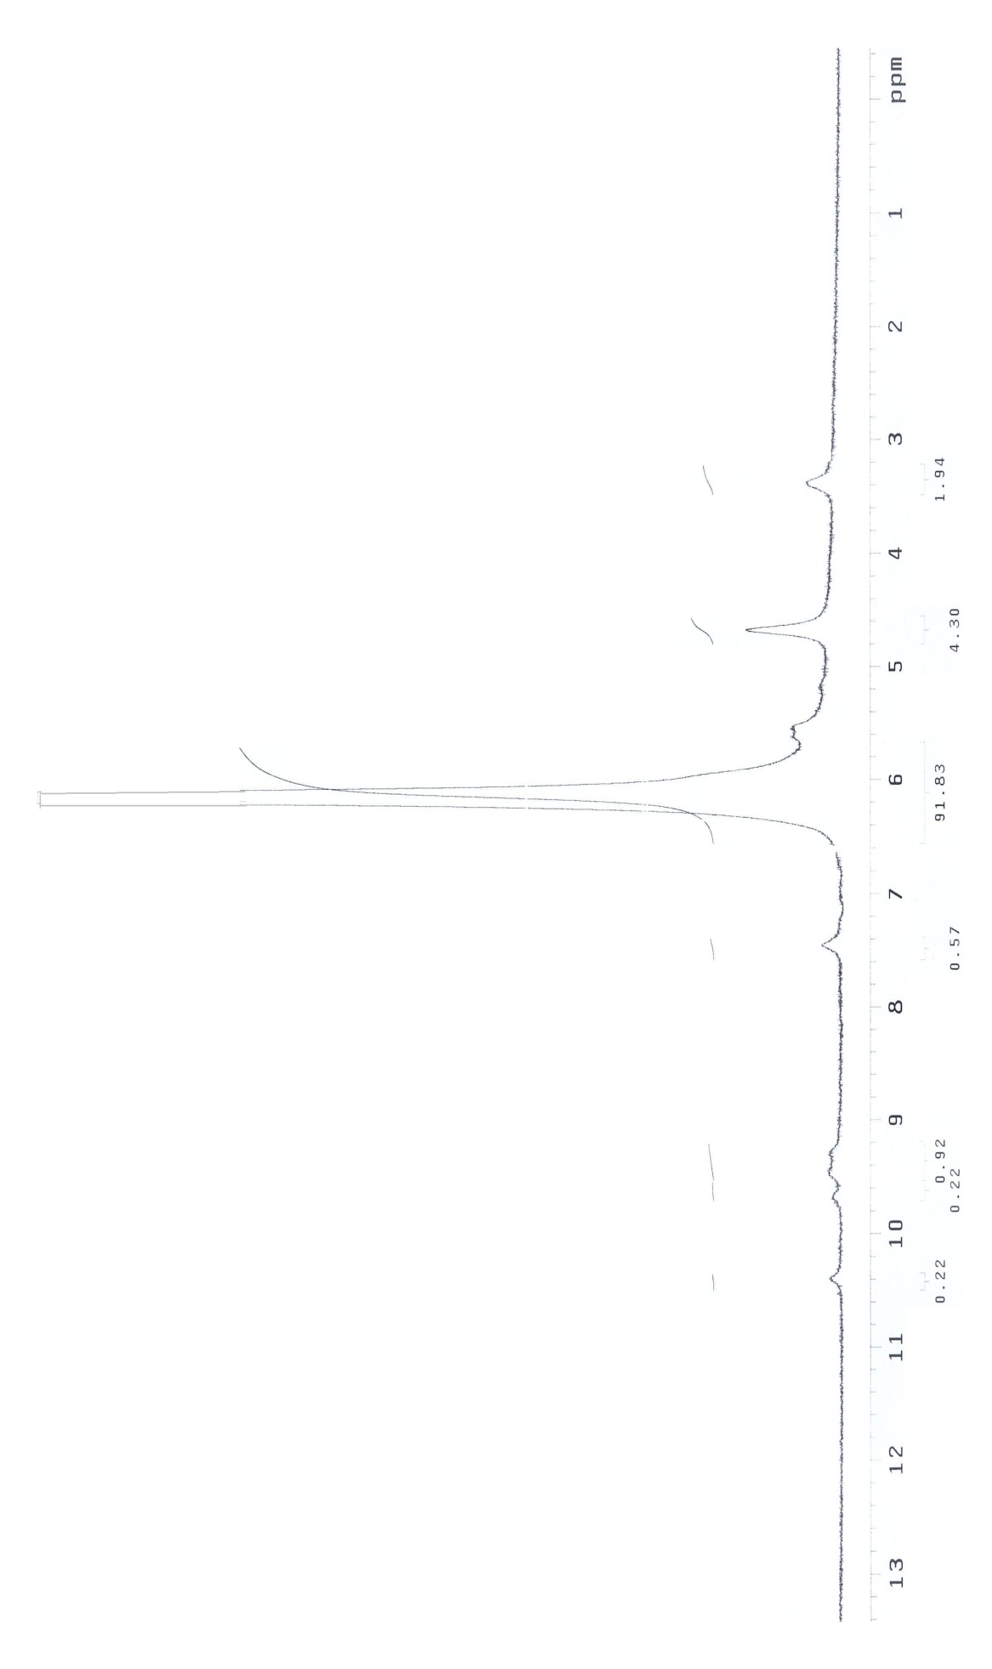



**Figure S31.** 1H NMR Exchange Spectrum (DMSO-d6 + D2O) **(9b)**

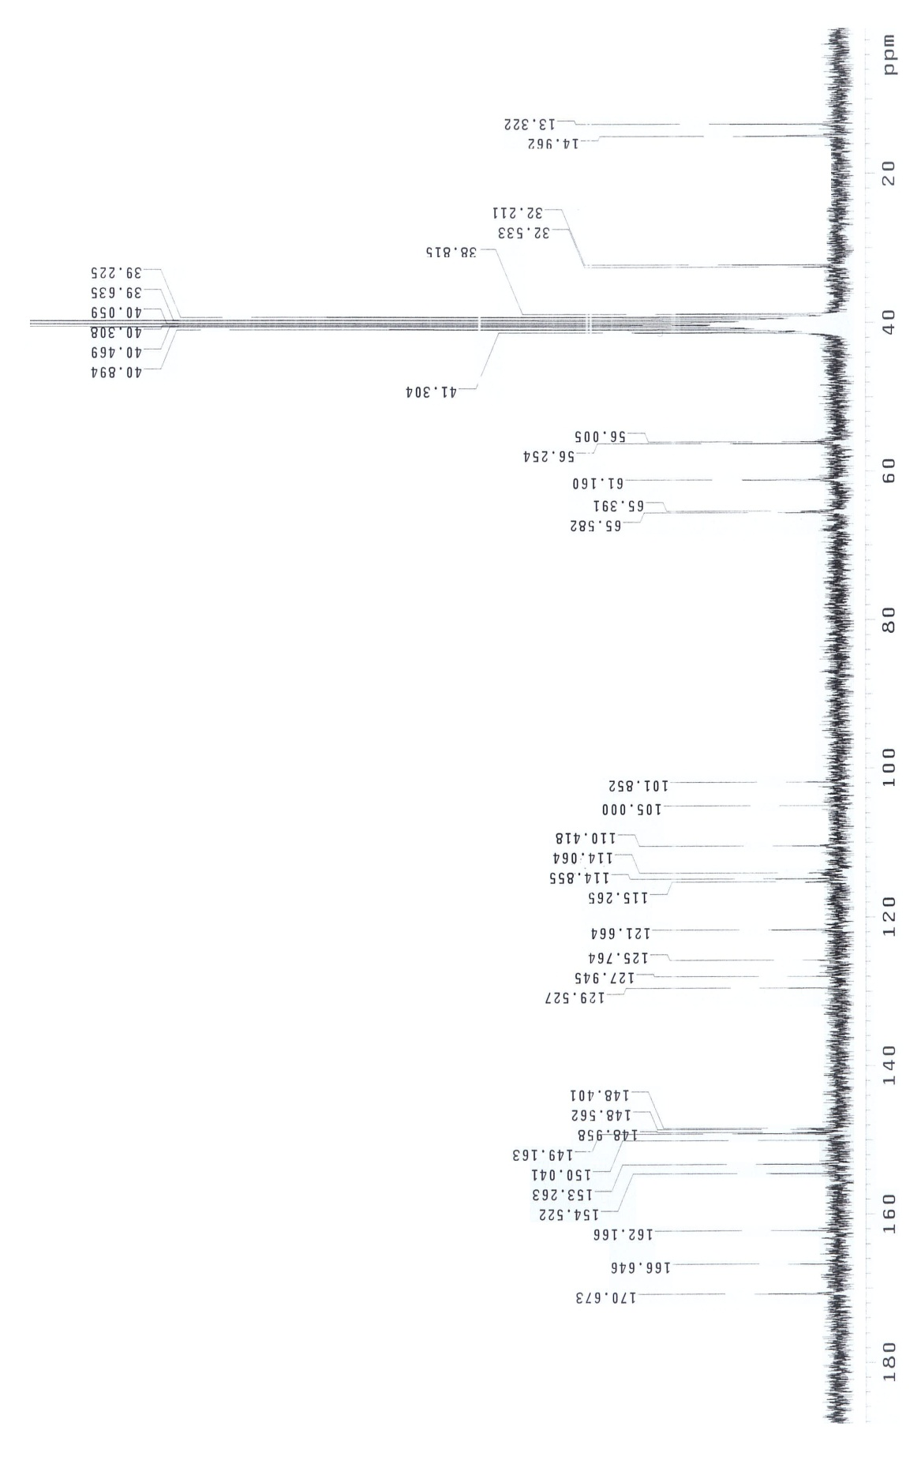



**Figure S32.** 13C NMR Spectrum (DMSO-d6) **(9b)**

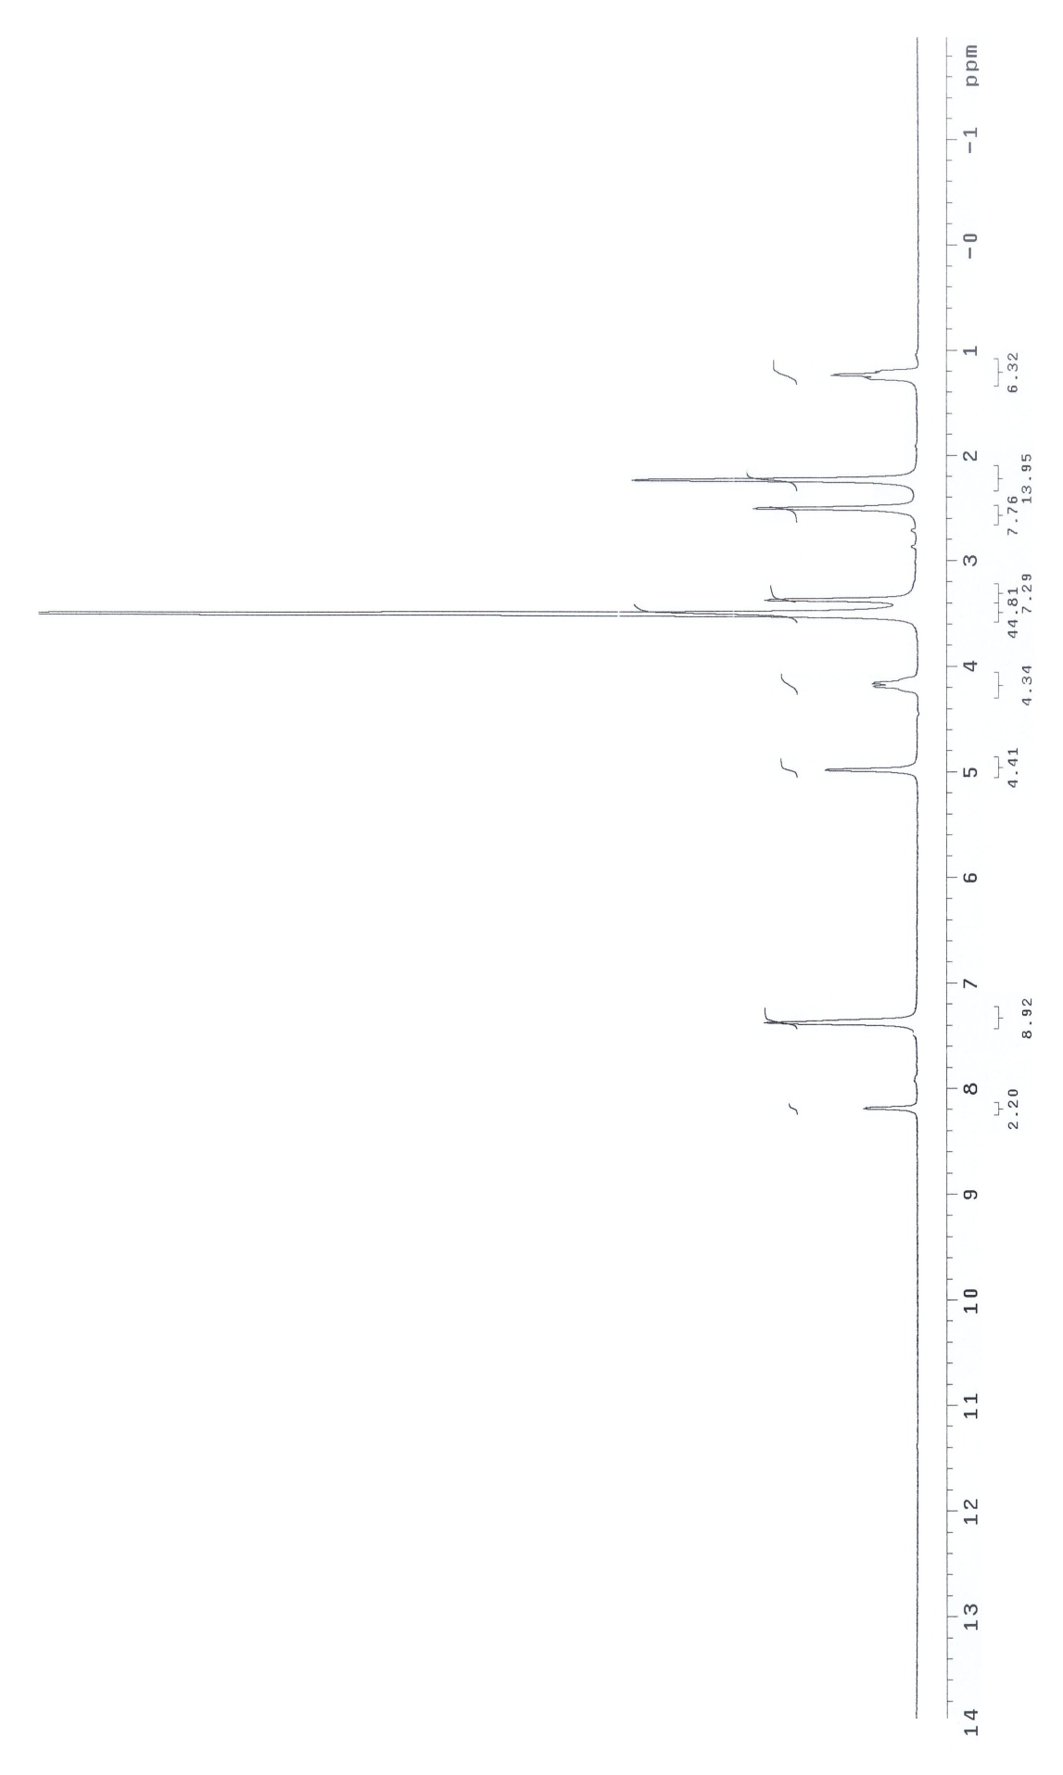



**Figure S33.** 1H NMR Spectrum (DMSO-d6) **(9c)**

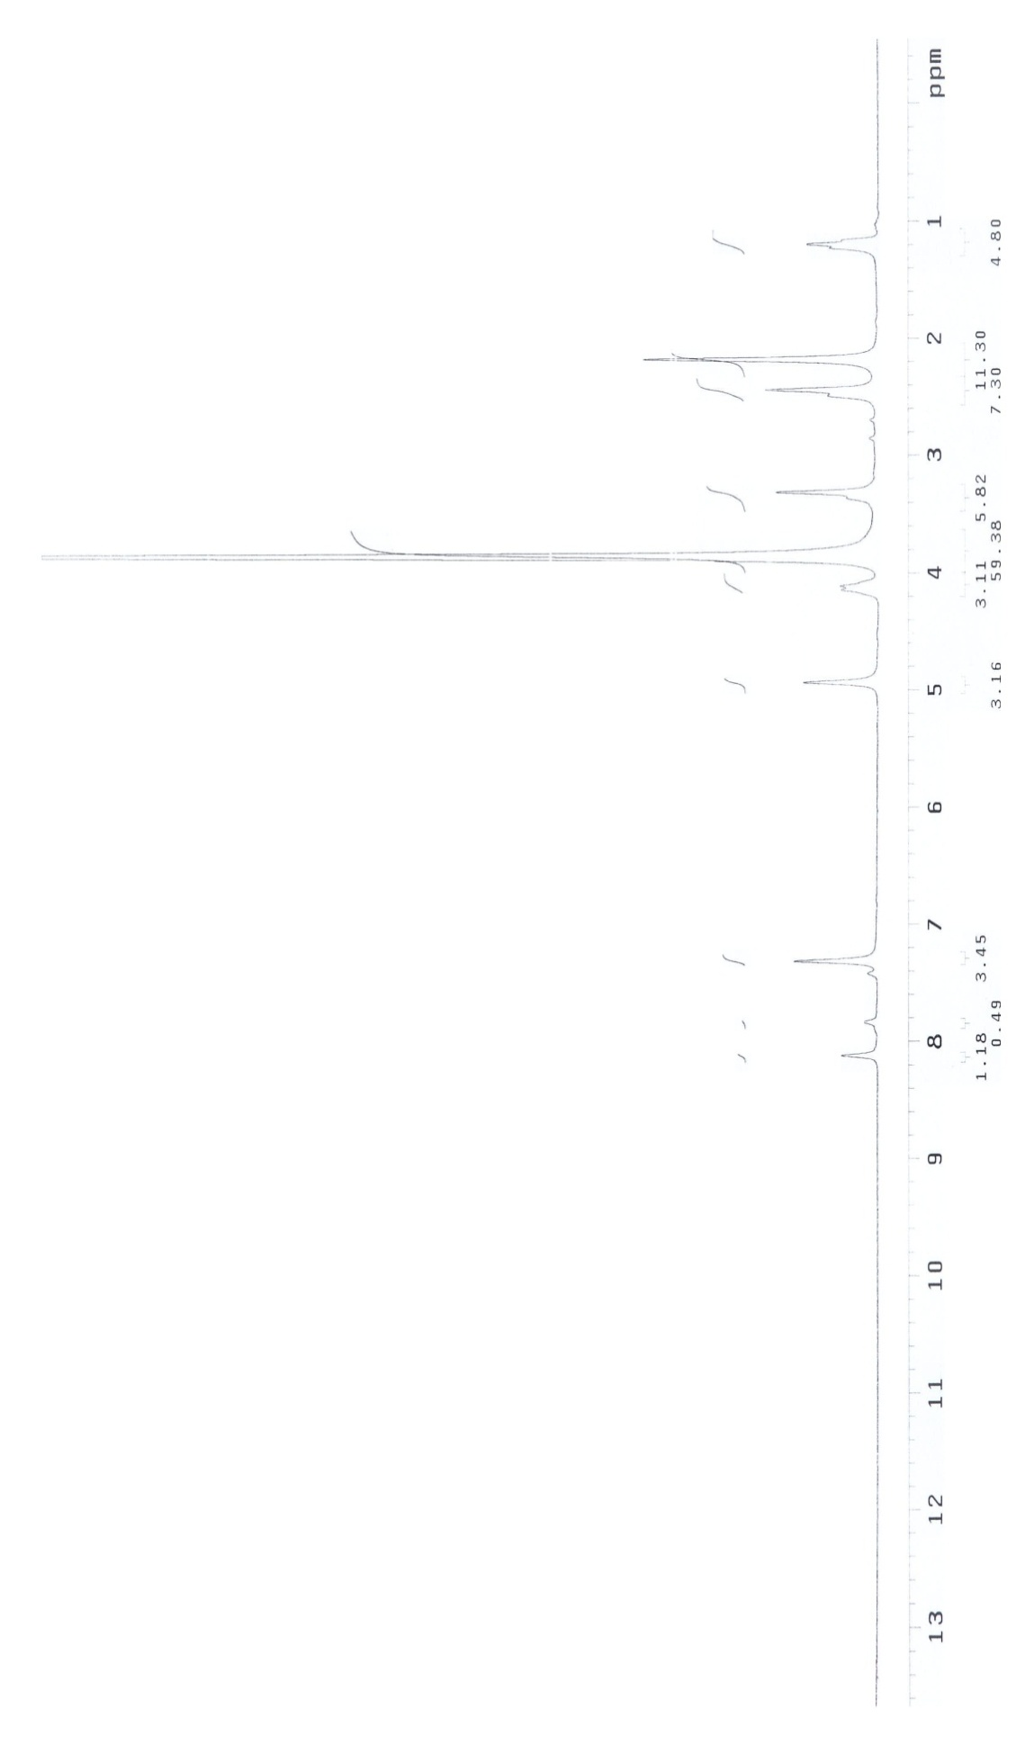



**Figure S34.** 1H NMR Exchange Spectrum (DMSO-d6 + D2O) **(9c)**

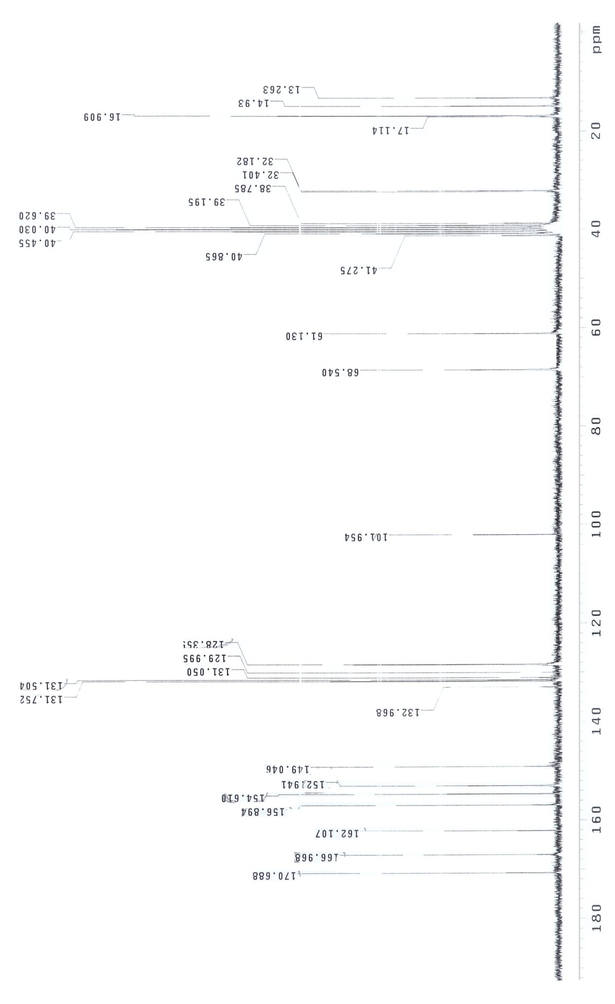



**Figure S35.** 13C NMR Spectrum (DMSO-d6) **(9c)**

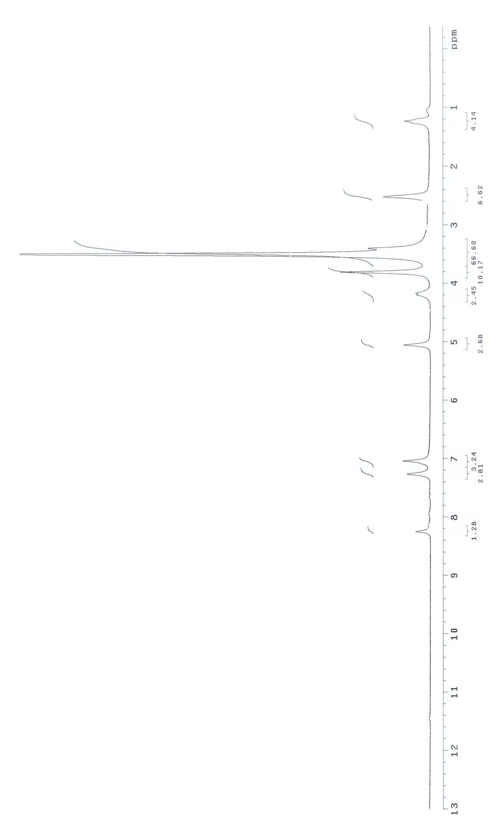



**Figure S36.** 1H NMR Spectrum (DMSO-d6) **(9d)**

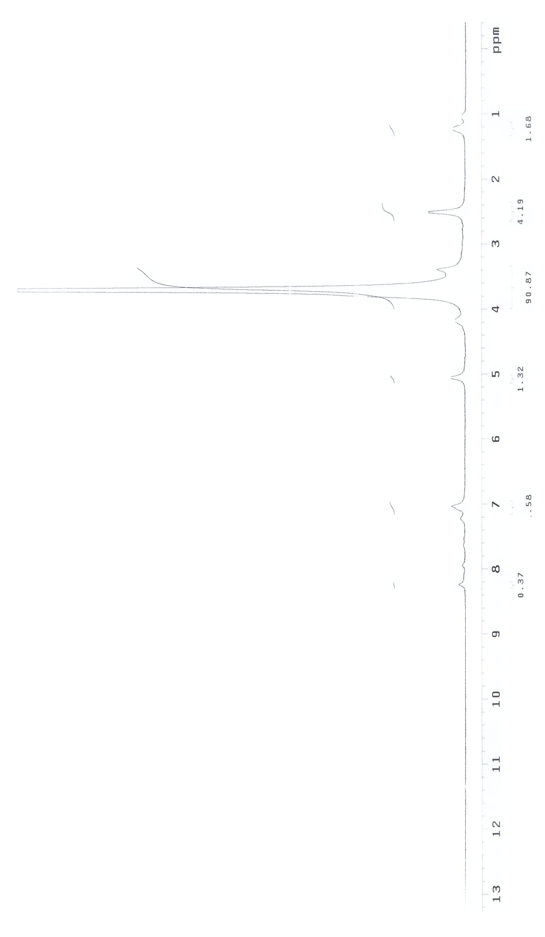



**Figure S37.** 1H NMR Exchange Spectrum (DMSO-d6 + D2O) **(9d)**

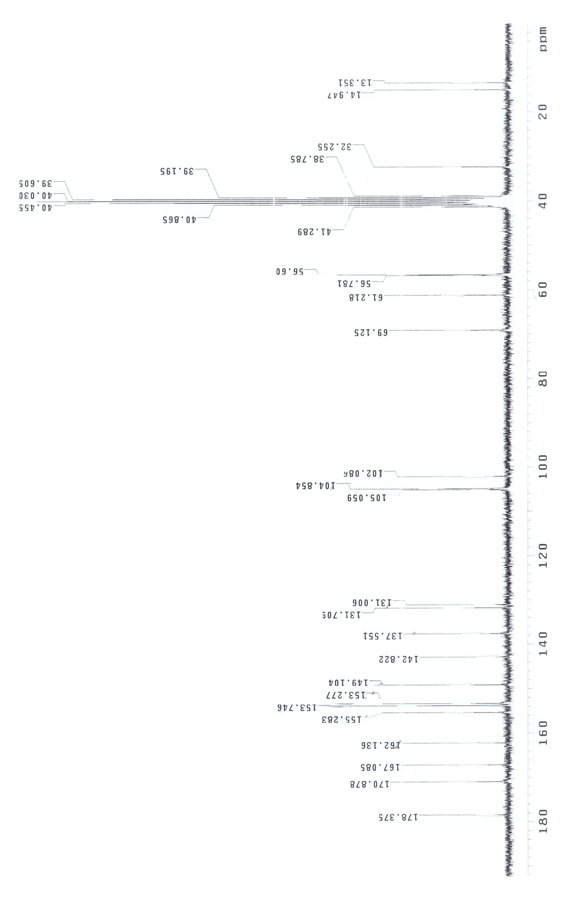



**Figure S38.** 13C NMR Spectrum (DMSO-d6) **(9d)**

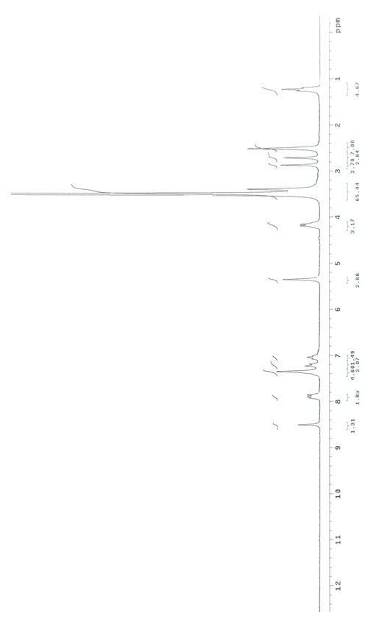



**Figure S39.** 1H NMR Spectrum (DMSO-d6) **(9e)**

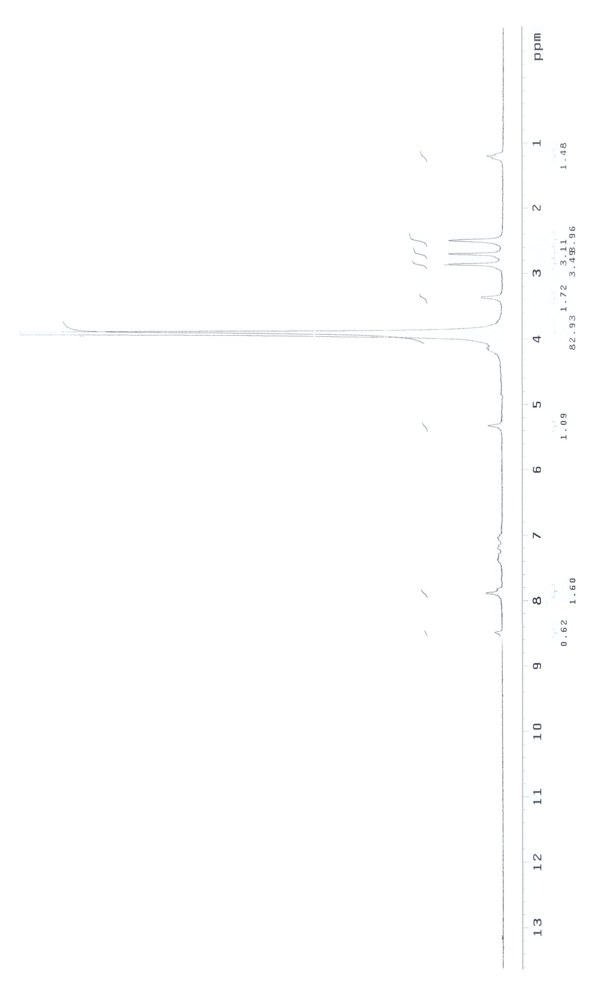



**Figure S40.** 1H NMR Exchange Spectrum (DMSO-d6 + D2O) **(9e)**

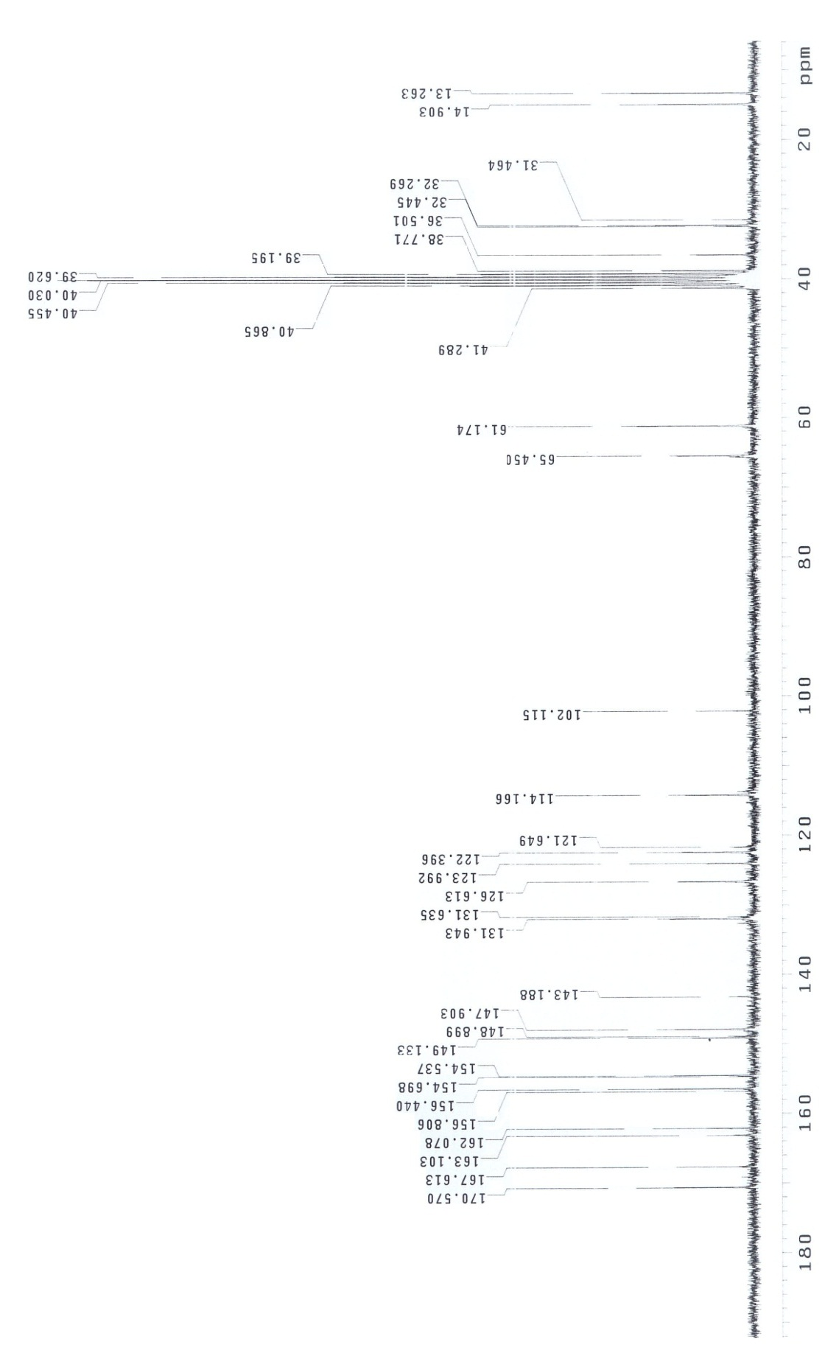



**Figure S41.** 13C NMR Spectrum (DMSO-d6) **(9e)**