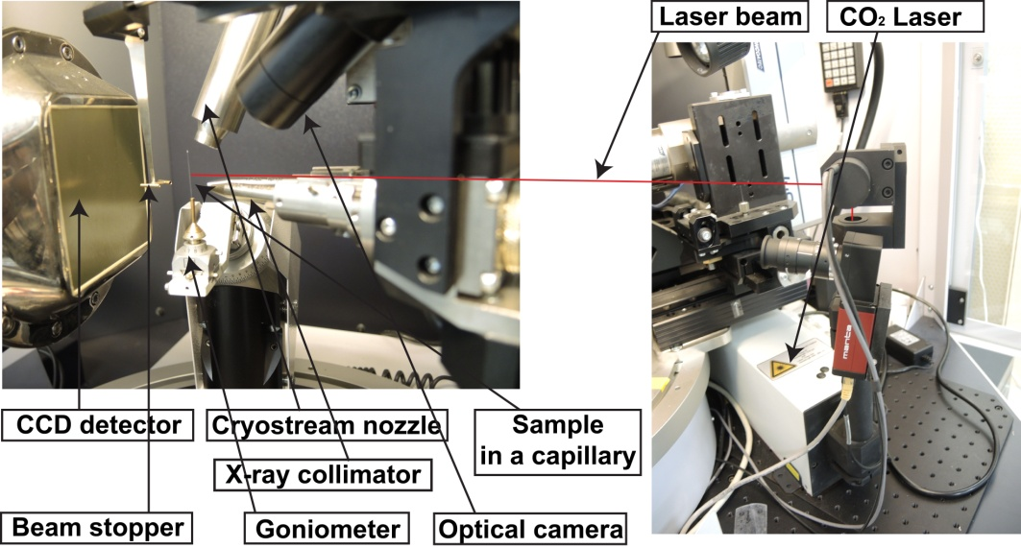

Figure 1. APEX DUO diffractometer (Bruker) with an OHCD accessory.

